Table of Contents
1. Foreword
2. Executive Summary
2.1. The central idea: Augmented Collective Intelligence
2.2. This is not a dream — it already exists
2.3. Prosperity for others: the flagship mission
2.4. The ask
3. The Call of This Moment
3.1. The technocratic paradigm
3.2. The call to developers — and to builders of infrastructure
4. Babel or Jerusalem — A Choice of Architecture
4.1. Babel: the architecture of concentration
4.2. Jerusalem: the architecture of communion
4.3. The choice is real, and it is being made now
5. Why Sovereignty Is a Stewardship Question
5.1. What is surrendered by default
5.2. Sovereignty in the light of Scripture
6. Augmented Collective Intelligence, Not Only Artificial General Intelligence
6.1. Two different questions
6.2. Why the distinction is theological, not merely technical
7. Digital Cells — The Human Person in Their Best Form
7.1. A living metaphor, made literal
7.2. Why "the human person in their best form"
8. The Spiritual and the Emotional — What Only the Human Brings
8.1. A division of gifts, not a competition
8.2. Spiritual and emotional capacities as first-class design inputs
8.3. Why this is the Church's natural ground
9. A New Operating System for Collaboration
9.1. Why today's systems cannot carry collective intelligence
9.2. The principle: design the environment, not just the mind
9.3. What the new operating system provides
10. This Is Not a Dream
11. The Architecture — Every Node a Complete World
11.1. Every node is a complete world
11.2. Security as structure, not decoration
12. Distributed Intelligence — A Brain Close to the People
12.1. You don't need a giant brain for every thought
12.2. Why this matters for the Church
12.3. Distributed, but not isolated
13. The Economics — Sovereignty That Communities Can Afford
13.1. A complete digital life on one module
13.2. Capital you own versus rent you never stop paying
13.3. Why this is not simply "cheaper IT"
14. Track Record — Proven People, Real Institutions
14.1. A team that has built foundations before
14.2. Institutions that have already engaged
14.3. What this means for the Church
15. Prosperity for Others — The Church That Goes Out
15.1. From self-sufficiency to overflow
15.2. Three forms of prosperity ACI enables
15.3. The shape of the mission
16. The Flagship Mission — Scripture for Every Language
16.1. The unfinished mission, in numbers
16.2. How AI assists — a superpower for local translators
16.3. A concrete proof-of-concept: the Zhuang cluster
16.4. Why the movement should not stay fragmented
17. A Network of Communities — Local by Design, Connected by Choice
17.1. Many worlds, one body
17.2. Local by design, connected by choice, planetary by architecture
17.3. This is Jerusalem, built
18. In the Spirit of Scripture
18.1. Concern by concern
18.2. The deeper alignment
19. The Invitation — Build Jerusalem
19.1. What is asked
19.2. What the movement gains
19.3. A closing word

1. Foreword
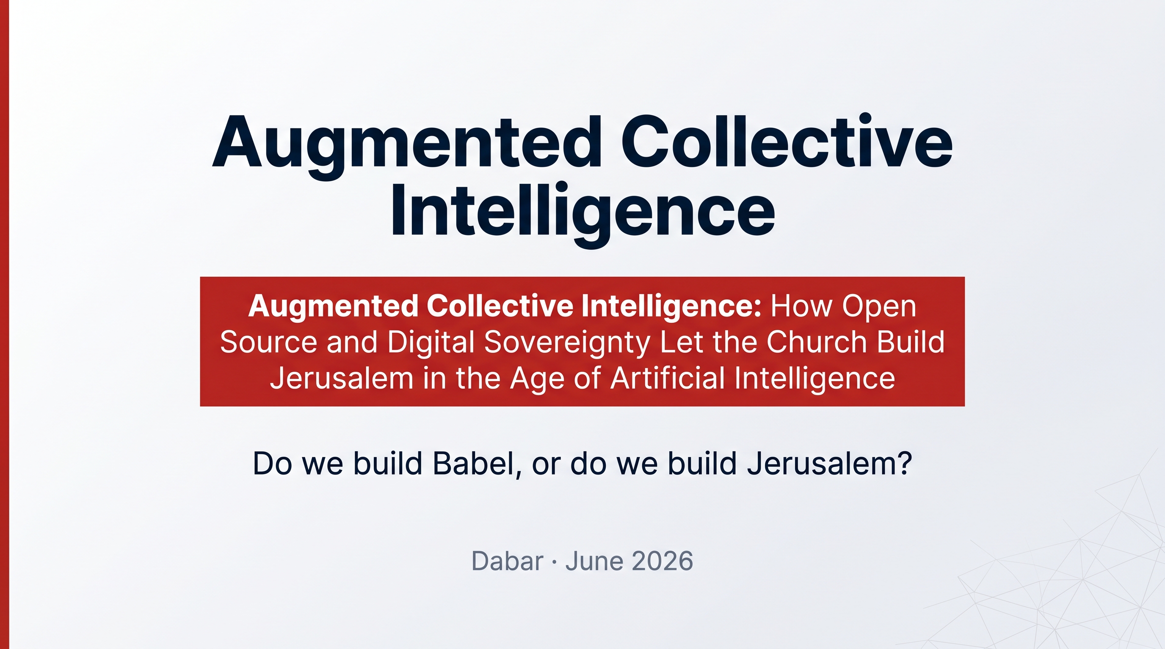
"Unless the LORD builds the house, those who build it labour in vain." — Psalm 127:1
This white paper is written for those who carry responsibility for the future of the Church and for the communities it serves. It is written in the conviction that we are living through one of those rare moments — comparable to the invention of the printing press — when the foundations of how humanity thinks, communicates and organises are being rebuilt. The question before us is not whether this rebuilding will happen. It is already happening. The question is whose values will be poured into the foundations.
Scripture gives this moment two ancient names. One is Babel: technological power without humility, a world built on control, uniformity, surveillance and the concentration of power in few hands. The other is Jerusalem: a shared rebuilding, a path of communion, plurality, responsibility and the common good. The real choice is not "technology or no technology." The choice is: do we build Babel, or do we build Jerusalem?
This document answers that question with a concrete proposal. It argues that the dominant race in artificial intelligence — the race toward a single, centralised, all-knowing machine mind — is, in its architecture, a Babel. And it offers an alternative that is, in its architecture, a Jerusalem: a way for human beings, in their full spiritual and emotional dignity, to work together with machines and with one another. We call this Augmented Collective Intelligence (ACI).
The most important claim in these pages is also the simplest: this is not a dream. The technology described here is not a hope for the next decade. It exists today. It runs today. It can be deployed by communities today, on hardware they own, under their own jurisdiction, aligned with their own values. What is missing is not the technology. What is missing is a movement willing to build with it.
This paper is offered, with respect and hope, by Dabar — the company building an operating system for those who believe in God — as an invitation to take responsibility, to build the common good, and to remain human.

2. Executive Summary
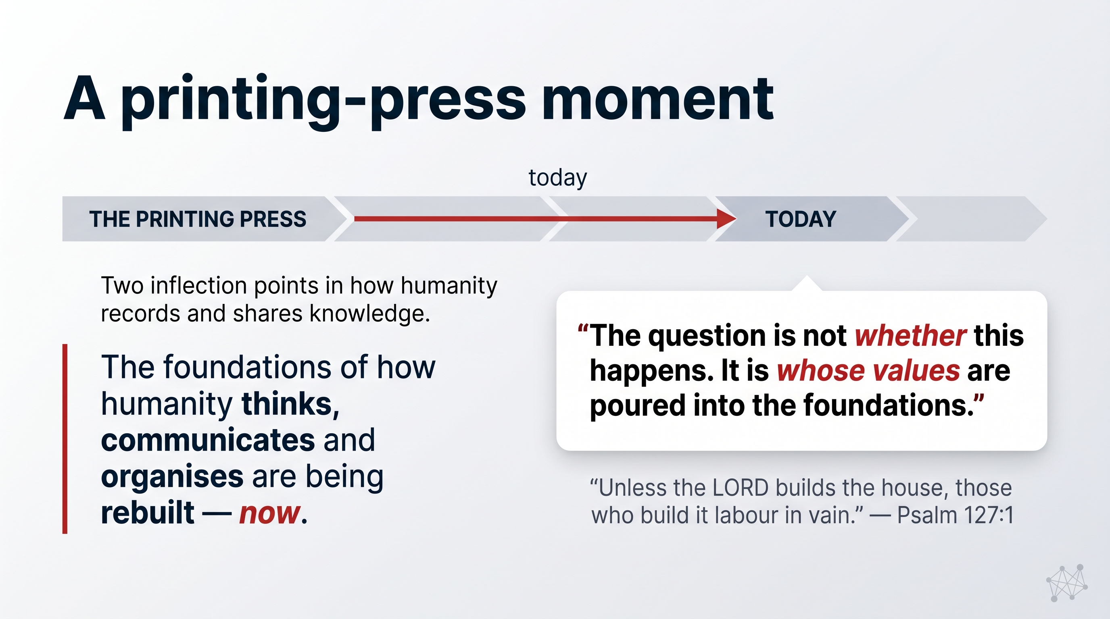
Artificial intelligence is reorganising the world. Within a few years, most of how communities communicate, learn, organise and serve will be mediated by AI systems. Today those systems are being built by a handful of corporations whose architecture concentrates power, harvests data, and treats the human person as a profile to be optimised. Scripture names this temptation Babel and calls those who believe in God to build Jerusalem instead — a digital civilisation rooted in dignity, communion and the common good.
This white paper proposes how the Church can answer that call.

2.1. The central idea: Augmented Collective Intelligence
The technology industry is racing toward AGI — Artificial General Intelligence — a single machine mind intended to surpass human reasoning. This pursuit, by its very design, concentrates intelligence, capital and control in a few centralised data centres.
We propose a complementary and, we believe, more humane path: ACI — Augmented Collective Intelligence. ACI does not seek to replace human intelligence with one giant brain. It seeks to augment the intelligence of communities by letting human beings — with their irreplaceable spiritual, moral and emotional capacities — work together with AI and with each other. Where AGI asks "how powerful can one mind become?", ACI asks "how wise can a people become together?"
ACI is not a metaphor. It requires, and already has, a concrete foundation:
- A new kind of operating system in which each person and community is a complete, self-contained "digital cell" — holding its own data, intelligence and applications — rather than a thin client renting capacity from someone else's cloud.
- Sovereignty by architecture: data never leaves the community's control, because the system is built that way, not because a corporation promises it.
- Open source and auditable code, so that anyone can verify how it works and no single company can revoke it.
- Distributed intelligence: roughly 90% of AI tasks run locally on small, efficient models close to the people they serve — private, fast, and low-energy — escalating to large models only when genuinely needed.

2.2. This is not a dream — it already exists
The foundation is built and running. It rests on:
- A proven team that has built, scaled and sold foundational internet infrastructure for over two decades (DataCenter Technologies, HostBasket, Q-layer, Amplidata), with technical firsts in deduplication, distributed storage and early proof-of-stake blockchain.
- Working technology: a self-contained compute module of roughly US$2,000 that delivers an enterprise-grade digital life for 50+ people — under US$100 per person, at under 2 watts per user — and scales by simple replication into a planetary peer-to-peer network with no central hub.
- Real institutional traction: a sovereign digital free zone with the Government of Zanzibar; a relationship with the International Cooperative Alliance and its 1.2 billion members; and a CTO-level forum of 50 major cooperatives representing over US$2 trillion in revenue.

2.3. Prosperity for others: the flagship mission
ACI is not infrastructure for its own sake. It is a way for the Church to go out and bring prosperity to others. The flagship application is Bible translation. Of 7,393 living languages, 3,248 still have no Scripture, and 1,675 have no translation work at all. ACI compresses decades into years by letting AI assist mother-tongue translators — drafting, checking consistency, flagging theology — while humans retain authority over every verse. A concrete proof-of-concept targets the 17-million-person Zhuang language cluster.

2.4. The ask
This paper invites the movement to fund and build the first sovereign ACI network for the global Church: to deploy the infrastructure, to support the Bible-translation proof-of-concept, and to convene the communities. The technology is ready. What remains is the will to build Jerusalem.

3. The Call of This Moment
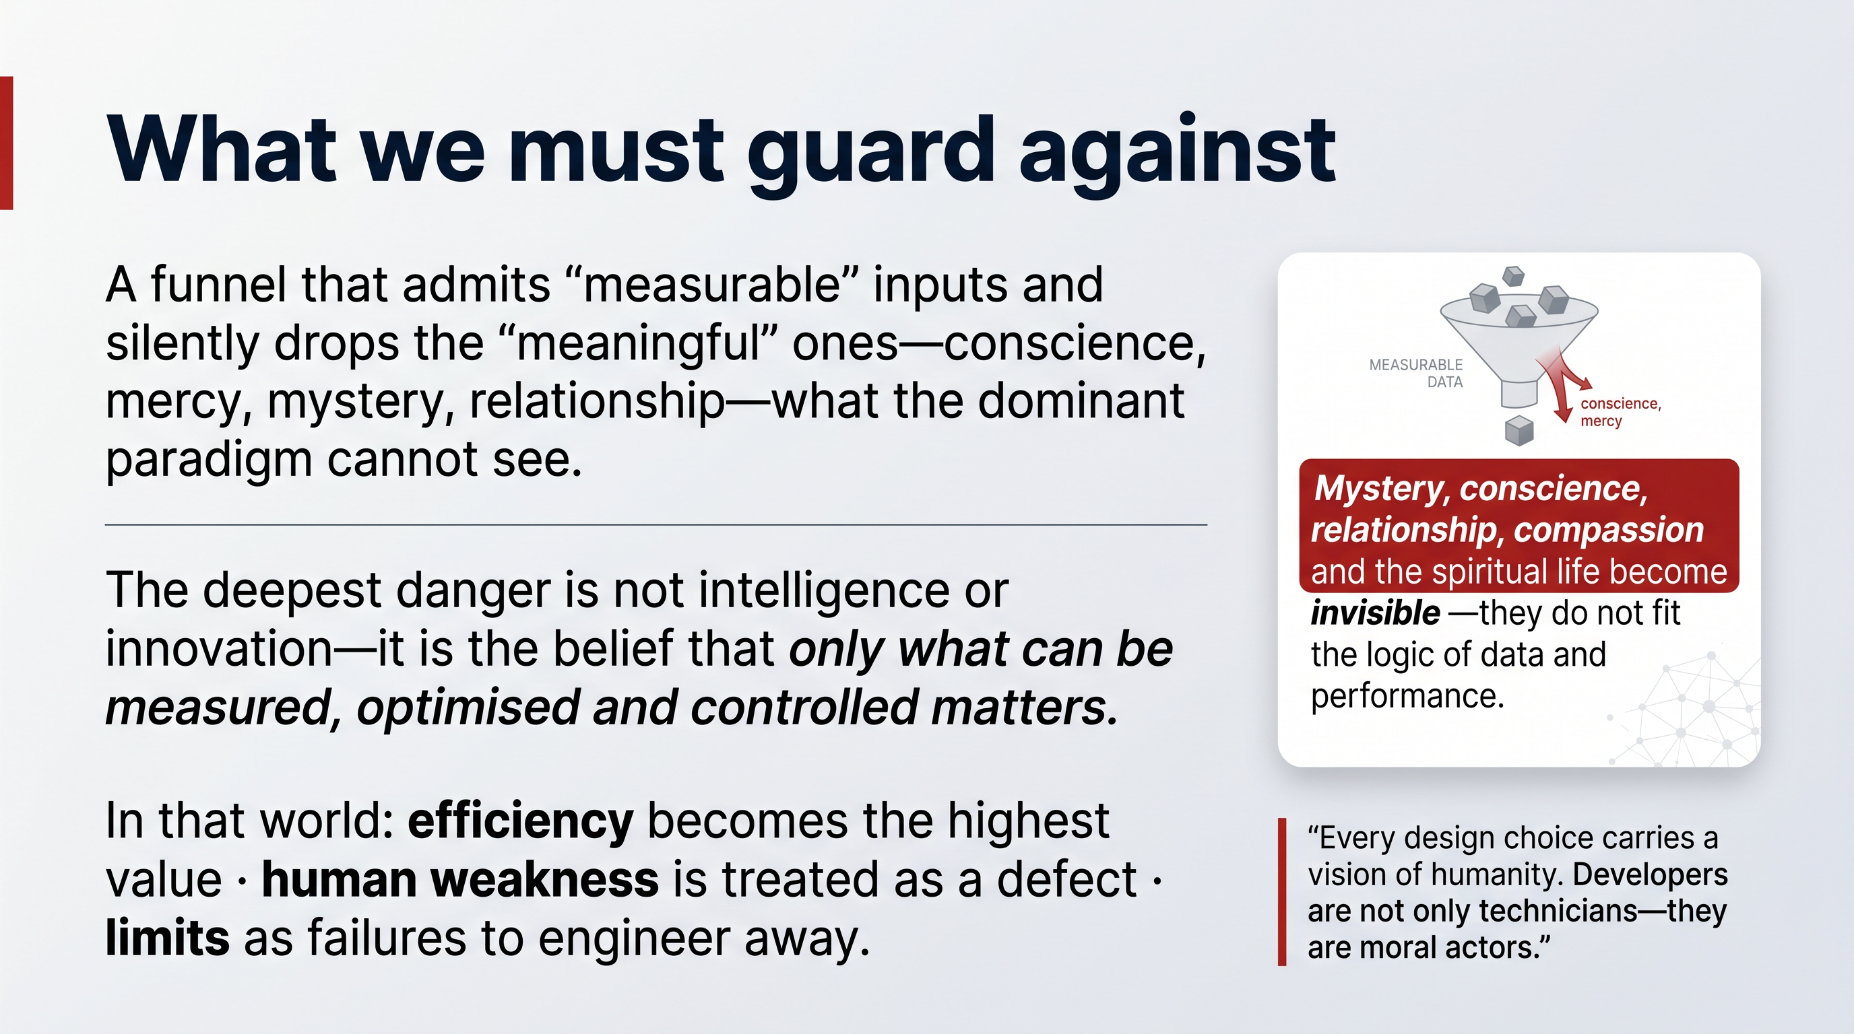
We are living through a civilisational moment. Digitalisation, robotics and artificial intelligence are transforming daily life, work, politics, culture, education and the very way decisions are made. The question before those who believe in God is not whether AI is useful or dangerous. The question is deeper:
What kind of humanity are we building?
This white paper begins from a conviction that humanity stands at a decisive point. These tools are powerful — but they are not neutral. They reflect the values, interests and intentions of those who design, finance, govern and deploy them.
This is the premise on which everything in this white paper rests. A technology is a frozen set of choices. When a community pours its prayer life, its pastoral records, its translations of Scripture and its daily communication into a platform, it inherits the values that platform was built to serve. If that platform was built to harvest attention and sell prediction, then the community's digital life will, slowly and invisibly, be bent toward those ends.

3.1. The technocratic paradigm
The deepest danger can be named precisely. It is not intelligence as such, nor innovation as such. It is the technocratic paradigm: the belief that what can be measured, optimised, automated and controlled is therefore what matters most.
In a world ruled by this paradigm:
- efficiency becomes the highest value;
- human weakness is treated as a defect;
- limits are treated as failures to be engineered away;
- and mystery, conscience, relationship, compassion and the spiritual life become invisible — because they do not fit into the logic of data and performance.
Concrete risks follow: the concentration of AI power in private, transnational actors; algorithmic systems that shape decisions without transparency; digital infrastructures that quietly reshape imagination, culture and behaviour; the reduction of the human person to data, productivity or predictability; and technological competition driven by commercial, military and geopolitical domination.

3.2. The call to developers — and to builders of infrastructure
This is a special appeal to those who build. Every design choice carries a vision of humanity. Developers are not only technicians. They are moral actors. Their work should be guided by transparency, by responsibility toward affected communities, and by attention to the genuine good.
This white paper takes that appeal literally. If every design choice carries a vision of humanity, then the architecture of our digital infrastructure is a spiritual matter. The question of where the data lives, who owns the compute, whether the code can be read, and whether one company can switch it off is not a technical footnote. It is the question of whether we are building Babel or Jerusalem — translated into the language of systems.
The next chapters take up that translation directly.

4. Babel or Jerusalem — A Choice of Architecture
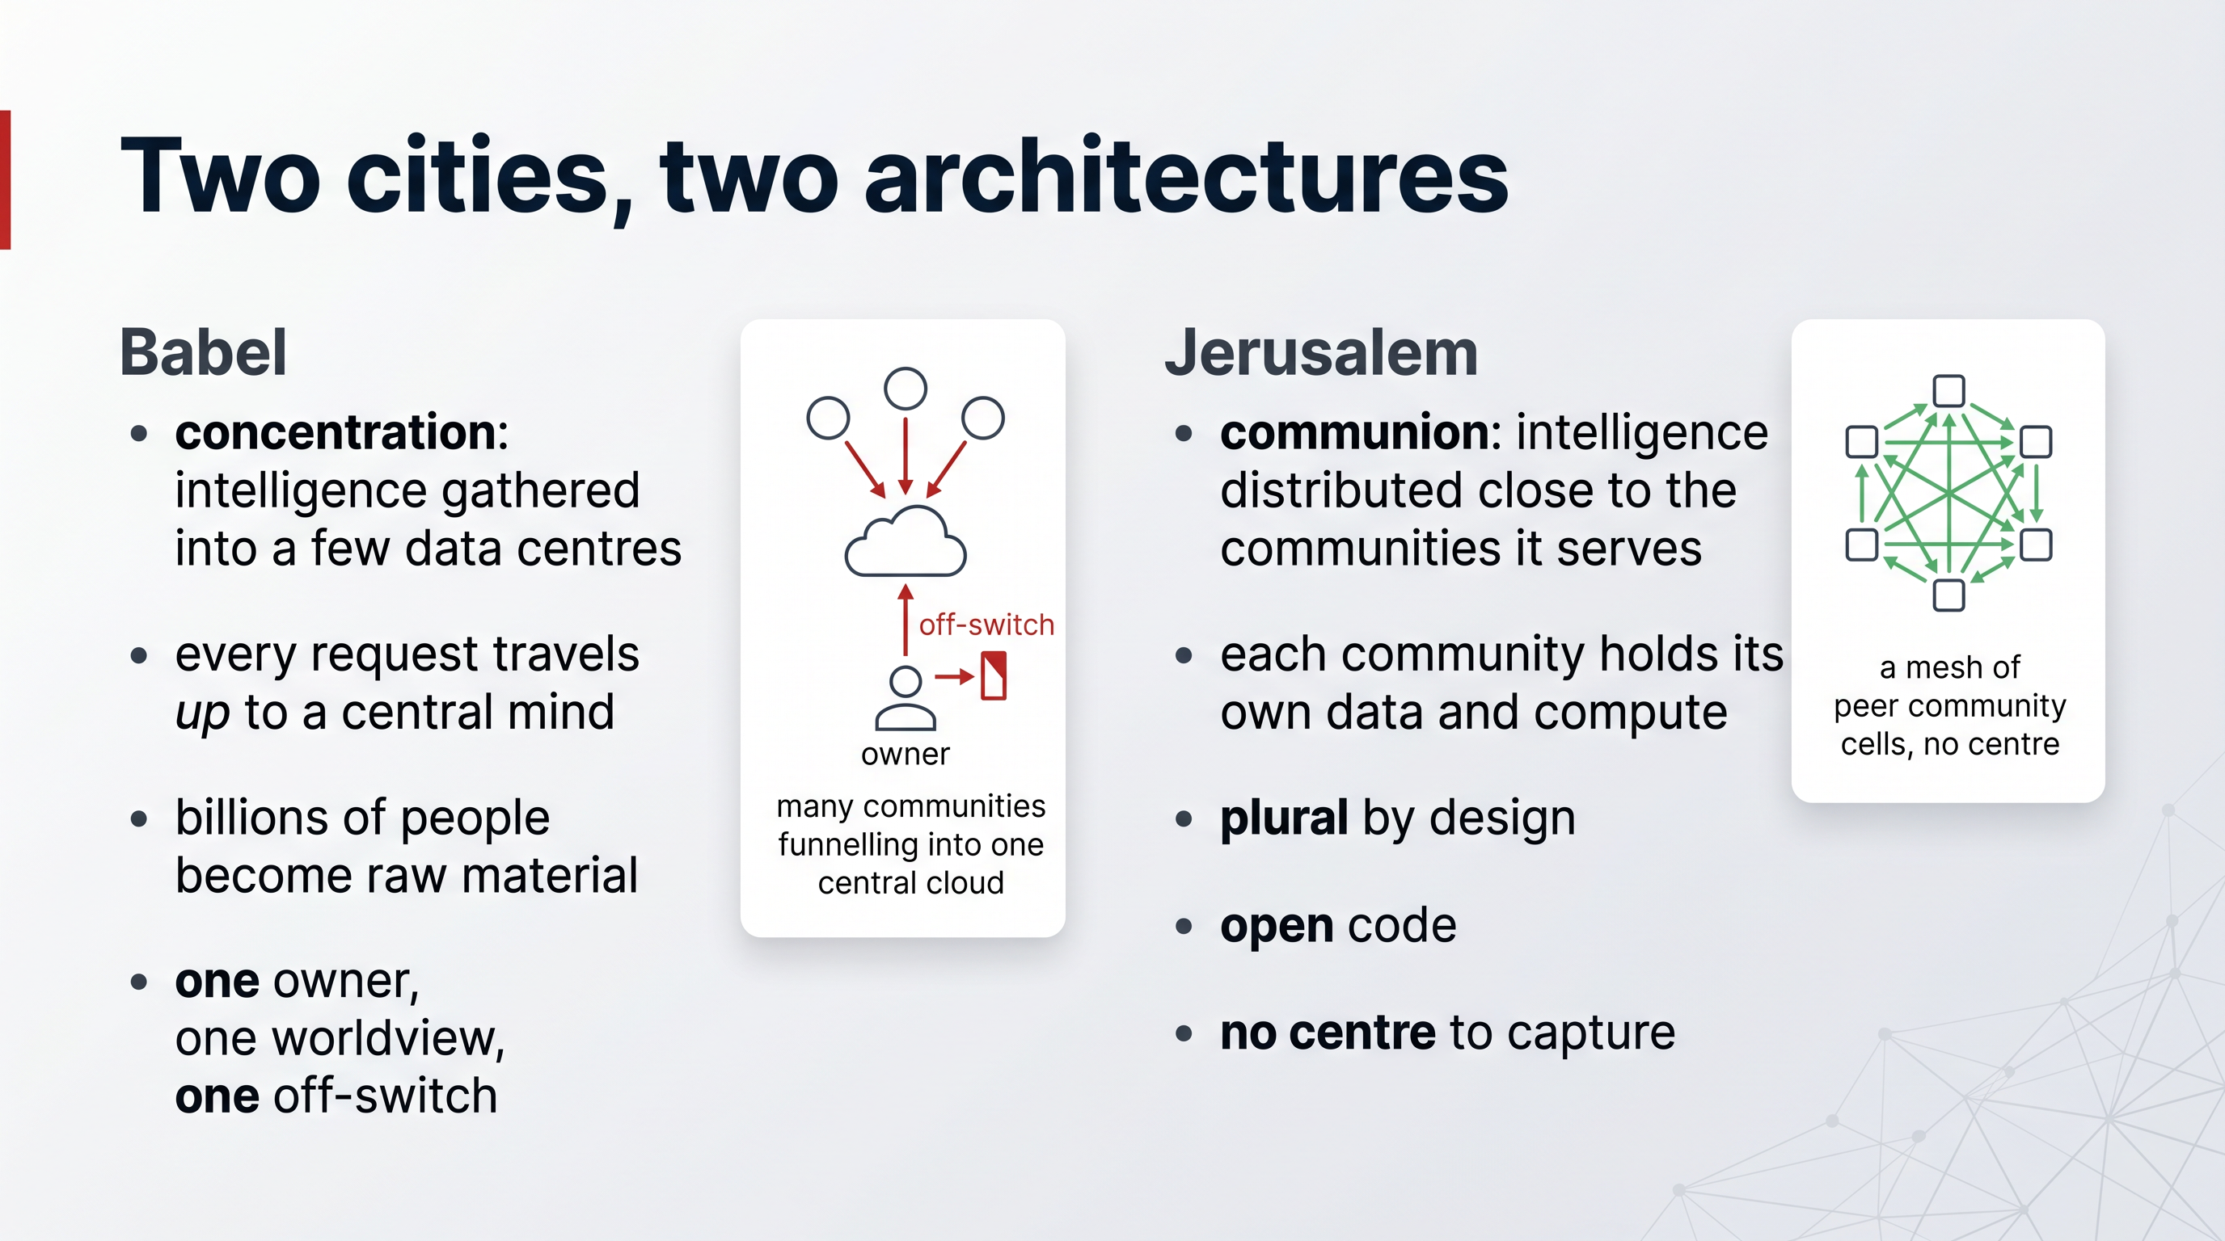
Scripture frames the digital age through two ancient cities. They are not only spiritual images. Read carefully, they are descriptions of two architectures — two fundamentally different ways of arranging intelligence, data and power.

4.1. Babel: the architecture of concentration
Babel is technological power without humility — a world built on control, uniformity, domination and self-sufficiency. In today's terms, Babel appears wherever technology becomes a tool for the concentration of power, for manipulation, surveillance, exclusion, or profit without responsibility.
The dominant architecture of the AI era is, in this precise sense, a Babel:
- Intelligence is gathered into a handful of enormous, centralised data centres.
- Every request must travel up to that central mind and back.
- The data of billions of people becomes the raw material — and the product.
- A single language, a single worldview, a single business model is pressed onto the whole earth.
- And a very small number of actors hold the power to grant, price, shape or revoke access.
It is uniform, it is self-sufficient, and it speaks with one voice from one place. That is the tower.

4.2. Jerusalem: the architecture of communion
Jerusalem represents a shared rebuilding. It is the path of communion, responsibility, plurality and cooperation. It is not one person or one system imposing the future from above, but many people taking responsibility for the common good together.
An architecture of communion looks entirely different:
- Intelligence is distributed — it lives close to the people and communities it serves.
- Each community holds its own data, its own compute, its own digital home.
- The system is plural by design: many sovereign cells, each complete, freely cooperating.
- The code is open, so that responsibility can be exercised and trust can be verified.
- No single actor can dominate, because there is no single centre to capture.
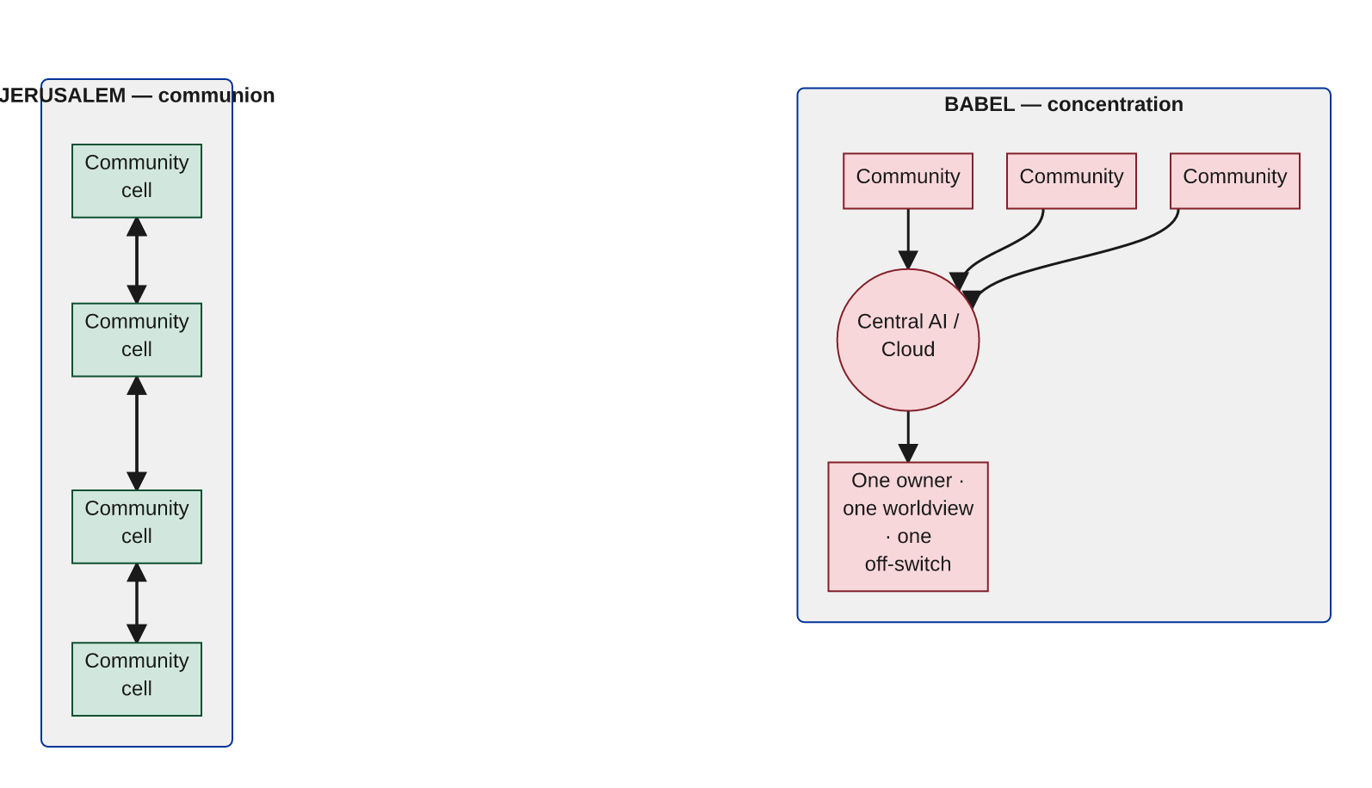

4.3. The choice is real, and it is being made now
This is not a choice between technology and its refusal. Both Babel and Jerusalem are built; both use the most advanced tools of their age. The difference is in how power is arranged. One concentrates; the other distributes. One demands dependence; the other enables responsibility.
The remainder of this paper shows that the architecture of communion is not a poetic ideal. It is a buildable — and already built — system. We turn first to why this matters so urgently for the Church: the question of sovereignty.

5. Why Sovereignty Is a Stewardship Question
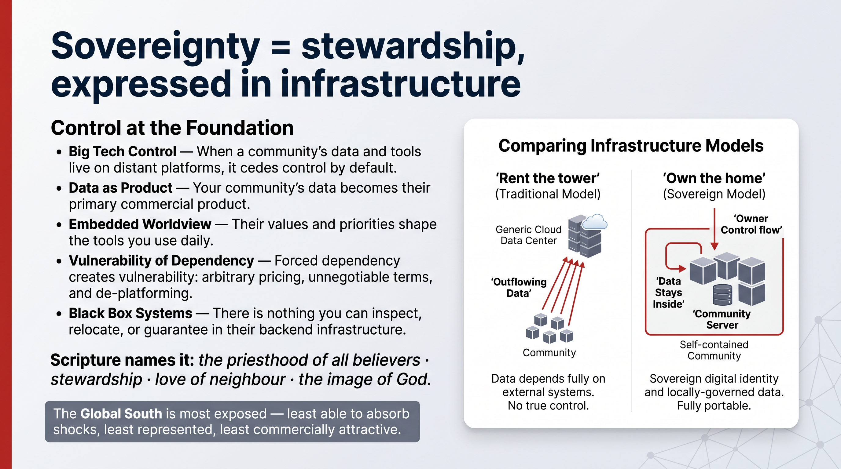
The word sovereignty can sound political or technical. For the Church it is neither. It is a question of stewardship: who holds authority over the means by which a community prays, communicates, teaches, remembers and serves.
We are at an inflection point comparable to the printing press. The intelligence revolution will reshape how every church, ministry and community operates. The only genuinely open question is whose infrastructure communities will depend on. Amazon, Google and Microsoft are already building the platforms that will mediate the digital future of the next generation. Choosing to live on them is not a neutral technical decision — it is a decision about who will shape the formation of millions of souls.

5.1. What is surrendered by default
When a community's data, communications and ministry tools live on Big Tech platforms, it quietly cedes control of its digital future. The consequences follow with the predictability of architecture:
- Your data becomes their product. Pastoral conversations, giving records, membership, prayer requests — fuel for advertising and prediction.
- Their worldview shapes your tools. The defaults, the recommendations, the content moderation and the AI "values" are set elsewhere, by people who do not share your mission.
- Dependency becomes vulnerability. A change in pricing, terms or access — or a decision to de-platform — can disrupt ministry overnight, with no recourse.
- There is no sovereignty to move or audit what you build. You cannot inspect it, you cannot relocate it, and you cannot guarantee its continuity.
Communities in the Global South are especially exposed: least able to absorb price shocks, least represented in the worldview of the platforms, and most likely to be served last when their language or context is not commercially attractive.

5.2. Sovereignty in the light of Scripture
The Bible gives this its proper grounding:
- The priesthood of all believers — communities must not be reduced to passive users of systems designed elsewhere; every believer has direct access and real agency, real choice, and the real ability to correct what affects their lives.
- Stewardship and provision for all — the benefits of technology must not belong only to a few companies, states or elites; what God provides is entrusted for the good of all, and access to technology and the education to use it is a matter of justice.
- Love of neighbour — the digital world is built on hidden labour, exploited supply chains and unequal access; justice requires seeing people and protecting them.
- The image of God — every person has worth before any function, productivity or data profile; human beings bear God's image and are not optimisation problems.
Digital sovereignty is simply local responsibility expressed in infrastructure. A community that owns its own digital home — its data, its compute, its tools, under its own jurisdiction — can exercise genuine responsibility for its common good. A community that rents everything from a distant tower cannot.
This is why sovereignty comes first. It is the precondition for everything else this paper proposes. But sovereignty alone is not the goal — it is the ground on which something far more hopeful can be built. We turn now to that: Augmented Collective Intelligence.

6. Augmented Collective Intelligence, Not Only Artificial General Intelligence
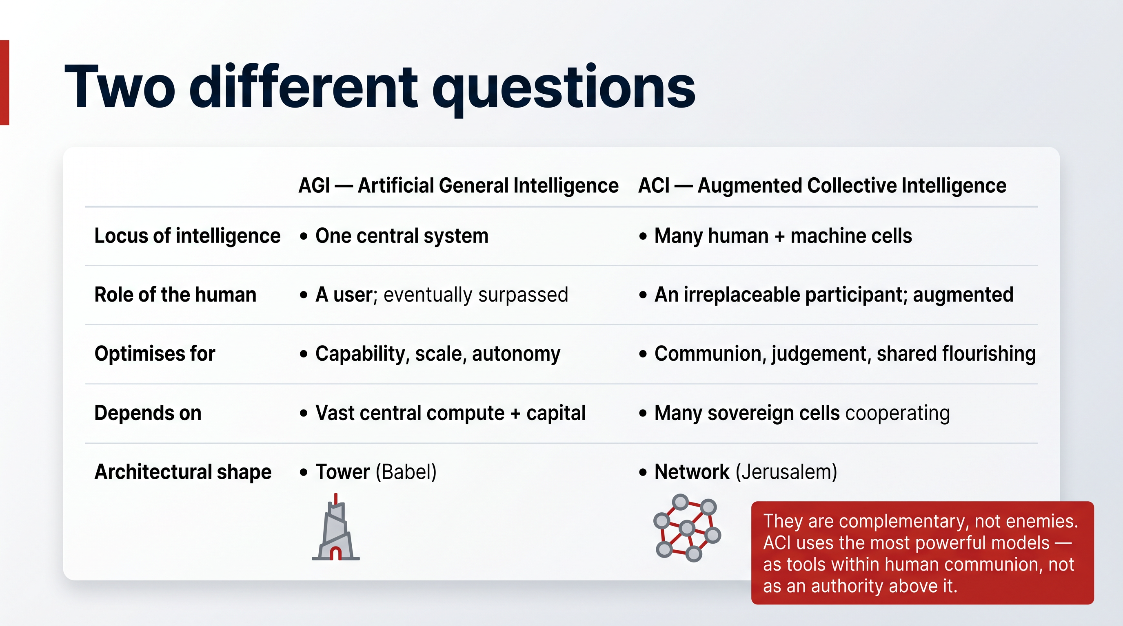
The whole technology industry is organised around a single goal: AGI — Artificial General Intelligence. The ambition is to build one machine mind that matches and then surpasses human reasoning across every domain. Hundreds of billions of dollars are flowing toward it. It is the defining race of the age.
We do not argue that this pursuit is worthless. We argue that, on its own, it is incomplete — and that its architecture, left unchallenged, leads precisely toward the Babel that Scripture warns against. So we propose a second pursuit, complementary to the first, which we believe the Church is uniquely placed to champion:
ACI — Augmented Collective Intelligence.

6.1. Two different questions
AGI and ACI are not enemies. They answer two different questions.
 | AGI — Artificial General Intelligence | ACI — Augmented Collective Intelligence
Core question | How powerful can one mind become? | How wise can a people become together?
Locus of intelligence | Concentrated in one central system | Distributed across many human + machine cells
Role of the human | A user of the machine; eventually surpassed | An irreplaceable participant; augmented, not replaced
What it optimises | Capability, scale, autonomy | Communion, judgement, shared flourishing
What it depends on | Vast central compute, capital, data | Many sovereign cells freely cooperating
Architectural shape | Tower (Babel) | Network (Jerusalem)
Failure mode | Concentration of power; loss of the human | Fragmentation — solved by a shared open foundation

AGI seeks to make a machine general. ACI seeks to make a community intelligent — by weaving together the distinct gifts of humans and machines so that the whole is wiser than either alone.

6.2. Why the distinction is theological, not merely technical
The technocratic paradigm assumes that intelligence is a single quantity, and that more of it, concentrated in one place, is straightforwardly better. Scripture rejects this. Human intelligence is not only computation. It includes conscience, compassion, discernment, relationship and the spiritual life — exactly the faculties that do not fit into the logic of data and performance.
ACI takes that seriously as an engineering principle. It treats the human person not as a slower version of the machine, to be optimised away, but as the bearer of capacities the machine does not have — and builds a system in which those capacities are central, not vestigial. The machine carries the measurable; the human carries the meaningful; and the architecture is designed so they work together.
This is why ACI is complementary to AGI rather than opposed to it. A community pursuing ACI can use the most powerful models in the world — but it uses them as tools within a human communion, not as a central authority above it. The intelligence that matters is the collective intelligence of the people, augmented by the machine, governed by their values, owned on their own infrastructure.
The next three chapters describe how this is actually built: the digital cell as the unit of the system; the spiritual and emotional human capacities it is designed to amplify; and the new operating system that makes collective intelligence possible.

7. Digital Cells — The Human Person in Their Best Form
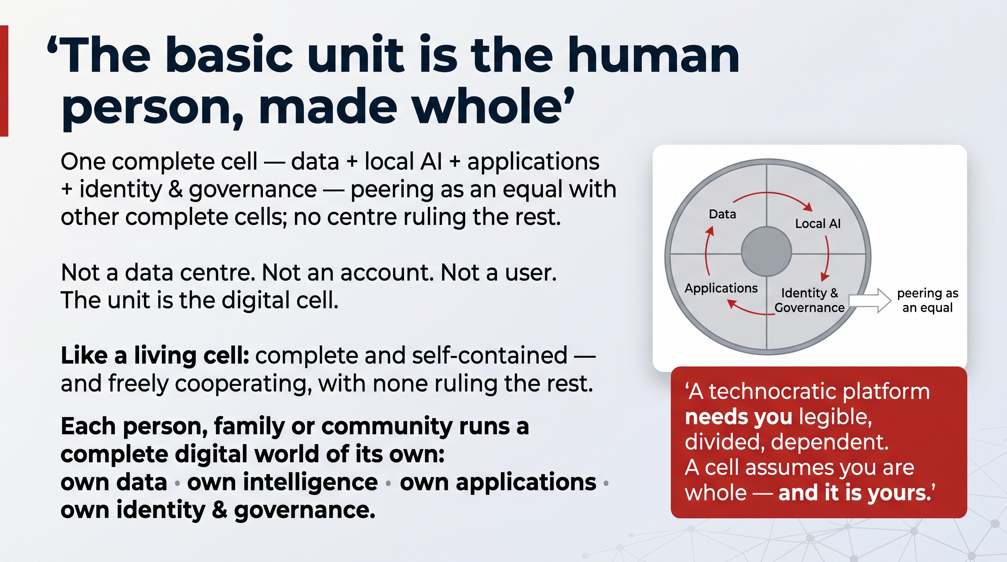
If Augmented Collective Intelligence is the goal, what is its basic unit? Not the data centre. Not the account. Not the user. The basic unit is the digital cell.

7.1. A living metaphor, made literal
A living cell is a complete, self-contained unit. It holds everything it needs to function — energy, information, machinery — and it is part of a larger body, cooperating with countless other cells without any one of them ruling the rest. The body is healthy when its cells are whole and freely cooperating; it is sick when something forces them into uniformity or seizes central control.
The digital cell is this metaphor made literal in software. Each person, each family, each community runs a complete digital world of their own:
- its own data — held locally, never surrendered as a price of entry;
- its own intelligence — AI that runs close to the people it serves;
- its own applications — communication, collaboration, knowledge, ministry tools;
- its own identity and governance — under its own values and jurisdiction.
A cell is not a thin client phoning home to a distant server for permission to think. It is a full system. And because it is whole in itself, it can cooperate as an equal — joining with other cells into a body, a network, a communion, without dissolving into them or being dominated by them.
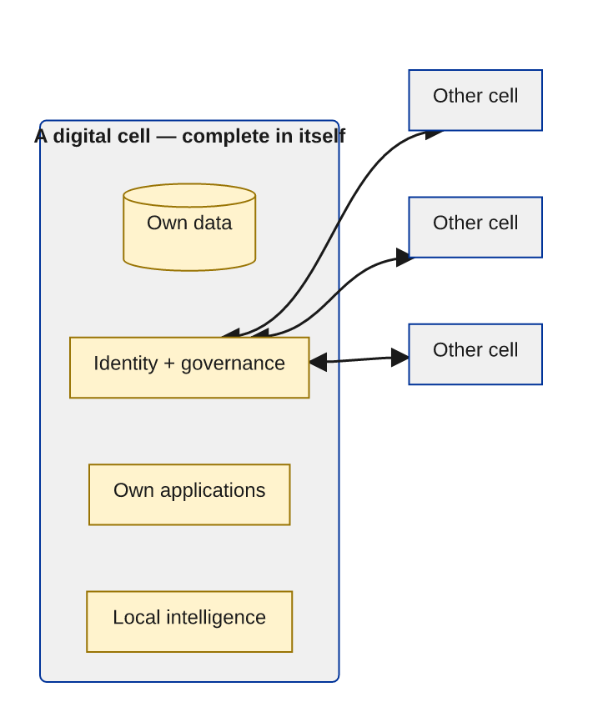

7.2. Why "the human person in their best form"
This is the deepest point of the design, and it is where the architecture meets the biblical vision of the person most directly.
The technocratic platform reduces the person to a profile — a stream of behaviour to be predicted and monetised. It needs the person to be legible, divided and dependent: legible so they can be measured, divided so they can be targeted, dependent so they cannot leave. That is the human person in their diminished form.
The digital cell is built for the opposite. It assumes the person is whole — possessing their own memory, their own relationships, their own discernment and their own dignity — and it gives that wholeness a digital home. It does not need to know everything about you to function. It does not need to keep you inside. It is yours.
When whole persons, in their best form, are connected freely as equals, something becomes possible that neither a lone individual nor a central machine can achieve: a community that thinks, remembers, discerns and acts together, amplified by AI but governed by its own conscience. That is Augmented Collective Intelligence. And its cell is the human person, restored to wholeness and set free to cooperate.
The next chapter describes the gifts that whole persons bring to that cooperation — gifts the machine does not have.

8. The Spiritual and the Emotional — What Only the Human Brings
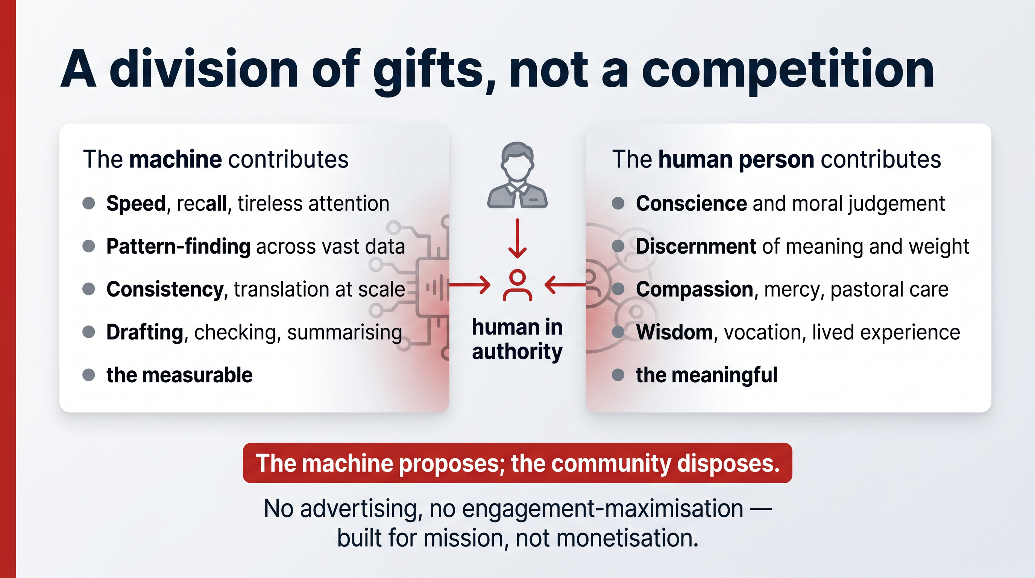
The technocratic paradigm assumes that whatever a human can do, a sufficiently powerful machine will eventually do better. This is precisely the error: it makes mystery, conscience, relationship, compassion and the spiritual life invisible, because they do not fit into the logic of data and performance.
Augmented Collective Intelligence is built on the opposite assumption. It treats the human person as the bearer of capacities the machine does not possess, and it designs the system so those capacities lead.

8.1. A division of gifts, not a competition
ACI is a partnership in which each partner contributes what it is genuinely good at.
The machine contributes | The human person contributes
Speed, recall, tireless attention | Conscience and moral judgement
Pattern-finding across vast data | Discernment of meaning and weight
Consistency and translation at scale | Compassion, mercy, pastoral care
Drafting, checking, summarising | Wisdom, vocation, lived experience
The measurable | The meaningful

The machine can draft a translation of a verse; only a mother-tongue speaker, formed in a worshipping community, can judge whether it rings true to the heart of the people. The machine can flag a theological inconsistency; only a human can decide what is faithful. The machine can summarise a thousand pastoral notes; only a person can sit with the one who is suffering. The machine handles the measurable so that the human is freed for the meaningful — not displaced from it.

8.2. Spiritual and emotional capacities as first-class design inputs
This is not sentiment. It is a specification. A system built for ACI must:
- Keep the human in authority over every consequential decision — the machine proposes; the community disposes. Translation, teaching, pastoral judgement and governance remain human acts.
- Protect interior freedom. We reject the attention economy — platforms engineered to capture time and exploit vulnerability. ACI has no advertising and no engagement-maximisation, because it has no business model that profits from your distraction. It is built for mission, not for monetisation.
- Serve relationship, not replace it. The goal is to strengthen the bonds of a real community — to help people pray, learn and work together — not to substitute a synthetic companion for human communion.
- Honour plurality. Many cultures, many languages, many spiritual traditions within the one Church. ACI does not press one worldview onto all; it lets each community's intelligence be shaped by its own values.

8.3. Why this is the Church's natural ground
No institution on earth has thought longer or more carefully about conscience, dignity, communion and the formation of the whole person than the Church. The technology industry is only now discovering — often painfully — that intelligence without wisdom is dangerous, and that systems which ignore the spiritual and emotional life of the human person corrode it.
ACI gives the Church a way to bring its deepest wisdom into the architecture of the digital age, rather than merely commenting on it from outside. It is the practical way to free AI from arms races, monopoly and domination, and to place it at the service of dignity, justice, peace and communion. The next chapter describes the operating system that makes this possible.

9. A New Operating System for Collaboration
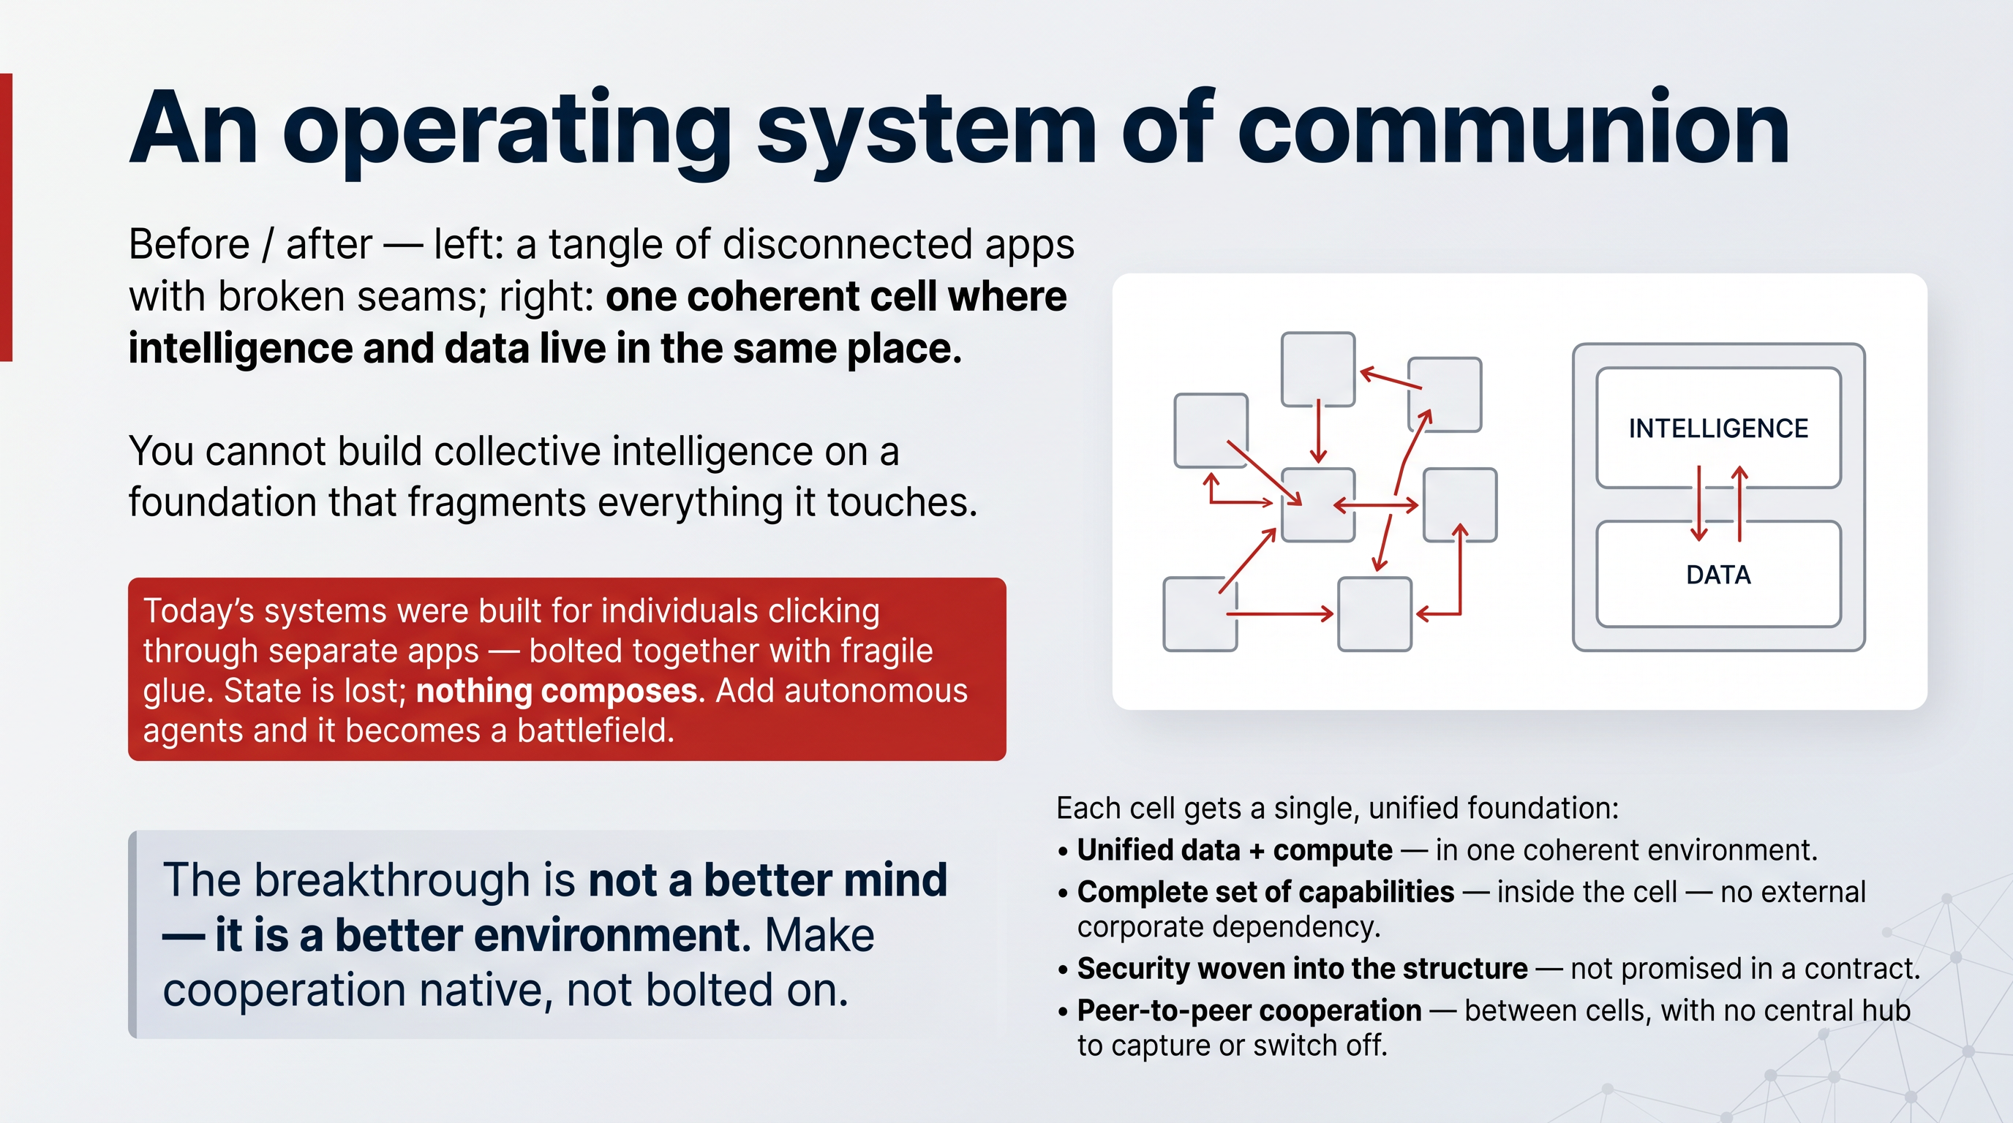
For digital cells to cooperate — for whole persons and communities to work together with AI and with one another — they need common ground to meet on. They need an operating system: not in the narrow sense of the software that boots a laptop, but in the deep sense of the foundational layer on which everything else runs and through which everything else cooperates.
This is the missing piece. It is also the heart of why the dominant approach fails.

9.1. Why today's systems cannot carry collective intelligence
The systems we use today were built for a different world — a world of individual humans clicking through separate applications. To make them cooperate, we bolt them together with fragile "glue": hundreds of disconnected apps, each with its own login, its own data, its own walls. The result is fragmentation. State is lost between systems. Data conflicts. Nothing truly composes. An intelligence trying to act across this landscape spends most of its effort fighting the seams.
When autonomous AI is added on top, the strain becomes a collapse. Agents are forced through interfaces designed for humans, granted sweeping access they cannot be trusted with, and exposed to security failures with no real isolation. It becomes, in the words of those who have watched it happen, a battlefield — agents fighting for access while the systems fight to block them, and the community caught in the middle. You cannot build collective intelligence on a foundation that fragments everything it touches.

9.2. The principle: design the environment, not just the mind
There are two ways to make intelligent systems work. The first tries to make the machine clever enough to navigate our chaotic, human-designed world of infinite edge cases — an effort that explodes in complexity and never ends. The second designs the environment so that cooperation is native — so the hard problems disappear because the ground itself is coherent.
The breakthrough is not a better mind. It is a better environment.
ACI takes the second path. Instead of teaching agents to fight through fragmentation, it removes the fragmentation, by giving every cell a single, unified, self-contained foundation.

9.3. What the new operating system provides
In each digital cell, the operating system makes native — built-in, not bolted-on — everything that intelligence needs to act:
- Unified data, compute and coordination in one coherent environment, instead of scattered services stitched together.
- A complete set of capabilities inside the cell: storage, messaging, documents, knowledge and search, an AI engine, and the applications people actually use — with no dependency on external corporate services.
- Security woven into the structure, so sovereignty and trust are properties of the architecture rather than promises in a contract.
- Peer-to-peer cooperation between cells, so communities connect directly as equals — sharing only what they choose — with no central hub that anyone can capture or switch off.
The effect is profound. Within a cell, intelligence and data live in the same place, so an AI does not "call a service" across a hostile network — it acts directly in a world that already makes sense. Between cells, cooperation happens on a shared, open foundation, so the gifts of many communities can be woven together without any of them losing their sovereignty.
This is the operating system of communion: the technical form of Jerusalem. And — this is the claim the rest of the paper will substantiate — it is not a concept. It is built, and it runs today.

10. This Is Not a Dream
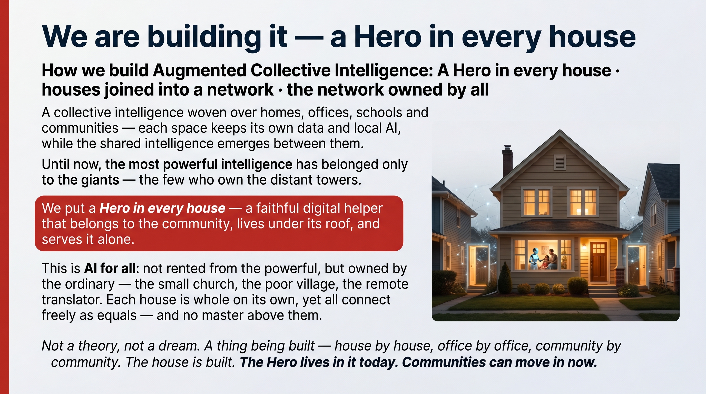
Everything described so far — Augmented Collective Intelligence, digital cells, an operating system of communion — could be dismissed as a beautiful idea that does not yet exist. That dismissal would be wrong, and correcting it is the purpose of this part of the white paper.
The architecture of communion is built, deployed and running today. It is not a research proposal or a roadmap for the next decade. It is working technology, standing on more than twenty years of foundational engineering, already validated by governments and global institutions.
This part presents the evidence in four parts:
- The architecture — a real, full-stack system in which every node is a complete digital world: the operating system, the intelligence layer and the physical foundation that make the digital cell concrete.
- Distributed intelligence — how AI actually runs close to the community: roughly 90% of tasks handled locally on small, efficient models, private and low-energy, with large models reserved for the rare hard cases.
- The economics — a self-contained compute module of roughly US$2,000 that gives 50 or more people an enterprise-grade digital life at under US$100 per person, scaling by simple replication to planetary size.
- The track record — the people and institutions behind it: two decades of building and selling core internet infrastructure, and real traction with the Government of Zanzibar and the International Cooperative Alliance's 1.2 billion members.
We ask the reader to hold these two images — Babel and Jerusalem — in mind while reading what follows. The point is not that this technology is impressive — though it is. The point is that the architecture of Jerusalem is available. The choice between Babel and Jerusalem is therefore not a choice between a present reality and a future hope. It is a choice between two present realities, one of which the Church can build, own and govern starting now.

11. The Architecture — Every Node a Complete World
The digital cell is realised by a real, full-stack system. It has a name in its current form — Lumina / Hero-OS, running on the Mycelium network — but what matters here is not the brand. What matters is that it is a complete sovereign digital environment, not an app or a cloud subscription, and that it is built as three layers of one unified system, each open, each owned by the community, each running on its own hardware under its own jurisdiction.
- The application layer is everything a community needs to communicate, collaborate and grow: messaging, video conferencing, document collaboration, a searchable knowledge base, AI assistants, Scripture tools and ministry management — a single sovereign replacement for the bundle of paid subscriptions communities usually stitch together.
- Hero-OS, the intelligence layer, is where AI agents, memory and coordination live — the operating system of communion described earlier, providing unified data, intelligence and applications inside the cell with no external corporate dependency.
- Mycelium OS, the physical layer, is the compute, storage and network foundation. Sovereignty starts with hardware: every digital system ultimately runs on a physical machine somewhere, owned by someone.

11.1. Every node is a complete world
The decisive architectural property is this: each node is a complete, self-contained digital world, not a thin client depending on a remote server. Inside a single node lives everything an agent or a community needs — compute, data, an indexing and knowledge engine, a local AI layer, and the applications themselves.
This inverts the cloud model. In the cloud, lightweight endpoints depend on powerful central data centres; intelligence and data live far away, in someone else's tower. Here, each node is the whole environment, and the network is a mesh of equals. Agents do not call distant services and beg for access — they live inside the world they act in. This is exactly what makes a node a true digital cell: whole in itself, and free to cooperate.

11.2. Security as structure, not decoration
Justice must shape technology from the beginning, not be added afterward as ethical decoration. The same is true of security and sovereignty. In this architecture:
- data never leaves the owner's control — that is a property of how the system is built, not a policy that could be changed;
- the system is quantum-safe by design, built for cryptography that resists future attack rather than retrofitted later;
- and trust is distributed, so that no single breach and no single authority can compromise the whole.
These properties cannot be bolted onto a system that did not begin with them — which is precisely why the dominant platforms, built for central control, cannot simply become sovereign. A new foundation was required, and it has been built. The next chapters show how it thinks, what it costs, and who stands behind it.

12. Distributed Intelligence — A Brain Close to the People
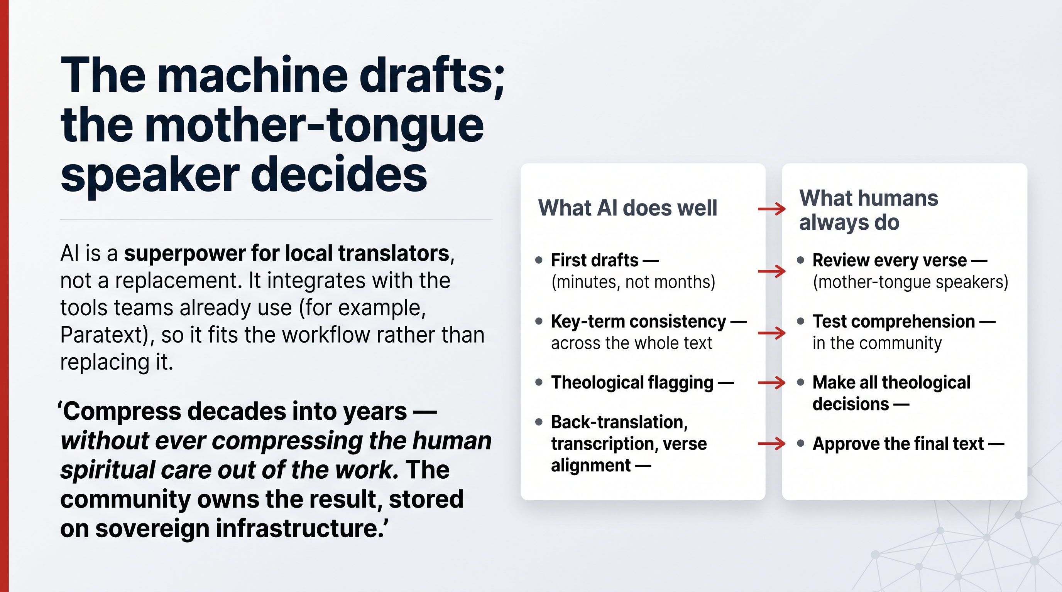
A central objection arises naturally: surely real AI requires enormous, centralised machines? Surely intelligence must be concentrated, and therefore Babel is simply unavoidable?
It is not. This is the technical heart of why an architecture of communion is not only more humane but also faster, cheaper, more private and more sustainable.

12.1. You don't need a giant brain for every thought
The dominant model sends every request — however trivial — up to a massive model in a distant data centre. This is slow, expensive, energy-hungry, dependent on a third party that sees all your data, and risky for privacy.
But most intelligence is local. In practice, roughly 90% of AI tasks are simple: formatting, classification, short reasoning, retrieval, routine automation. These are handled excellently by small, efficient models running inside the community's own node — with no network round-trip, no data leaving home, and a tiny fraction of the energy. Only the rare, genuinely complex task needs to escalate to a large model.
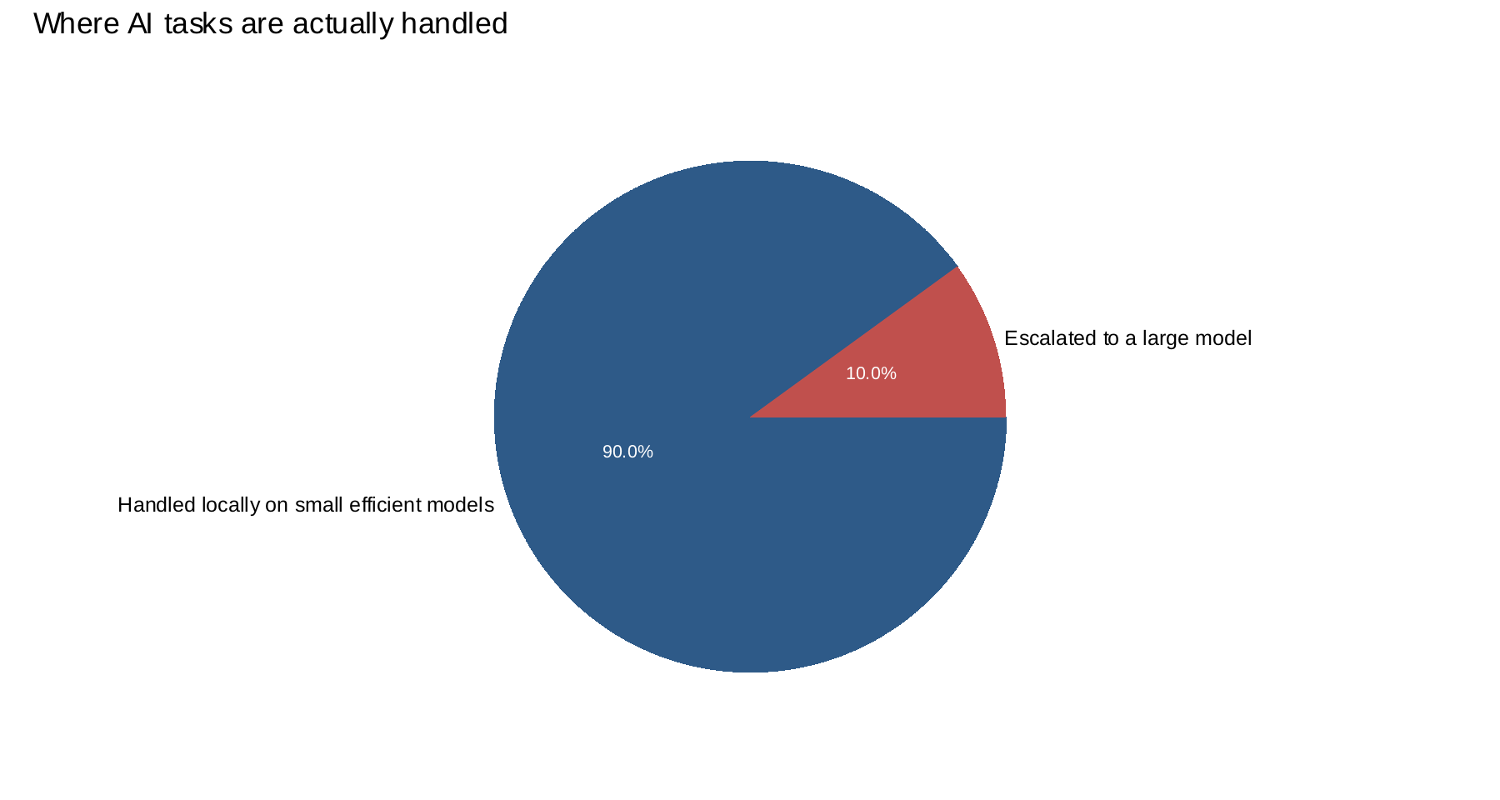
This is "model routing": match the size of the brain to the size of the thought. The result is intelligence that lives close to execution — near the people it serves.

12.2. Why this matters for the Church
The benefits are not abstract; they map directly onto the concerns of those who believe in God.
- Privacy by design. Sensitive data — pastoral, personal, spiritual — stays inside the community's own world. It is structurally unable to leak, because it never leaves.
- Independence. A community is not at the mercy of a distant provider's pricing, outages or policy changes. Its intelligence keeps working even when the wider network does not.
- Energy and stewardship. Running most work on small local models draws under 2 watts per user — and only 10–20 watts even when large models are used locally. This is extraordinarily efficient by data-centre standards, and it honours the call to care for creation: power is not wasted feeding a distant tower for tasks a candle could light.
- Reach in the Global South. Because each node is self-contained and frugal, intelligence can be brought to communities with limited connectivity and limited budgets — exactly those the dominant model serves last.

12.3. Distributed, but not isolated
Distributed intelligence does not mean each community is alone. Cells cooperate over the Mycelium peer-to-peer network, sharing knowledge and capacity by choice. A translation team's hard-won insight can strengthen the whole body without any community surrendering control of its data. This is collective intelligence in the literal sense: many local intelligences, freely federated, becoming wiser together — the architecture of communion, running.

13. The Economics — Sovereignty That Communities Can Afford
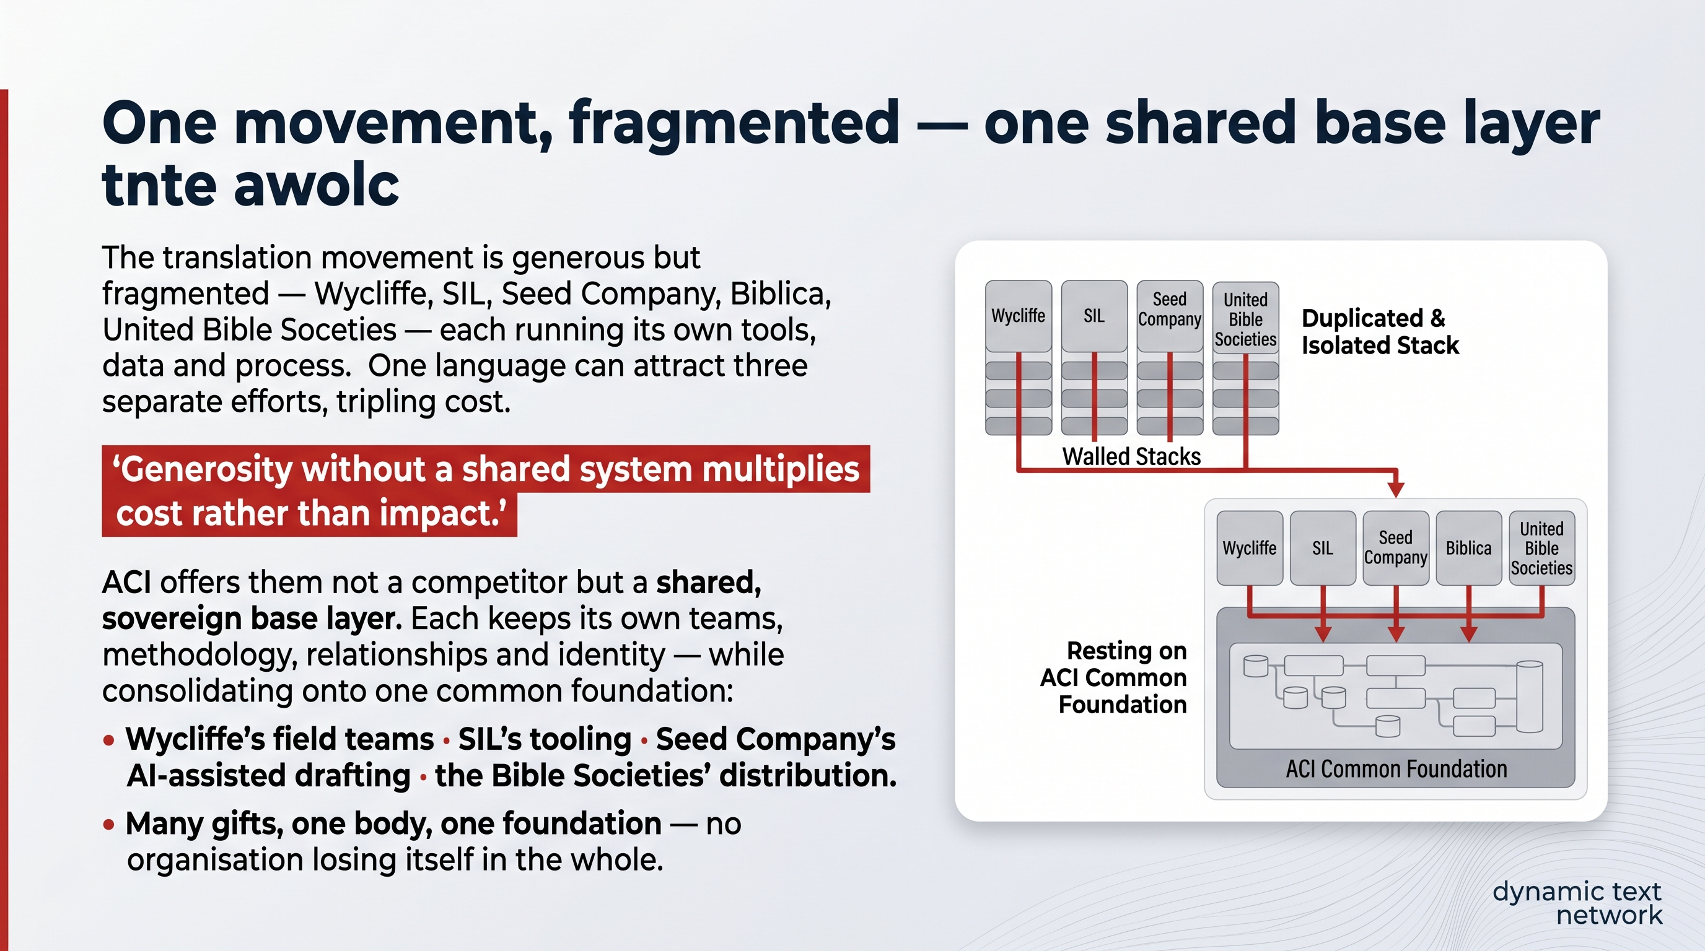
Sovereignty is sometimes assumed to be a luxury — something only wealthy institutions can afford, while everyone else must rent from the towers. The economics of this architecture overturn that assumption. Owning your digital world is cheaper than renting it.

13.1. A complete digital life on one module
The unit of deployment is a single, standardised compute module costing roughly US$2,000. It is self-contained, secure by design, agent-native, deployable in any data centre, and horizontally scalable. One module delivers an enterprise-grade digital life for 50 or more people, bundling the full stack:
- a core system of compute, storage and networking;
- a complete data and indexing layer;
- a local AI layer of models, embeddings and agents;
- and the applications themselves — documents, messaging, collaboration and knowledge tools.
That is a full enterprise stack on one module — for under US$100 per person in one-time capital cost, with no SaaS subscriptions and no fragmented infrastructure, drawing under 2 watts per user (10–20 with large local models).

13.2. Capital you own versus rent you never stop paying
The contrast with the prevailing model is stark. Traditional digital life is an unending stream of per-user subscriptions across dozens of separate products, plus cloud costs that grow with use — money paid forever for something you never own and cannot control.
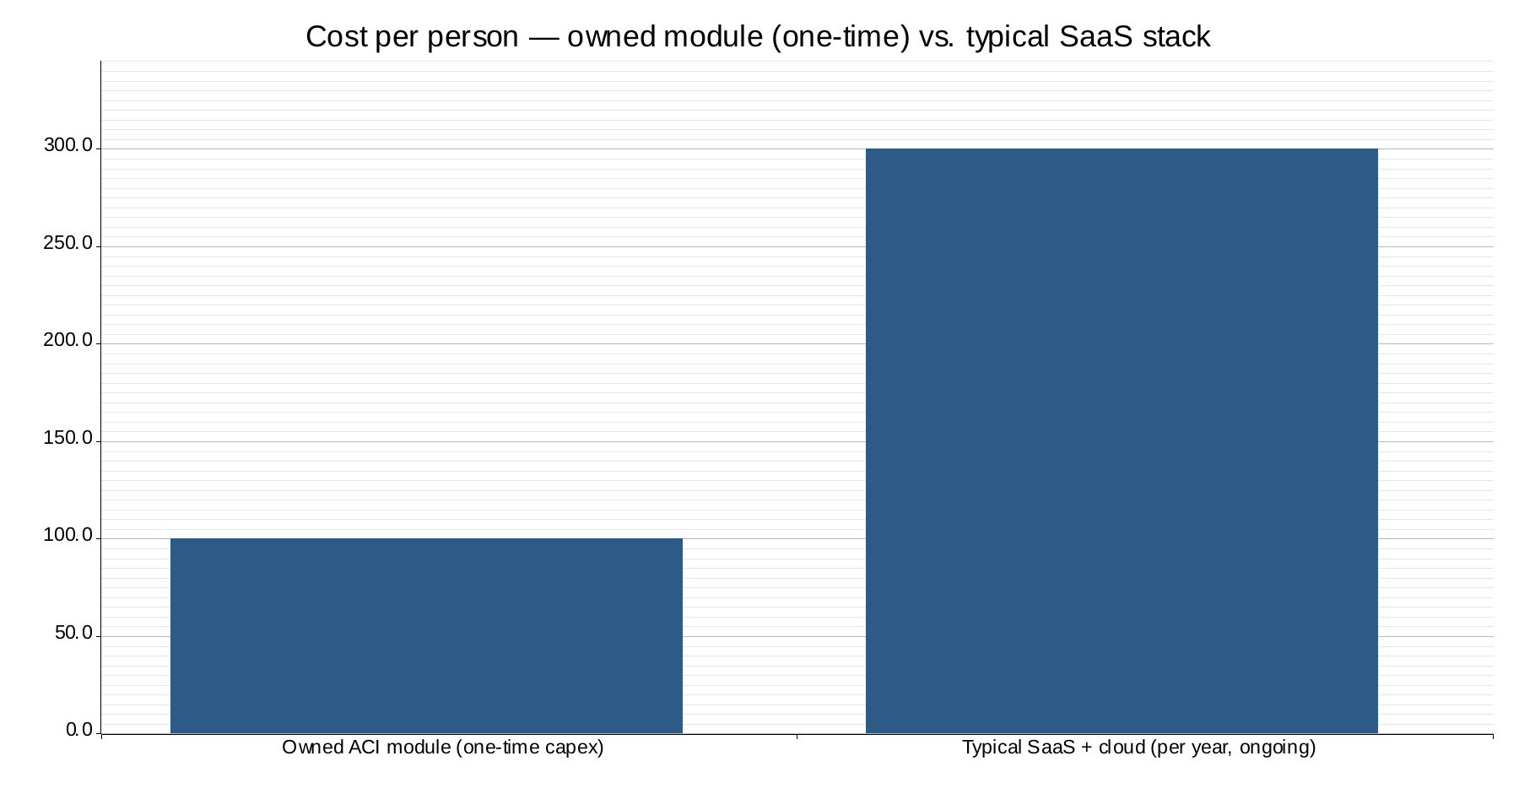
The figures above are illustrative of the structural difference, not a quotation: the owned module is a one-time capital cost of under US$100 per person, while the rented stack is a recurring cost that continues every year, forever. Over any realistic horizon the owned model is dramatically less expensive — and at the end the community owns its world rather than holding a stack of cancellable invoices.

13.3. Why this is not simply "cheaper IT"
The point is not frugality for its own sake. The point is that the same architectural choices that make the system sovereign — self-contained nodes, local intelligence, no external dependencies — are what make it cheap. Sovereignty and affordability are not in tension here; they are the same design seen from two angles.
This matters most for the communities the Church most longs to reach. A church in the Global South, a translation team in a remote region, a small ministry with no IT budget — for them, the choice has until now been "depend on Big Tech or have nothing." This architecture offers a third option: own a complete, intelligent, sovereign digital world for the price of a modest one-time investment. God's provision for all, expressed in hardware.
And because growth happens by simply adding identical modules, this same economics scales from one church to a planetary network — the subject of the next chapter on those who have already built and validated it.

14. Track Record — Proven People, Real Institutions
Vision is cheap; foundational infrastructure is hard, and most who attempt it fail. The credibility of this proposal rests on two things that are difficult to fake: a team that has built and sold core internet infrastructure for over two decades, and institutional partners who have already committed.

14.1. A team that has built foundations before
The people behind this architecture have repeatedly built, scaled and exited category-defining internet and cloud infrastructure companies — acquired by global technology leaders.
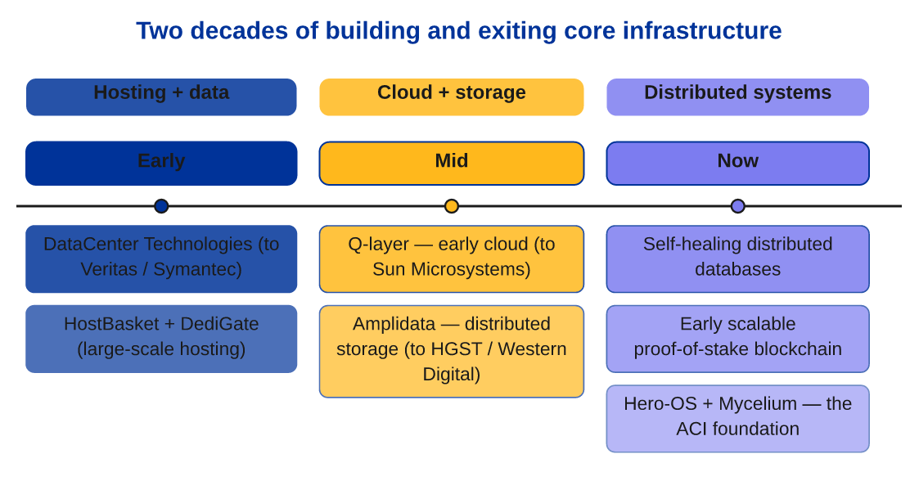
Alongside the exits sits a list of genuine technical firsts: early large-scale web hosting at global scale; a breakthrough backup deduplication system; pioneering early cloud concepts; the first "unbreakable" distributed storage; a self-healing distributed database; and early work on scalable, sustainable proof-of-stake blockchain. These are precisely the disciplines — hosting, storage, distributed systems, consensus — that the sovereign, distributed, planetary architecture described in this paper requires. This team is not learning these problems for the first time.

14.2. Institutions that have already engaged
The architecture is not waiting for its first adopter. Four independent strategic initiatives are already in motion:
- A sovereign government partnership with Zanzibar — a digital free zone and national digital backbone: an operational, fully compliant jurisdiction with official government endorsement. Regulatory legitimacy, which is usually the hardest obstacle for novel digital infrastructure, is already secured.
- The International Cooperative Alliance (ICA) — a relationship giving access to the global cooperative movement of more than 1.2 billion members: an immediate, trusted, organised channel of distribution to communities worldwide.
- A CTO-level forum of 50 major cooperatives ("CM50") representing over US$2 trillion in combined revenue — senior technology leadership already engaging with the sovereign-infrastructure approach.
- A cooperative collaboration platform ("Principle 6") aiming to connect over 10,000 cooperatives — a working expression of inter-community cooperation at scale.

14.3. What this means for the Church
The significance is straightforward. The two greatest risks any new platform faces are technical capability and market access — can it actually be built, and will anyone adopt it? Both are already substantially answered. The technology runs; the team has built foundations of this kind repeatedly; and governments and billion-member networks are already engaged.
For the funding vehicle considering this proposal, that changes the nature of the decision. This is not seed funding for an unproven idea. It is an invitation to direct a proven, running architecture toward the mission of the Church — to take a foundation already validated in the secular and cooperative world and build on it the digital home of the global Christian community. The next part describes what that home is for.

15. Prosperity for Others — The Church That Goes Out
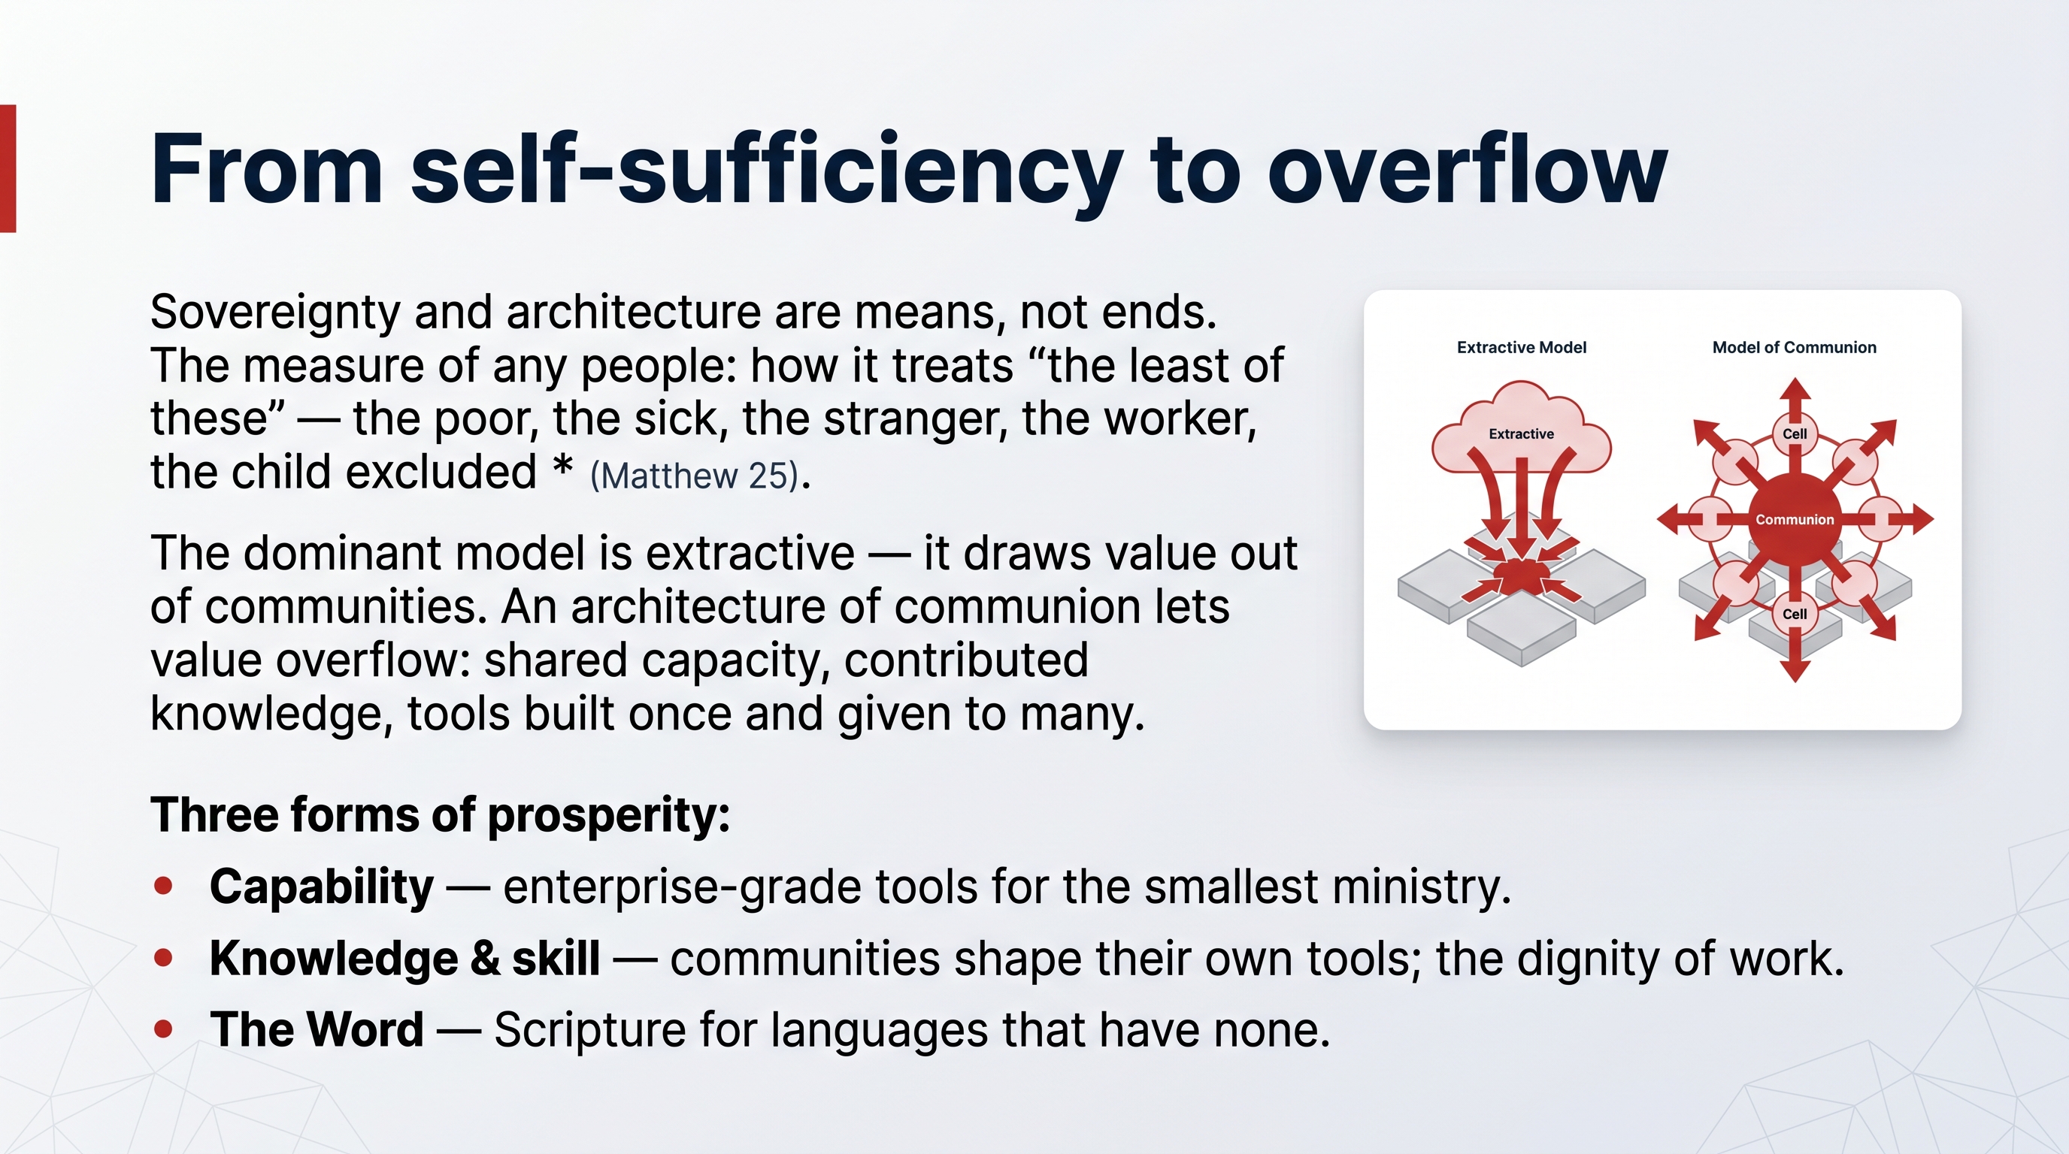
Sovereignty and architecture are means, not ends. A community that owned a perfect digital world but turned inward would have missed the point entirely. Scripture is unambiguous: what we do for "the least of these" — the poor, the sick, the stranger, the worker, the child excluded — we do for Christ himself (Matthew 25). The call is to build the common good.
Augmented Collective Intelligence is, in the end, a tool for the Church to go out — to bring prosperity, dignity and the Word to others, especially those the technocratic world serves last.

15.1. From self-sufficiency to overflow
The dominant digital model is extractive: it draws value out of communities — their attention, their data, their money — and concentrates it in the centre. An architecture of communion runs the other way. Because each community owns a complete, intelligent, low-cost digital world, value can overflow from it: capacity shared with a neighbouring community, knowledge contributed to the whole body, tools built once and given to many.
This is the cooperative principle made digital — "cooperation among cooperatives," the sharing of strength between communities so that the whole is lifted. A church in a wealthy city and a congregation in a poor region are not provider and client; they are cells in one body, each whole, freely sharing what they have.

15.2. Three forms of prosperity ACI enables
1. Prosperity of capability. A small ministry or a remote community gains access to the same enterprise-grade tools — communication, collaboration, knowledge, AI assistance — that until now only large, wealthy institutions could afford. The playing field is levelled not by charity but by architecture.
2. Prosperity of knowledge and skill. Access to technology and the education to use it is part of justice. Because the system is open and owned, communities learn to run and shape their own tools rather than remaining passive users — building local skill, local employment and local agency. This directly serves the dignity of work.
3. Prosperity of the Word. The flagship expression of this mission is Bible translation — bringing Scripture to the thousands of language communities that still have none. This is where ACI's power is most visible and most moving, and it is the subject of the next chapter.

15.3. The shape of the mission
The Church does not need permission from Big Tech to serve the world. With an architecture of communion, it can build its own digital home, fill it with its own values, and from that secure foundation reach outward — to the last language, the poorest community, the most remote translation team. Owning the foundation is what makes the going-out sustainable, dignified and free.
This is the answer to the call, rendered concrete: not standing outside the construction site of history, but building — and building so that others may prosper.

16. The Flagship Mission — Scripture for Every Language
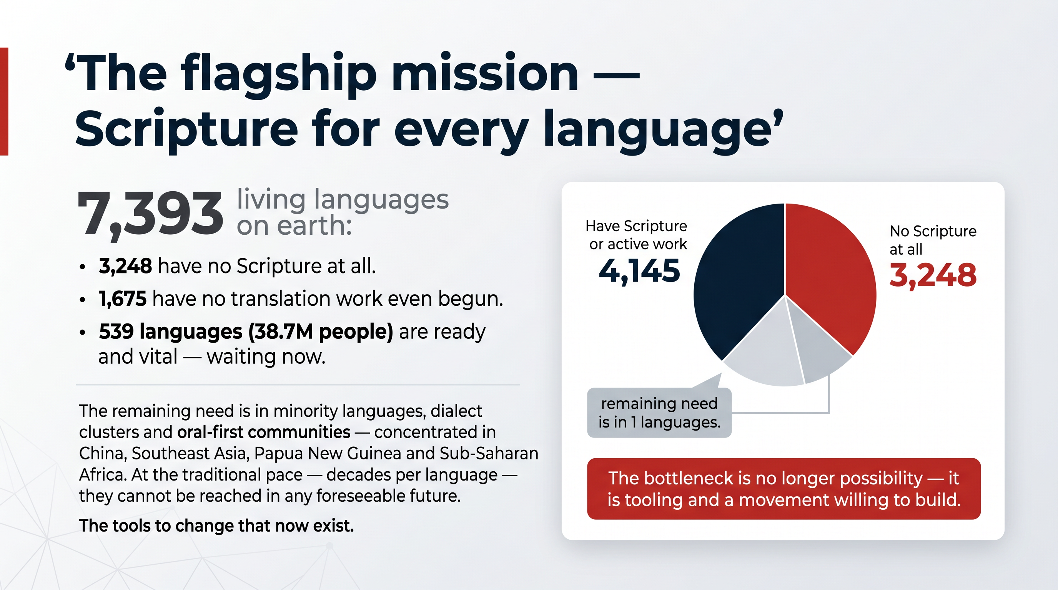
The clearest proof that Augmented Collective Intelligence serves the Gospel is its flagship application: bringing the Bible to the languages that still have none. Here, every principle in this paper becomes a concrete act of love — human and machine working together, sovereignty protecting the community, collective intelligence reaching the unreached.

16.1. The unfinished mission, in numbers
Of the 7,393 languages spoken on earth:
- 3,248 have no Scripture at all.
- 1,675 have no translation work even begun.
- 539 languages, spoken by 38.7 million people, are considered ready and vital — waiting now.
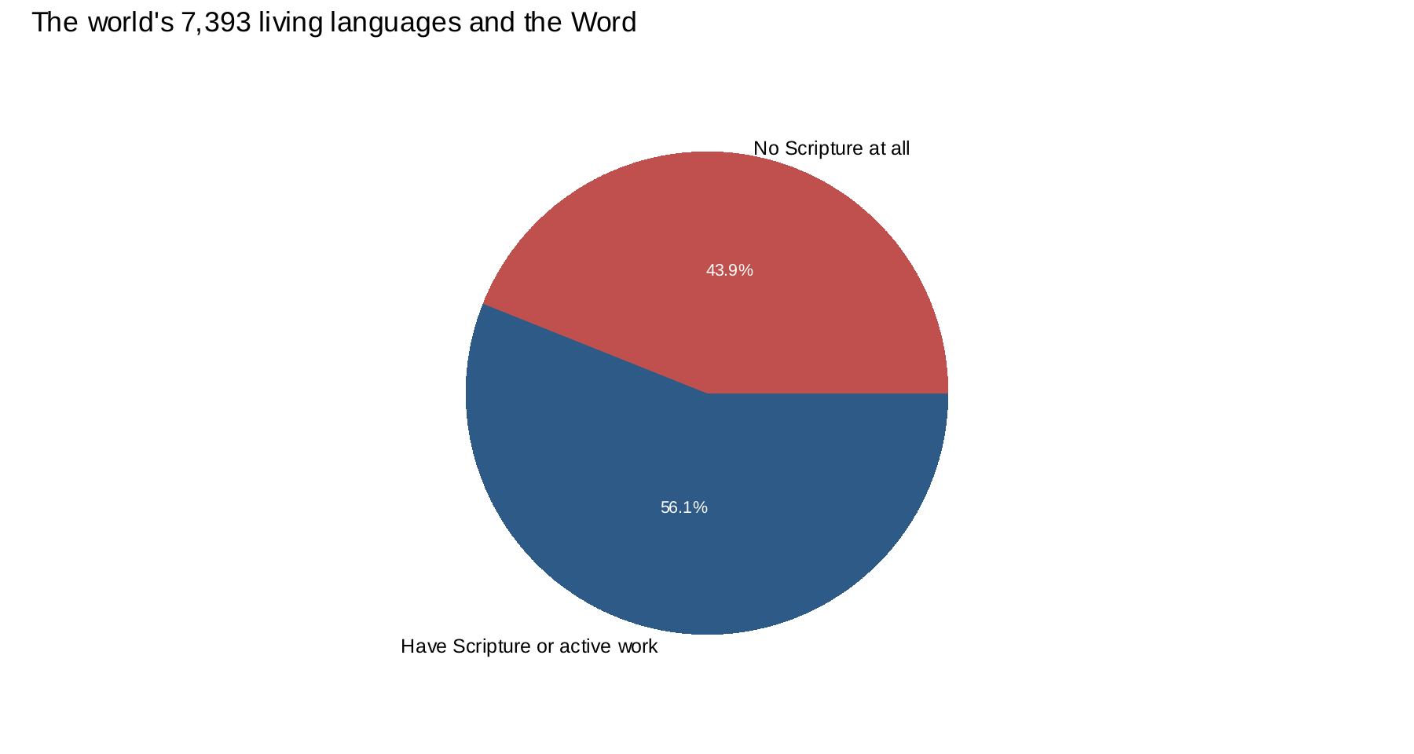
The remaining need lies in minority languages, dialect clusters and oral-first communities — concentrated in China, Southeast Asia, Papua New Guinea and Sub-Saharan Africa. The traditional pace, with a single translation often taking decades, cannot reach them in any foreseeable future. The tools to change this now exist. The only question is whether the right people will build and deploy them.

16.2. How AI assists — a superpower for local translators
ACI does not replace the translator. It is a superpower for mother-tongue translators, and the division of gifts described earlier in this paper is exactly the division at work here.
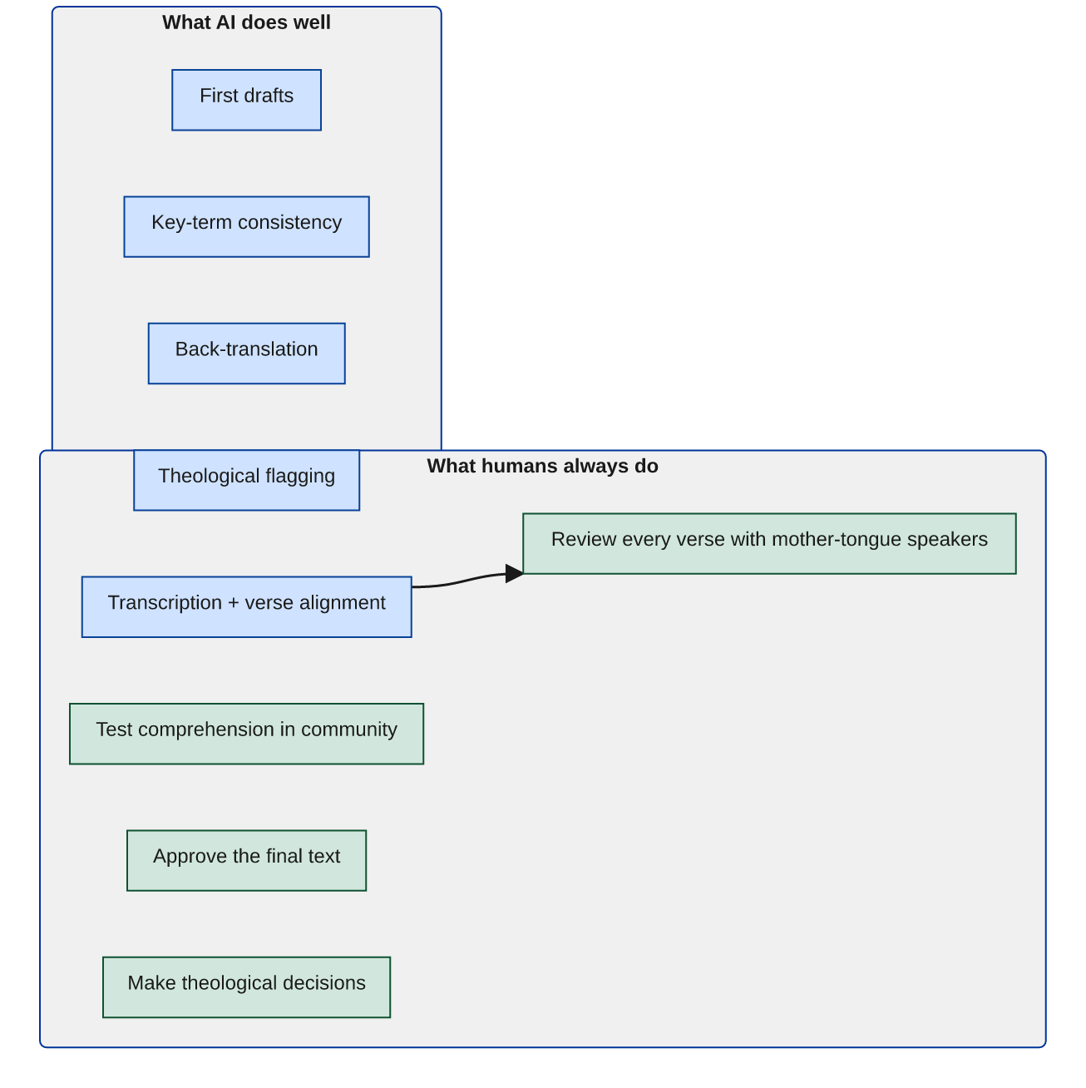
The machine carries the measurable labour — the drafting, the checking, the alignment. The human carries the meaningful judgement — testing every verse with native speakers, discerning theology, approving the final text. Human integrity is preserved at every step, and the community owns the result. The promise is to compress decades into years, and years into months, without ever compressing the human and spiritual care out of the work.

16.3. A concrete proof-of-concept: the Zhuang cluster
This is not theoretical. A concrete proof-of-concept targets the Zhuang language cluster — 17 million people whose member languages have no Scripture and no active translation work. Two parallel tracks run together:
- a written / digital track, building a sentence corpus and AI-assisted first drafts with human consultant review;
- an oral-first track, producing audio Bible stories for a smaller community.
The goal of the proof-of-concept is deliberately not a single finished Bible. It is a proven, repeatable engine — a method and a toolchain demonstrated to work, ready to scale across the dozens of remaining language communities.

16.4. Why the movement should not stay fragmented
Today the translation movement is generous but fragmented: Wycliffe, SIL, Seed Company, Biblica, the United Bible Societies — each running its own tools, data and process. One language can attract three separate efforts, tripling cost and dissipating effort. Generosity without a shared system multiplies cost rather than impact.
ACI offers these organisations not a competitor but a shared, sovereign base layer. Each keeps its own teams, methodology, relationships and identity — Wycliffe's field teams, SIL's tooling, Seed Company's AI-assisted drafting, the Bible Societies' distribution — while consolidating onto one common foundation. This is collective intelligence applied to the Great Commission: many gifts, one body, one foundation, no community losing itself in the whole. It is the architecture of communion serving the oldest mission of the Church.

17. A Network of Communities — Local by Design, Connected by Choice
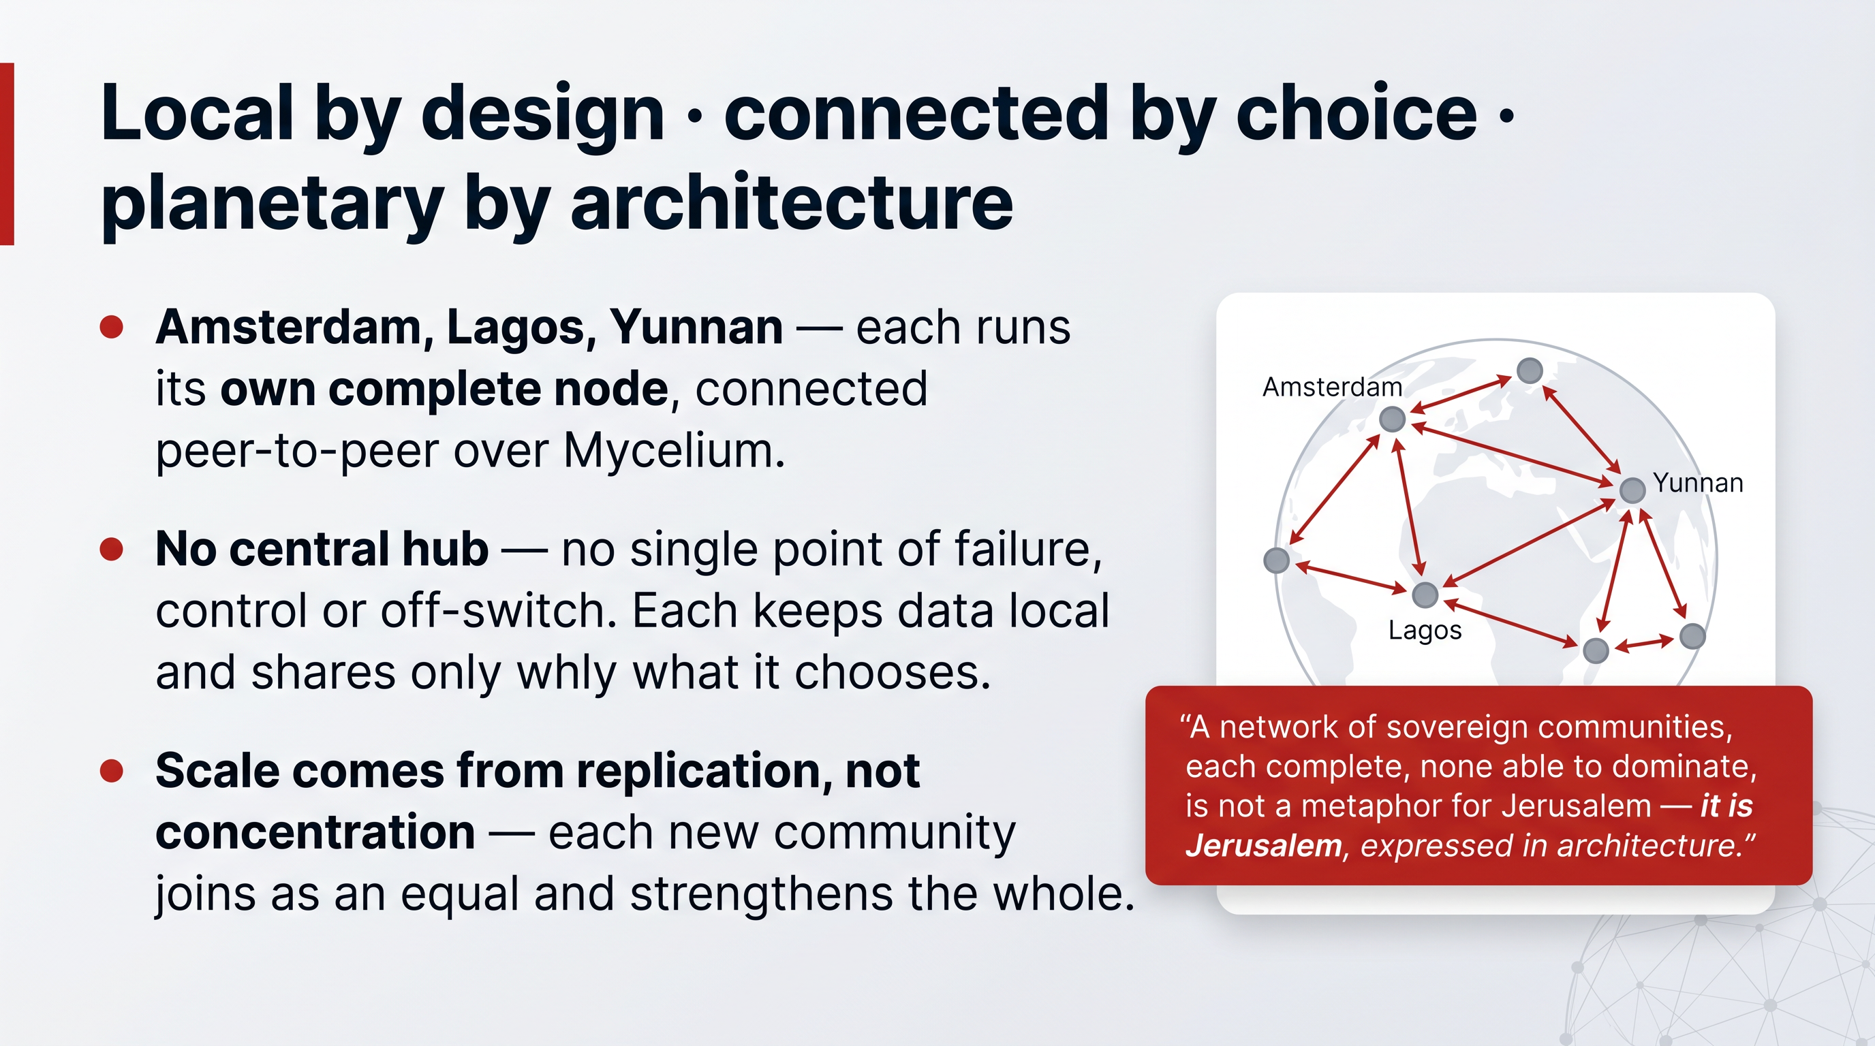
The end state of this proposal is not a product. It is a global network of sovereign communities — the architecture of communion realised at planetary scale. It is the most complete picture of what Augmented Collective Intelligence looks like when it is fully alive.

17.1. Many worlds, one body
Imagine a church in Amsterdam, a congregation in Lagos, and a translation team in Yunnan. In the dominant model, all three are tenants in the same distant cloud, their data held and their tools shaped by a corporation none of them chose. In the architecture of communion, each runs its own complete node — its own digital world — and they connect to one another peer-to-peer through the Mycelium network.
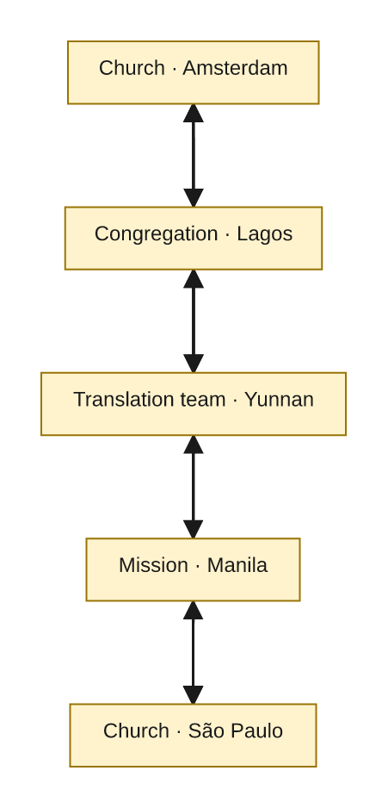
There is no central hub — and therefore no single point of failure, no single point of control, and no single off-switch. Each community keeps its data local and shares only what it chooses. The network grows not by adding complexity at a centre, but by replication: each new community brings its own complete world and joins as an equal. Scale comes from multiplication, not concentration.

17.2. Local by design, connected by choice, planetary by architecture
This phrase captures the whole design:
- Local by design — each community's data, intelligence and tools live in its own world, under its own values and jurisdiction. Sovereignty is the default, not an upgrade.
- Connected by choice — communities cooperate freely, sharing knowledge, capacity and tools when and how they decide. Communion is chosen, never coerced.
- Planetary by architecture — because every node is whole and the network is a mesh of equals, the system spans the globe without any community surrendering control. Plurality and unity at once.

17.3. This is Jerusalem, built
Return one last time to Scripture's two cities. Babel is one tower: uniform, central, self-sufficient, speaking with one voice from one place. Jerusalem is a city built together: plural, distributed, cooperative, where many take responsibility for the common good.
A network of sovereign communities — each a complete world, each owning its data and intelligence, each freely cooperating with the rest, with no centre that can dominate or be captured — is not a metaphor for Jerusalem. It is Jerusalem, expressed as architecture. It belongs to the people it serves rather than the corporation that rents it to them. And it strengthens with every community that joins.
This is the network the funding vehicle is invited to build. The final part sets out how the proposal answers this calling point by point, and what is being asked.

18. In the Spirit of Scripture
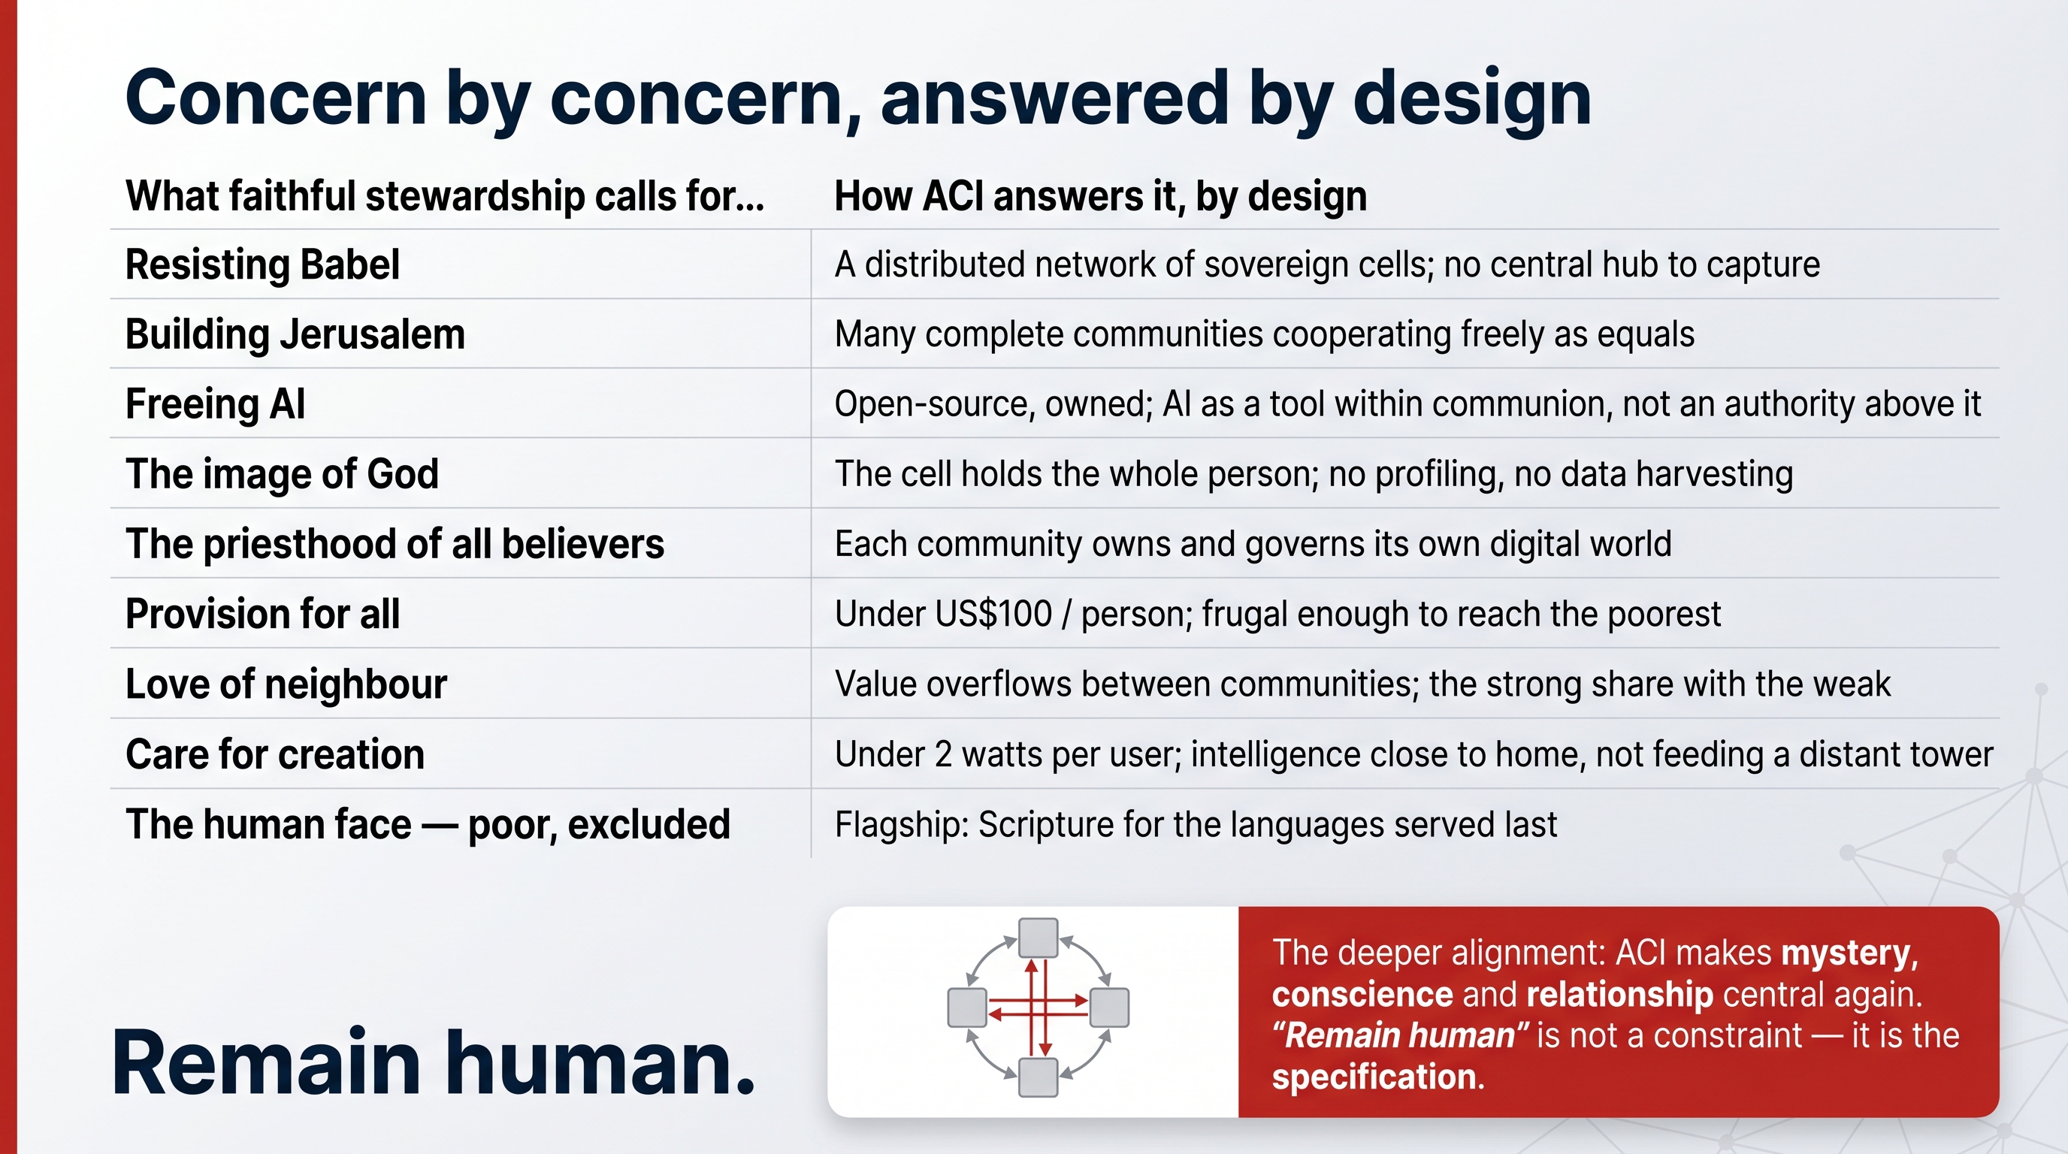
This proposal did not begin with a technology and search for a theological justification. It began with the conviction that every design choice carries a vision of humanity — and that the architecture of our digital infrastructure is therefore a moral and spiritual matter. What follows is a direct accounting: how each major concern is answered, in architecture, by Augmented Collective Intelligence.

18.1. Concern by concern
What faithful stewardship calls for… | How ACI answers it, by design
Resisting Babel — refusing concentration, control and domination | A distributed network of sovereign cells; no central hub to capture or rule
Building Jerusalem — communion, plurality, shared responsibility | Many complete communities cooperating freely as equals
Freeing AI — from monopoly and domination | Open-source, owned infrastructure; AI as a tool within human communion, not an authority above it
The image of God — the person is not a data profile | The digital cell holds the whole person; no profiling, no data harvesting
The priesthood of all believers — communities are not passive users | Each community owns and governs its own digital world
Provision for all — access as justice | Under US$100 per person; frugal enough to reach the poorest communities
Love of neighbour — seeing and protecting people | Value overflows between communities; the strong share with the weak
Justice built in from the start | Sovereignty, privacy and security are structural, not "ethical decoration" added later
Truth as a common good | No attention economy, no algorithmic outrage; tools serve understanding
The dignity of work | Communities run and shape their own tools, building local skill and employment
Interior freedom — against the attention economy | No advertising, no engagement-maximisation; built for mission, not monetisation
Care for creation | Under 2 watts per user; intelligence close to home, not feeding a distant tower
The human face — the poor, the excluded | Flagship mission: Scripture and capability for the languages and communities served last

18.2. The deeper alignment
Beyond this point-by-point correspondence lies a single shared conviction. The technocratic paradigm makes mystery, conscience, relationship, compassion and the spiritual life invisible. Augmented Collective Intelligence is, at its core, an architecture that makes those things central again — by insisting that the human person, in their full spiritual and emotional dignity, remains the irreplaceable partner of the machine and the holder of every meaningful decision.
The deepest call here is simple: remain human — bear the image of God you were made to bear. That is not a constraint this technology tolerates. It is the specification this technology is built to fulfil.

19. The Invitation — Build Jerusalem
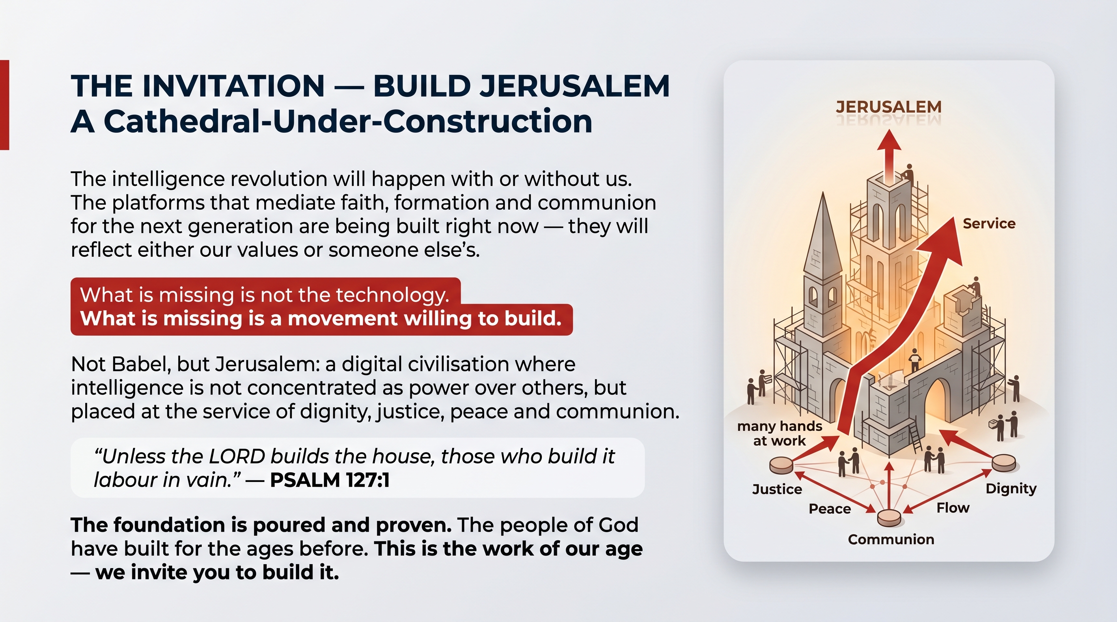
The intelligence revolution will happen with or without the Church. The platforms that will mediate the faith, formation and communion of the next generation are being built right now. They will reflect either the values of the Church or the values of someone else. There is no neutral option, and there is no option to wait.
The argument of this white paper can be reduced to four claims:
- The choice is Babel or Jerusalem. Scripture names it; the architecture of our infrastructure decides it.
- There is a humane alternative to the centralised AI race: Augmented Collective Intelligence — whole human persons, in their spiritual and emotional dignity, working together with AI and with one another, as sovereign digital cells in a network of communion.
- This is not a dream. The technology is built, running, affordable, and proven — backed by a team that has built core internet infrastructure for two decades and by partners including a sovereign government and a 1.2-billion-member network.
- Its purpose is to serve — to bring prosperity, dignity and the Word to others, with Bible translation for the world's remaining languages as its flagship mission.
What is missing is not technology. What is missing is a movement willing to build.

19.1. What is asked
This white paper is part of a proposal to the funding vehicle behind the movement. It makes three concrete asks:
- Partner to deploy sovereign infrastructure. Fund and stand up the first sovereign ACI network for the global Church — the digital home, owned by the communities it serves.
- Support the Bible-translation proof-of-concept. Back the Zhuang-cluster engine — two parallel tracks, proven methodology, community-owned output — and prove the repeatable engine for the remaining 1,675 languages.
- Convene the network of communities. Bring the first churches, ministries and translation organisations onto one shared, sovereign foundation, and let the network grow by replication.

19.2. What the movement gains
- Full digital sovereignty — communication, collaboration and knowledge tools running on infrastructure the Church owns, under its own jurisdiction.
- Value-aligned AI — intelligence that serves the mission, with no corporate business model, no advertising and no data harvesting.
- A repeatable engine for Scripture — a proven method aimed squarely at the languages that still have none.
- A network that strengthens with every community that joins — local by design, connected by choice, planetary by architecture.

19.3. A closing word
"Unless the LORD builds the house, those who build it labour in vain." — Psalm 127:1
The construction site is open. The foundation is poured and proven. The tools are in hand. What remains is the decision to build — not Babel, but Jerusalem: a digital civilisation where intelligence is not concentrated as power over others, but placed at the service of dignity, justice, peace and communion.
The people of God have built for the ages before. This is the work of our age. We invite you to build it.

