About This Document
This is a technology document written for business people.
You do not need to be an engineer to read it. Where we describe how things work under the hood, the goal is always the same: to make it clear why a particular design choice translates into a real commercial advantage — lower cost, higher revenue, better security, faster deployment, or all four at once.

What we will and won't do here
- We will explain the category GeoMind plays in, how operators deploy in the real world using GeoMind's technology, and the four layers of technology that make the standard different.
- We will keep each layer to roughly a single page, so the picture stays clear.
- We will not drown you in protocol-level detail. The genuinely low-level material — bootloaders, forward-error-correcting codes parameters, image formats — lives in the Appendix. It is there as evidence, not as required reading.

The thread that runs through everything
There is one idea that connects every chapter:
Modern hardware is roughly a million times more powerful than the machines of a generation ago — yet we use it worse. Not because we ran out of hardware, but because we ran into architecture limits.
GeoMind's entire reason to exist is that we rebuilt the cloud technology from first principles to fix that — so that operators can deploy sovereign, autonomous capacity on their own hardware. Every advantage in this document — cost, security, autonomy, AI efficiency — is a downstream consequence of that one decision.
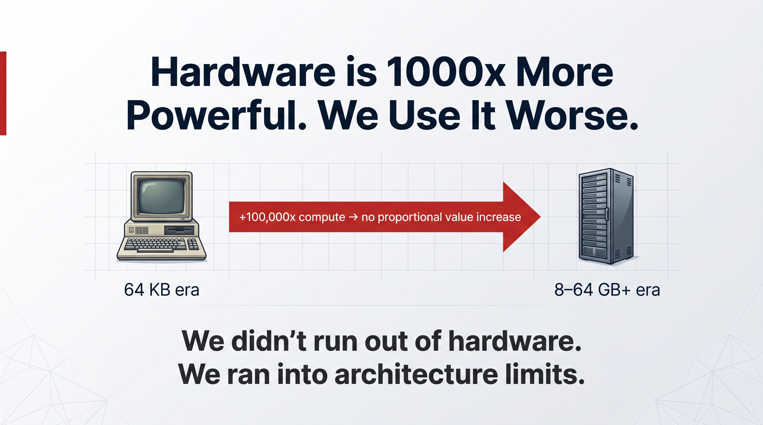

What Is GeoMind?
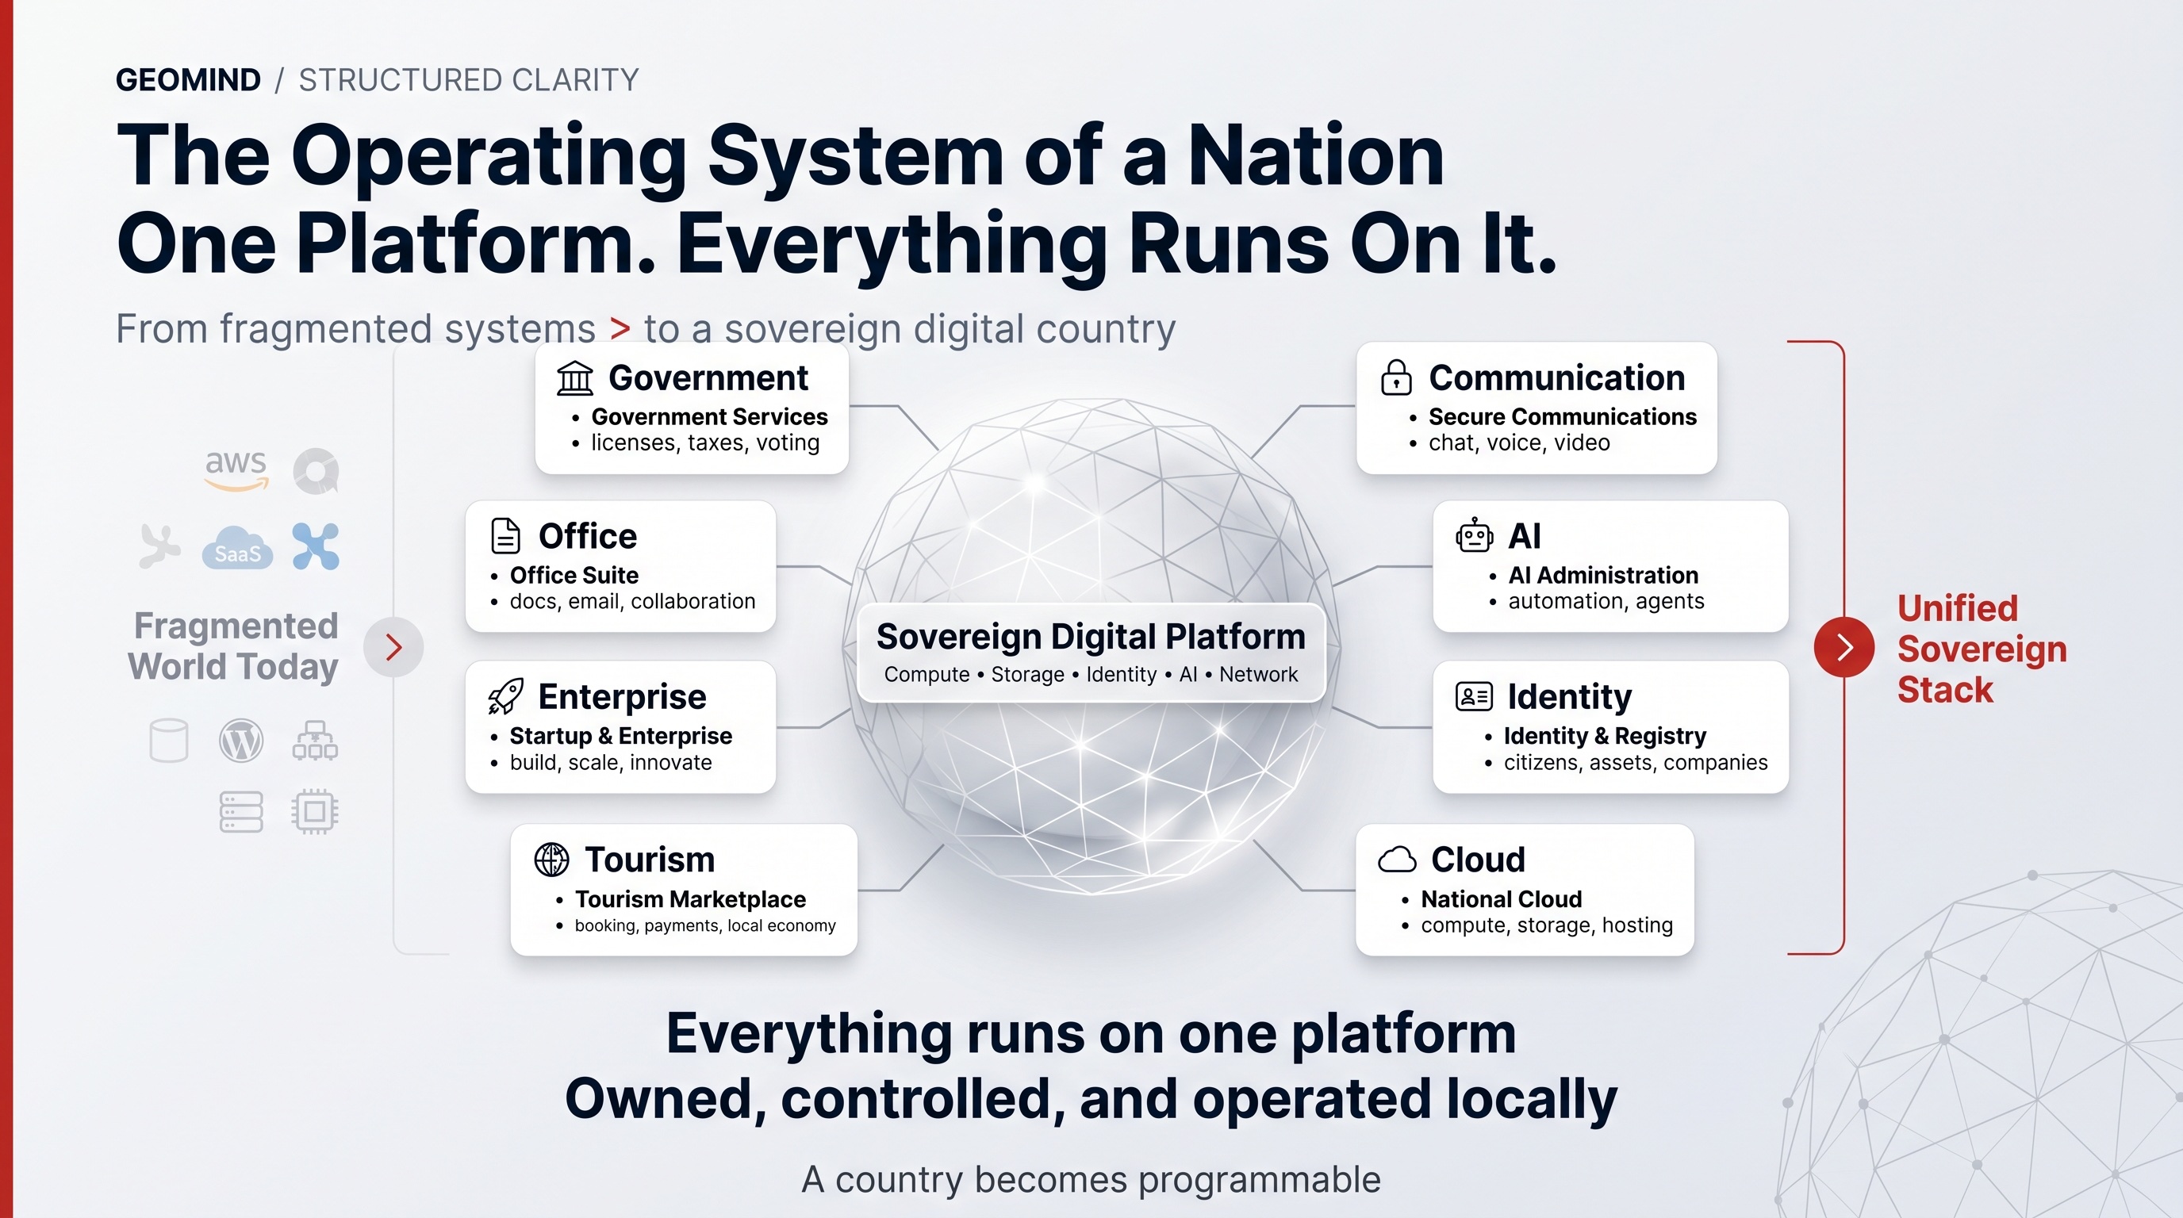
GeoMind is a software and technology company. We build the full-stack technology behind sovereign AI infrastructure — a four-layer software stack and the deployment standard around it — and we license it to operators who buy the hardware and run the cloud themselves.
That is the whole model: GeoMind provides the software and the standard; operators run the AI cloud. We are not a datacenter company, we do not rent out GPUs, and we do not operate sites — the operator does all of that. The operating system, the network, the storage, and the AI and agent layers are all GeoMind's IP. Operators deploy modular datacenters next to energy sources, inside existing buildings, and anywhere they own or control a site, running them on GeoMind's technology. The result is sovereign, agent-ready compute in any location that needs it — owned and operated locally.

Said simply
- The world is racing to build AI capacity. Most of that build-out is "neoclouds" — large, centralized clusters of GPUs in big buildings (more on this in Chapter 1).
- GeoMind enables a different category. Operators using GeoMind's technology run an edge, distributed neocloud — capacity placed wherever there is energy and demand, stitched together into one fabric, instead of concentrated in one mega-site.
- The deployment model follows the energy. Operators find places where there is power — ideally green power — and place a modular datacenter right next to it. These modular units can sit inside existing buildings, or arrive as containers. They own the hardware and the site; GeoMind provides the blueprint, the certified bill-of-materials, and the operating manuals.
- The magic is not the container. The magic sits in four layers of software that GeoMind built and owns, and that run on top of the operator's hardware. That is what this document is really about.

Where the value sits
The physical box — a container of servers next to a solar field — is the easy, visible part. Anyone can buy hardware, and operators do. The value GeoMind licenses is the four-layer stack we built and own — the technology that turns an operator's hardware and energy into secure, agent-ready capacity:
Layer | In one phrase
1 — Hardware Operating System | Use the silicon far better and more securely than any standard OS.
2 — Network & Storage | Quantum-safe, self-healing connectivity and storage between every node.
3 — AI | Run inference in the most efficient possible way, with an intelligent broker.
4 — Agentic | An operating system for AI agents — Anthropic-class quality at a fraction of the cost.

The rest of this document walks through each of these, why they are genuinely unique, and what they mean for your bottom line.
GeoMind in one sentence: we provide the full-stack technology that lets operators turn scattered (green) energy into secure, self-healing, agent-ready AI and cloud capacity — deployed anywhere, run autonomously, at a fraction of the cost.

What Is a Neocloud?
A neocloud is a new kind of cloud provider, built specifically around AI and agentic workloads — rather than the general-purpose infrastructure that the traditional hyperscalers (AWS, Microsoft Azure, Google Cloud) were designed for.
The term emerged in late 2024 and went mainstream through 2025, as a wave of companies recognised that AI workloads are fundamentally different in character — and that the old cloud platforms were never designed for them.

The defining idea: focus
A hyperscaler is a supermarket — it sells databases, serverless functions, load balancers, queues, and a thousand other services. A neocloud is a specialist. It is built from the ground up to run one class of workload: AI inference, AI training, and increasingly, autonomous AI agents.
This focus allows neoclouds to optimise every layer — hardware, networking, storage, software — for AI rather than for general compute. The result is better performance, lower cost per workload, and the ability to deploy where the hyperscalers cannot or will not go.

Why neoclouds emerged
Three forces created the category almost overnight:
- The AI surge. Serving and training large models requires enormous, specialised capacity — far more than traditional clouds made available.
- Hyperscaler limits. General-purpose clouds bolted AI accelerators onto platforms that were never designed for them, at premium prices and with limited availability.
- Speed and economics. A neocloud can bring AI capacity online in months, not the multi-year timelines of a hyperscale build — and at significantly lower cost.

The shift toward agents
The neocloud category is already evolving. The first wave was about raw compute for model training. The next wave — already underway — is about AI agents: autonomous software that reasons, plans, and acts continuously, not just in response to a prompt.
Agent workloads are different:
- They run continuously, not in short bursts — demanding always-on, low-latency infrastructure.
- They require orchestration, not just raw GPU capacity — an intelligent layer that schedules, routes, and manages many agents at once.
- They generate recurring, predictable revenue — more like a utility than a spot market.
The neoclouds that will win the next phase are those that built for agents from the start — not those that are retrofitting agent support onto a GPU-rental model.

What a neocloud actually does
Function | What it means
Runs AI inference | Serves model requests efficiently at scale — the core of any AI workload.
Supports AI training | Provides the dense compute needed to build and fine-tune models.
Orchestrates agents | Manages autonomous agents — scheduling, routing, lifecycle, billing.
Operates the infrastructure | Keeps hardware running, cooled, powered, and utilised — ideally without armies of engineers.

The next page looks at who the main players are. The page after that explains why GeoMind, although it lives in this world, is a fundamentally different category: it is not another neocloud operator but the technology standard that enables a new kind of distributed, sovereign neocloud — one built and run by many independent operators rather than by a single company.

The Neocloud Landscape
Industry analysts (SemiAnalysis) segment the market into four tiers. Understanding them makes it clear where GeoMind sits — and where it deliberately does not.

The four tiers
- Hyperscalers — AWS, Microsoft Azure, Google Cloud. General-purpose giants that also rent GPUs.
- Neocloud Giants — the pure-play leaders: CoreWeave, Nebius, Lambda, Crusoe.
- Emerging neoclouds — a long tail of regional and specialist GPU providers.
- Brokers & aggregators — marketplaces at the spot-market end (RunPod, Vast.ai, and similar).

The leading players
Player | Identity | Notable
CoreWeave | The category leader | Began as a rendering service (2017), pivoted to AI compute (~2020). IPO'd March 2025 at ~$23B valuation; first neocloud past $5B annual revenue; signed a multi-billion-dollar contract with a major AI lab.
Lambda | The "AI developer cloud" | Developer-first, built on AI-workstation heritage. Offers cloud GPUs plus on-prem/private clusters with InfiniBand. Raised $480M Series D in Feb 2025.
Crusoe | Energy-led | Specializes in low-cost stranded-energy sourcing — running compute where wasted power is.
Nebius | Full-stack European | Vertically integrated GPU cloud.
RunPod / Vast.ai | Marketplaces | Independent hardware operators list spare capacity on a shared platform.

The architectural split
There are really two shapes in this market:
- Curated central clusters (CoreWeave, Lambda) — large, enterprise-grade GPU farms with SLAs, concentrated in a relatively small number of big sites.
- Marketplace models (RunPod, Vast.ai) — aggregate independent operators' hardware into one pool.

Where GeoMind sits — and does not
GeoMind does not compete as another neocloud giant, and it is not a broker or marketplace renting out GPUs. It does not own datacenters, buy hardware, or operate sites.
Instead, GeoMind sits above and across this whole landscape. It is the company that invented the full-stack technology the rest of this market is missing — a four-layer software stack that lets anyone run AI and cloud infrastructure with lower TCO, far stronger security, and near-zero operational overhead than the players above can offer. We do not keep that technology for ourselves; we enable others to run with it.
The people who run with it are a distributed network of independent operators — regional infrastructure companies, energy owners, telcos, enterprises, governments, and cooperatives — who own their hardware and run their own sovereign capacity on GeoMind's technology. So GeoMind is two things at once: the innovative technology that makes a better neocloud possible, and the standard that lets many operators build to a single, certified bar of quality. It is not one operator in a tier — it is the layer that makes everyone in the tiers run better.

Where the whole industry is heading
The relationship between neoclouds and hyperscalers has shifted from pure competition to something more symbiotic — hyperscalers now partner with neoclouds to fill their own capacity gaps. The market is widely expected to be a multi-trillion-dollar build-out over the coming decade.
But almost all of today's effort goes into one layer of the problem: securing GPUs and renting them out as fast as possible. That is necessary — but it is not where durable, defensible value will be created. GeoMind instead provides the technology layers above the GPU — the operating system, network, storage, AI optimization, and agentic orchestration — which, as the next page argues, is exactly where the lasting value lies.
— — — — —
Sources: SemiAnalysis via ABI Research, CloudAtler, ModulEdge.

How GeoMind Is Different
From the outside, a GeoMind-powered operator can look like the other neoclouds: containers, renewable energy, sovereign AI. The difference is structural, not cosmetic — and it starts with the fact that GeoMind does not operate a neocloud at all.
Most neoclouds optimize one layer — GPU volume. GeoMind provides the whole stack as technology, so that many operators can each run an edge, distributed, self-healing, sovereign neocloud where value is created at every layer.
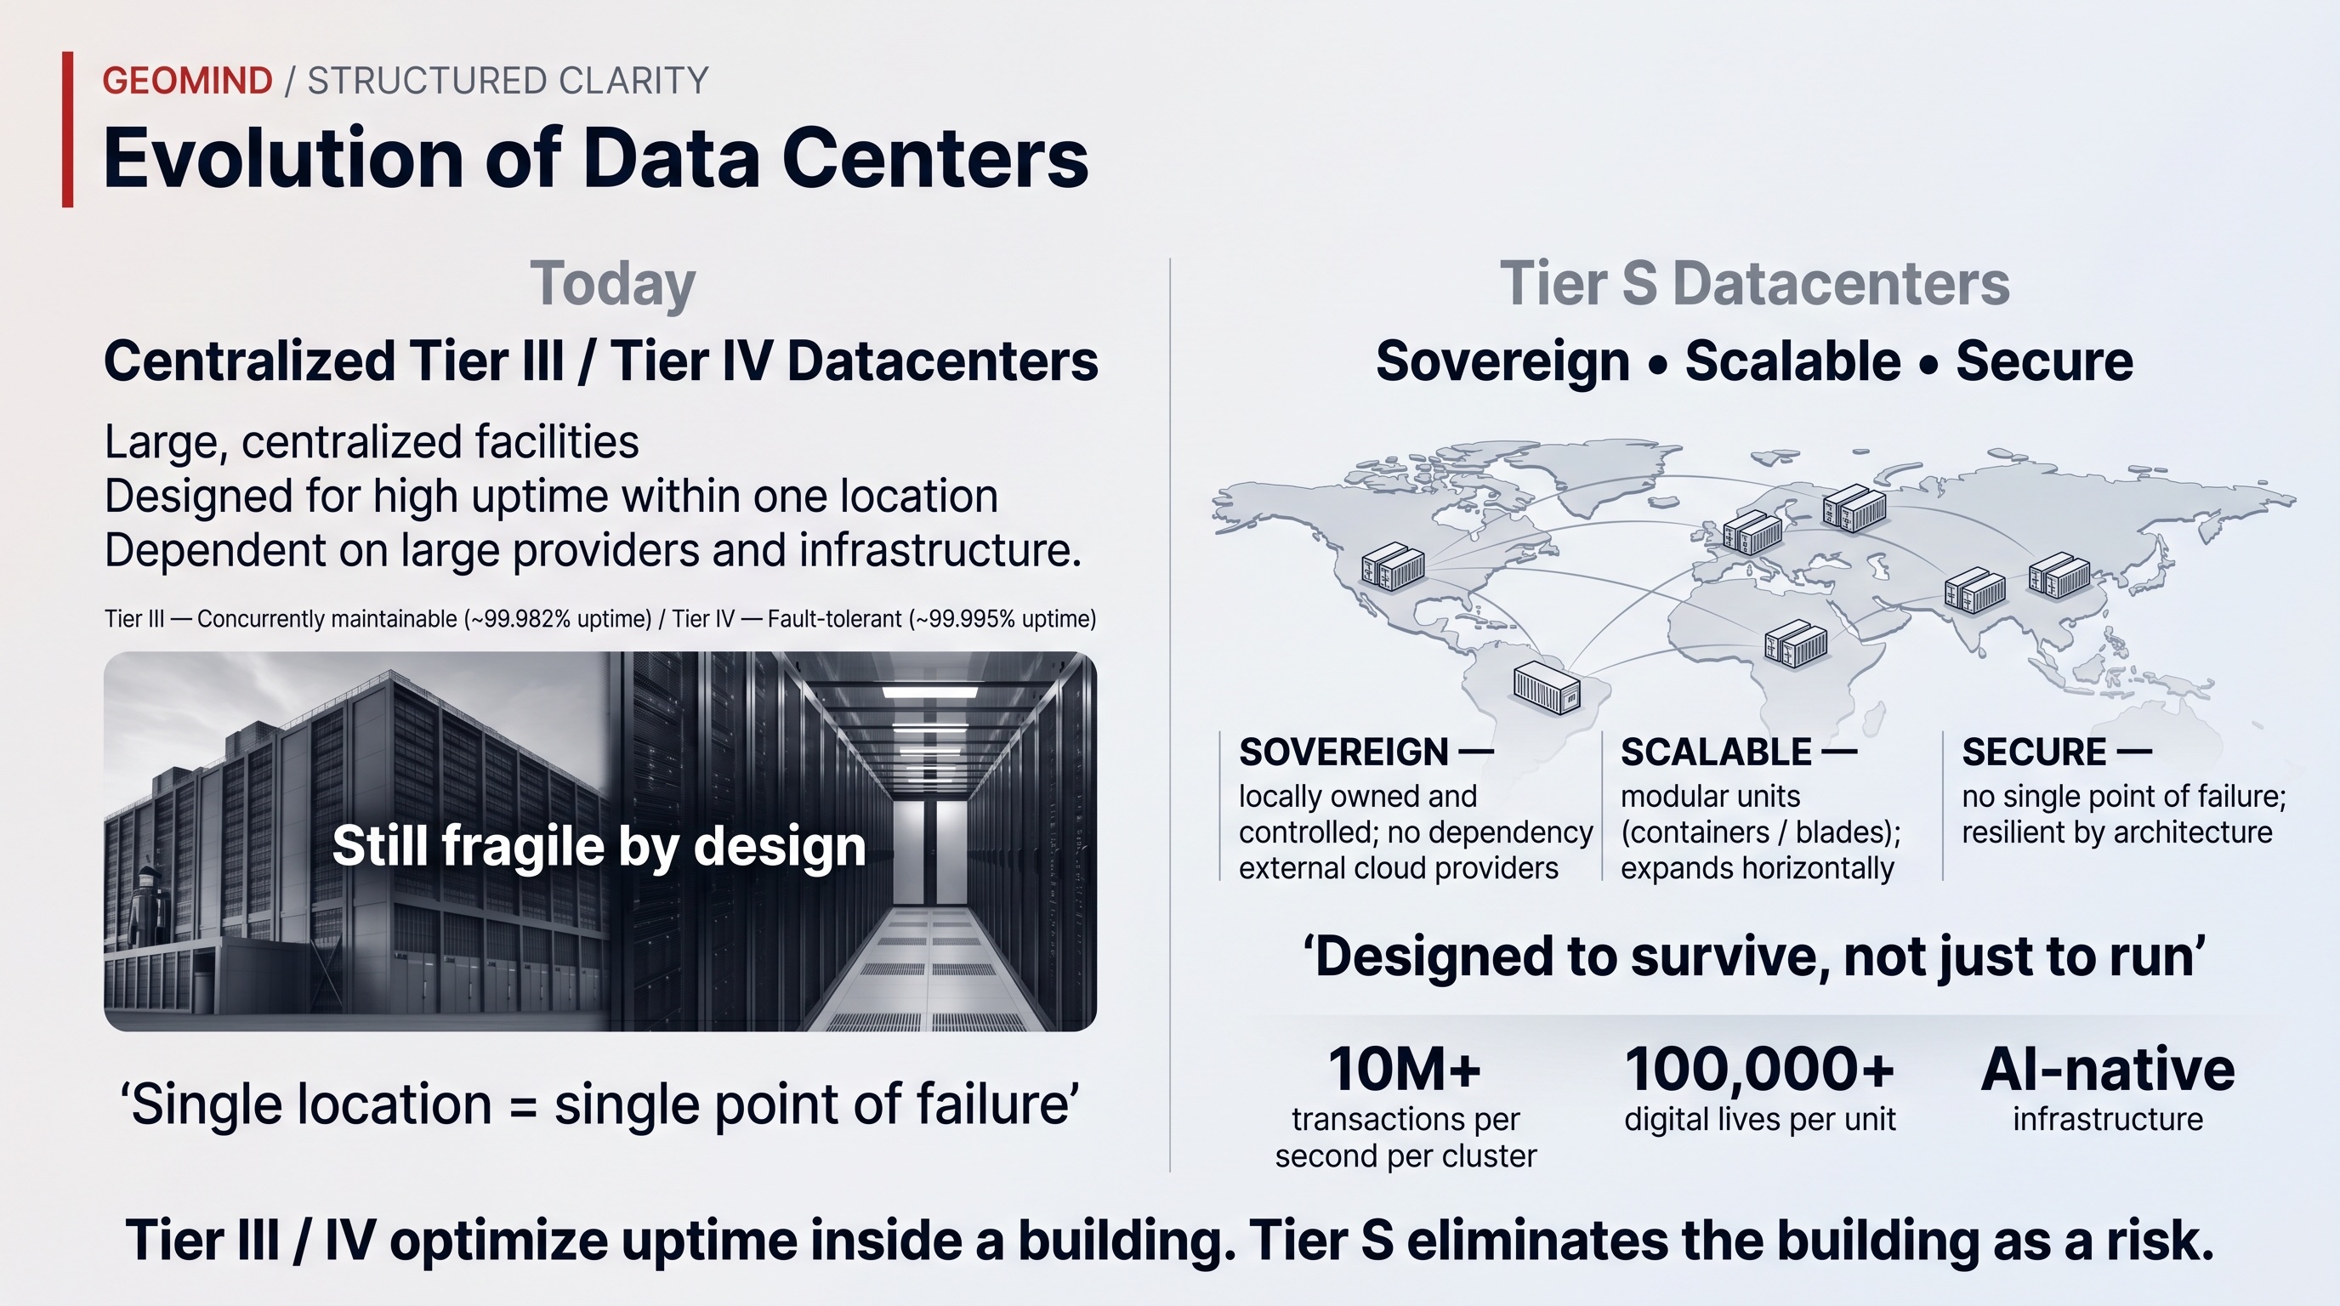

Three differences that matter

Distributed and edge-native — not concentrated in mega-sites
The neocloud giants concentrate capacity in a small number of very large buildings. That is fast to start but fragile by design: a single location is a single point of failure, and it forces data to travel to the compute.
GeoMind's technology inverts this. It lets operators place capacity wherever there is energy and demand and stitch it into one fabric. The building stops being a risk. Compute moves to the data, not the other way around — which is exactly what sovereignty, latency, and resilience require.

GeoMind owns the full technology stack — operators own the hardware
The GPU is only one component, and it is the part that ages fastest. GeoMind owns the entire technology stack — the operating system, the network, the storage, the AI optimization, and the agentic layer. GeoMind builds it, certifies it, and improves it, then licenses it to operators who own and run the hardware themselves.
This means the IP, the roadmap, and the sovereign architecture all sit in GeoMind — with no foreign dependencies — while ownership and operation of the infrastructure sit with the operator (see Chapter 2). That separation is precisely what lets sovereign and regulated operators trust it: the technology is GeoMind's end to end, but the hardware, the site, and the data stay under local ownership and control.

Four layers of value, not one
 | Typical neocloud | GeoMind-powered operator
Compute | Standard OS + hypervisor on the GPU | GeoMind hardware OS — more efficient, more secure, lower TCO
Network & storage | Bought-in components | Quantum-safe, self-healing, built into the stack
AI | Rent the GPU, you bring the software | Inference optimized to the hardware + intelligent broker
Agents | Not addressed | A full agentic operating system, Anthropic-class quality
Operations | Teams of engineers per site | Self-healing — runs itself across millions of nodes

A pure GPU-rental model lives and dies on the GPU utilization rate. Because the GeoMind stack creates value at hardware-efficiency, network-resilience, AI-optimization and agentic-orchestration levels, the same megawatt of power yields materially higher revenue and a longer useful life for the operator that runs it.

The strategic point
The first wave of this market is being won on who can deploy GPUs fastest. The long game will be won by whoever owns the layers above the GPU — the OS, the network, the storage, the orchestration, and the agents.
GeoMind owns those layers and licenses them to operators. That is the category GeoMind is built for: not cheap compute, but the technology standard for sovereign, secure, agentic compute that any operator can run. The rest of this document explains how.

First-Principles Thinking
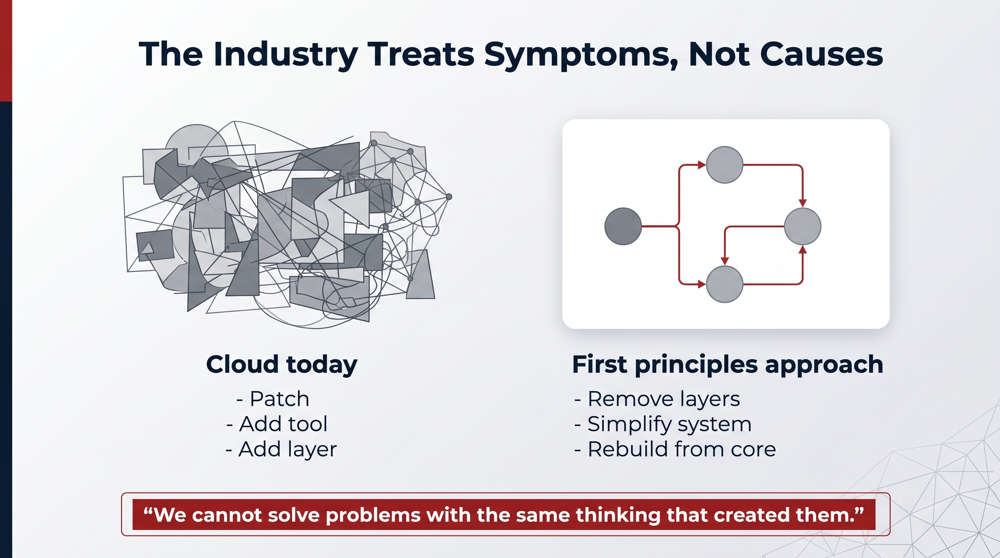
Before we describe a single layer of technology, we need to explain how we decided what to build. Because the most important decision GeoMind ever made was not a feature. It was a method: we designed the entire stack from first principles.

What "first principles" means
A first principle is something that is true on its own — it cannot be deduced from anything else. First-principles thinking means stripping a problem down to those few things you know to be true, and then reasoning upward from there, rather than copying what already exists.
The opposite — and the default in our industry — is reasoning by analogy: you look at how everyone else builds a cloud, take what they have, and make small improvements at the edges. It is faster and safer in the short term. But it carries every assumption baked into the thing you copied, including the ones that no longer make sense.
 | Reasoning by analogy | Reasoning from first principles
Starting point | What already exists | What is actually true and actually needed
Method | Copy and tweak | Decompose and rebuild
Inherits | All the old assumptions | Only the laws of physics and the real requirements
Result | A slightly better version of the past | Something genuinely new when the past no longer fits

The path we deliberately did not take
If you set out today to build the technology behind AI and cloud capacity, the conventional path is well worn:
- Take a general-purpose Linux distribution.
- Install a hypervisor, an orchestration layer, monitoring, networking and storage software on top.
- Bolt on security tools afterwards.
- Hire armies of engineers to keep the whole assembly running.
Each piece is reasonable on its own. The problem is what happens when you stack them: you are gluing together components that were each designed in a different decade, for a different problem, by different people who never expected to be combined. You inherit forty years of assumptions — and you stay locked inside an old paradigm, just with newer logos.
You cannot reach a fundamentally different outcome by reassembling the same parts in a slightly different order.

The question we asked instead
We did not ask "how do we make the existing cloud a bit better?" We asked a first-principles question — the question that defines GeoMind:
If operators must run secure, autonomous compute in millions of locations all over the world — fully distributed, with no army of engineers — what technology must exist for that to be possible?
That question has a very different answer from "improve the data­center." Once you take distributed, everywhere, autonomous and secure as the non-negotiable starting truths, most of the conventional stack simply does not survive contact with the requirements. GeoMind answered the question by designing the whole stack — from the silicon up — from first principles, so that any operator can own and run the hardware while the technology does the hard part. The next page works through why we had to rebuild, and what GeoMind now licenses to operators as the standard.

Why We Rebuilt Everything
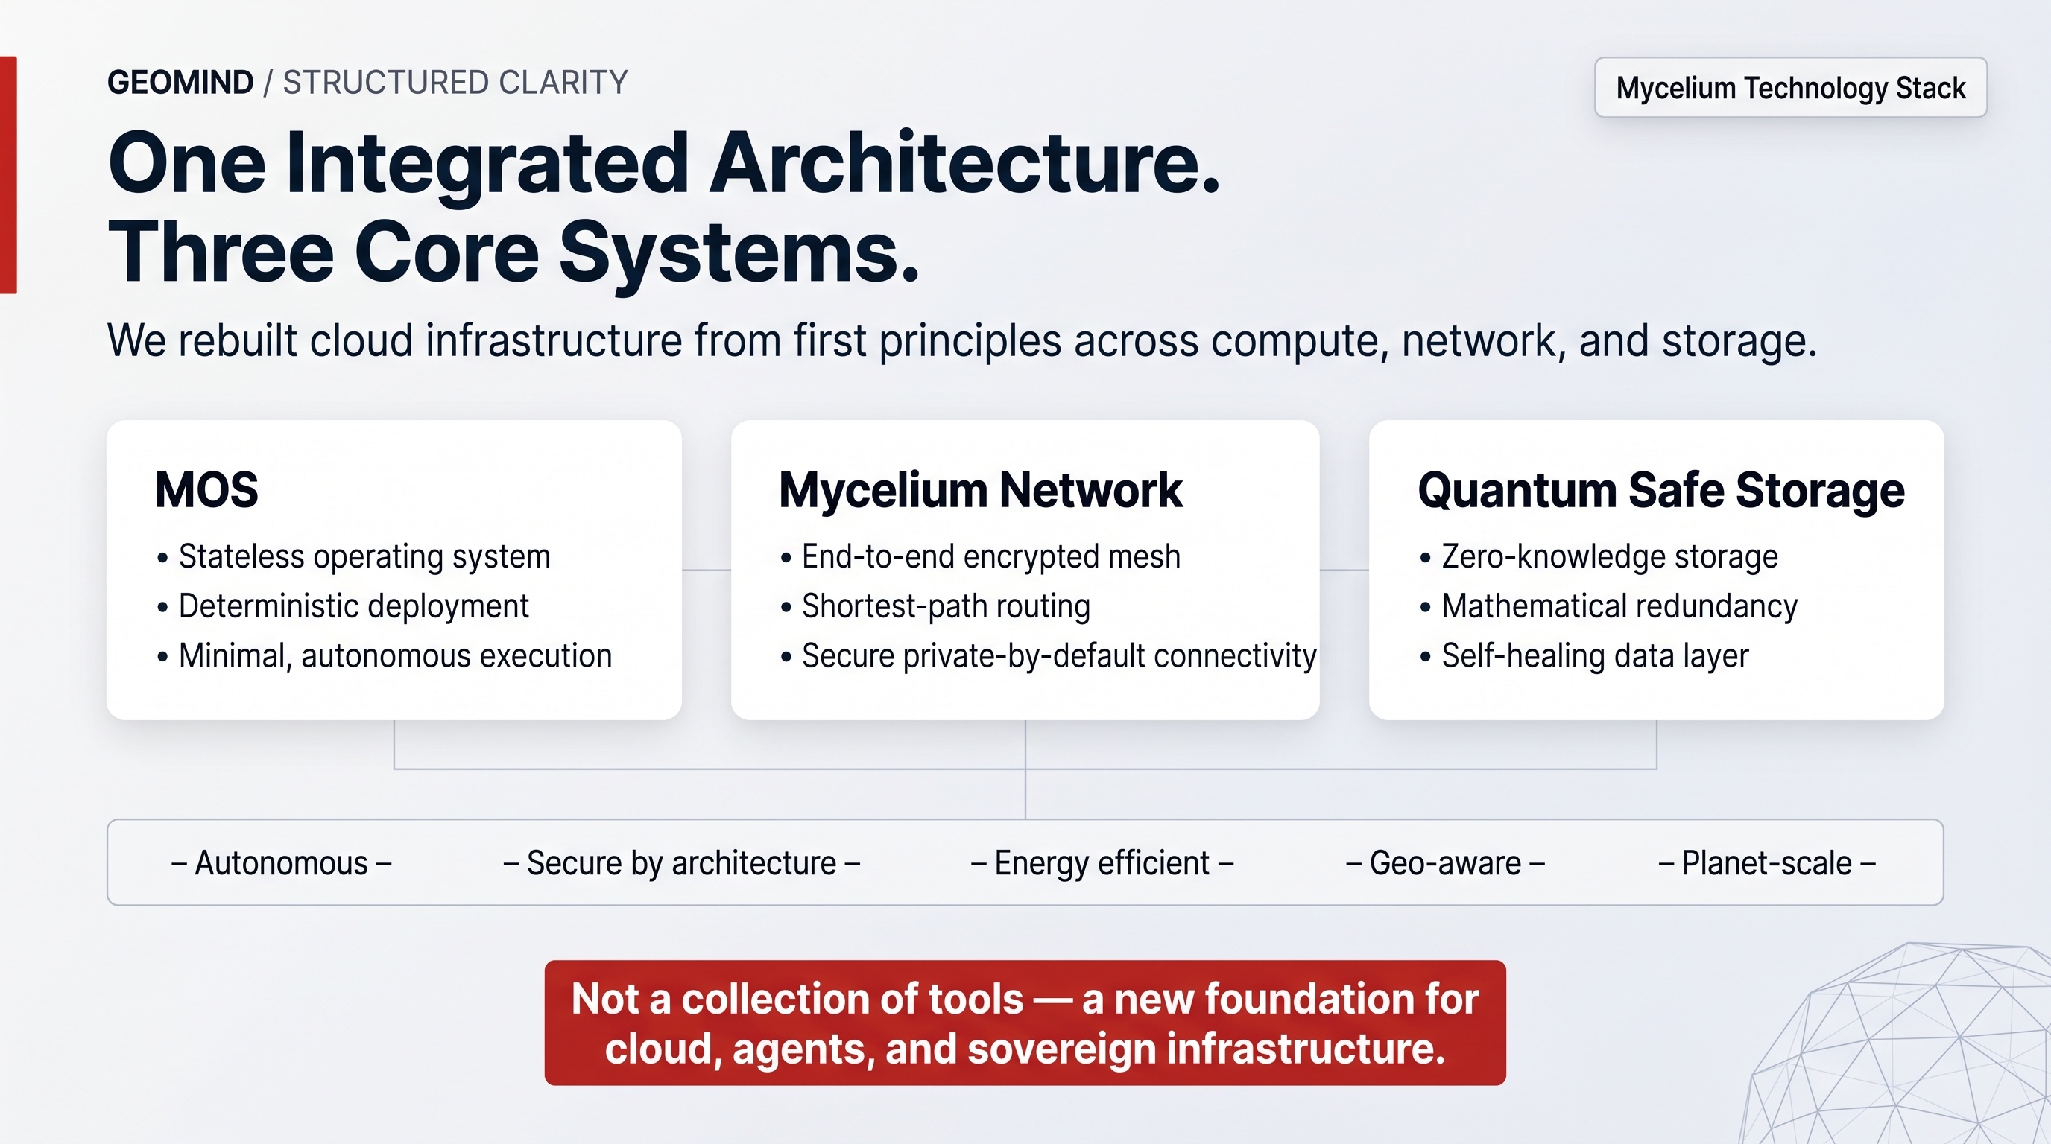
First-principles thinking only earns its keep when you follow it honestly to its conclusion — even when that conclusion is inconvenient. Ours was inconvenient: for operators to bring AI and cloud capacity everywhere in the world, GeoMind could not slap existing technologies on top of one another. We had to redesign the foundations — and then license that foundation as the standard operators build on.

Start from the requirements, not the tools
If the goal is sovereign, distributed compute in vast numbers of locations, the real requirements are clear. The technology must let an operator:
- Run across millions of nodes — not a few large datacenters, but capacity scattered wherever there is energy and demand.
- Need no technical experts — operators cannot be required to field armies of system administrators.
- Be far more secure — a smaller attack surface by design, not security bolted on afterwards.
- Be greener — more useful work per watt, less waste.
- Run itself — nobody should have to manage each node by hand.
Hold those five requirements together and a hard fact appears: no existing operating system can meet them. Today's server operating systems were designed decades ago, for a world of single machines, local installation, persistent state and human administrators. That model does not stretch to millions of autonomous nodes. The more you stack on top of it, the more complex it becomes — and complexity is exactly what breeds security holes.
The current way of doing things does not fail because the hardware ran out. It fails because the architecture will not scale to where operators need to go.
So GeoMind did the only thing the requirements allowed. We rebuilt — in four places — and these four rebuilds are the technology operators now license from us.

A new hardware operating system
GeoMind built its own operating system at the hardware level. It keeps the Linux kernel — there is no reason to rewrite that — but everything around the kernel we remade from scratch, with one obsession: stay as clean, as simple and as close to the hardware as possible.
That design choice is what delivers the five requirements at once:
- No install. The OS is delivered over the network and verified at boot, so a node has nothing to configure and nothing to drift.
- Stateless and autonomous. A node can restart or be replaced at any time; it manages its own lifecycle without an administrator.
- Minimal. Less code means less to attack and less to go wrong — which is why operators can scale this to millions of nodes with very few people, and with far fewer security issues.
This is Layer 1, described in full in The Four Layers → Hardware Operating System.

A new operating system — for agents
Here a second first-principle truth surfaces: the user of IT is changing.
Today, humans are the integrators. We hold everything together in our heads — this app, that chat, a dozen tools, remembering what we were doing and why. It is inconvenient, and it does not scale.
In the new world, the entities that actually use the infrastructure are AI agents: digital cells working on our behalf, persistent and always on. Agents have completely different requirements from people. They do not even need to speak our language. An operating system built for humans is simply the wrong shape for them.
So GeoMind built a second operating system — one made for agents, providing the primitives they need: persistent identity, long-term memory, secure state, and coordination, all native. This is Layer 4, described in The Four Layers → Agentic.

& 4. A new network and a new storage system
Two operating systems running in millions of places are useless unless they can talk to each other securely, and unless data can live safely across many sites at once. The conventional internet and conventional storage were not built for that level of distribution, security or self-healing — so GeoMind reinvented both.
- Network — a secure, self-healing mesh so every node reaches every other node privately, wherever they sit. (Layer 2)
- Storage — data fragmented and mathematically distributed across sites, so it cannot be lost or stolen and repairs itself. (Layer 2)

The logical conclusion
What operators needed | Why the old stack failed | What GeoMind built
Millions of autonomous nodes | OSs assume install, local state, admins | New hardware OS
The real user is now an agent | OSs are built for humans | New agent OS
Nodes must talk securely everywhere | Internet not private or resilient by default | New network
Data safe across many sites | Replication is costly and fragile | New storage

None of this was rebuilt for the sake of it. Each piece is the direct, unavoidable consequence of taking the requirements seriously. GeoMind started from what is genuinely needed, and found no other path than to reinvent the stack as one coherent whole — which operators now own the hardware for, and license the technology to run.
GeoMind did not set out to rebuild four systems. We set out to make it possible for operators to put compute everywhere, securely and autonomously — and rebuilding the four systems was the only honest way to give them that.
The rest of this document shows what that rebuilt stack does, layer by layer.

Energy First: Follow the Power
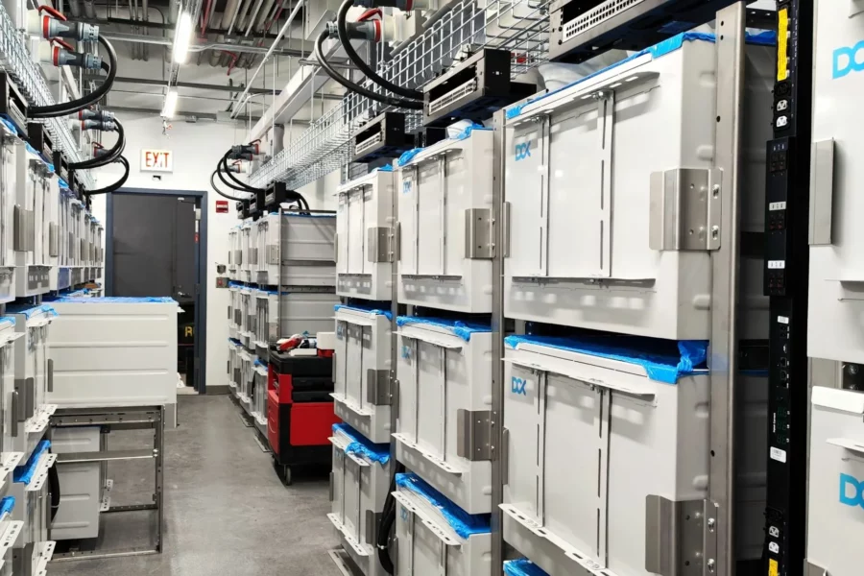
GeoMind's deployment model starts with a simple observation: the scarcest, most expensive input to AI infrastructure is energy — and the cheapest, greenest energy is rarely where the big datacenters already are.
So GeoMind's model reverses the usual order. Instead of building a datacenter and then connecting it to the grid at great cost, operators find places where there is energy — preferably green energy — and place a modular datacenter right next to it.

Why energy-first wins
- No transmission loss or cost. Compute at the source of generation avoids the losses and fees of moving power across the grid.
- Monetize stranded and curtailed power. Solar, wind, hydro, biomass and similar sources often produce more than the local grid can absorb. That surplus is normally wasted. Operators turn it into compute revenue.
- Green by default. Placing capacity next to renewable generation means a genuinely lower carbon footprint — not an offset purchased after the fact.
- Cost advantage. Power is the dominant operating cost of any datacenter. Cheaper, local power directly improves the economics of every workload.

The energy reality
A high-power conventional datacenter can cost over $15 million per megawatt to build, and powering a 10 MW load on diesel alone can run to roughly $51 million per year — economically unviable. The world is expected to spend more than $1 trillion fuelling the expansion of AI.
Against that backdrop, where you put the compute and how you power it is not a detail — it is the whole game. Renewable, baseload-capable generation (nuclear, biomass, hydro, large solar) paired with compute at the source is one of the few models that makes the numbers work.

What this enables
Because GeoMind's standard is distributed and modular (next page), operators are not forced to find one giant site with one giant power connection. They can place many smaller units next to many smaller pockets of energy — and then aggregate all of that scattered capacity into one coherent cloud (see Aggregating Capacity).
Big datacenters go looking for enough power in one place. GeoMind's model lets operators go looking for power anywhere, and makes it add up.

Modular Datacenters
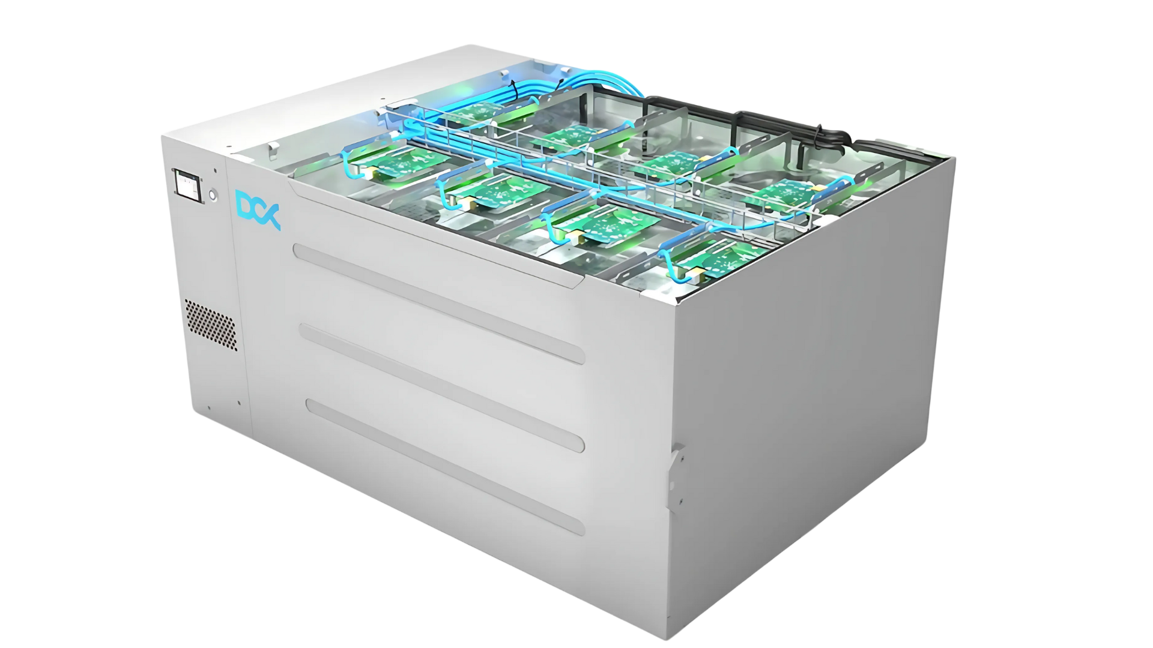
Once the energy is found, the operator places a modular datacenter next to it, following GeoMind's certified designs. Modular means exactly what it sounds like: a self-contained, pre-built unit of compute, storage, networking, cooling, power and security that can be dropped into place and brought online in weeks, not years.

Two physical forms
A modular datacenter can take whichever shape fits the site:
- Inside an existing building. A wing of a building, a basement, a decommissioned telecom exchange, or an industrial hall can host the racks directly — reusing existing power, connectivity and permits.
- As a container. A standard shipping-container-sized unit arrives factory-built — with immersion or liquid cooling, networking, fire suppression and security already integrated. Installation takes days.
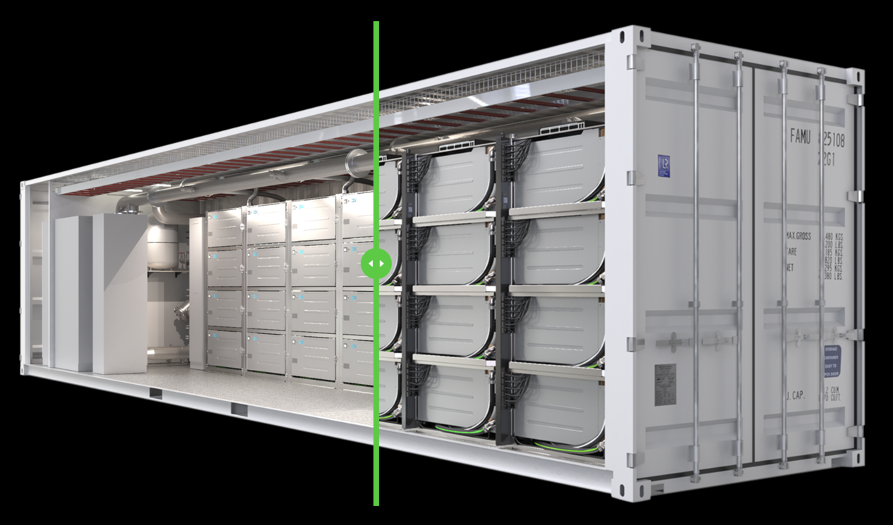

What's inside (illustrative)
A single container unit can be remarkably dense. For example, one reference configuration in GeoMind's certified bill-of-materials packs roughly:
- ~352 kW of power capacity in a 40ft container
- Compute and AI nodes for cloud and agentic workloads
- GPU nodes (liquid-cooled) for heavy inference and training
- Petabytes of quantum-safe storage
- Room to expand with additional GPU clusters as demand grows

Why modular beats the mega-build
 | Traditional mega-datacenter | GeoMind modular
Time to live | Years | Weeks to a few months
Civil works | Extensive | Minimal or none
CapEx shape | One huge up-front commitment | Scales in modular steps
Capacity | Fixed at build time | Grows pod by pod with demand
Risk | One site, one point of failure | Many small, independent units

But this is not where the magic is
It is important to be honest about this: modular hardware is the easy, visible part. Containers and racks are a commodity — many companies can ship them, and operators source the boxes from manufacturers in Europe, the Middle East and elsewhere. GeoMind does not build or own the hardware; it provides the certified configurations, the bill-of-materials and the supplier guidance that tell the operator exactly what to buy and how to integrate it.
The real advantage — the reason a GeoMind-certified pod is worth far more than the sum of its hardware — is the four-layer software stack that GeoMind provides and that runs on it. That is what Chapter 5 and Chapter 7 are about.
The container gets the operator to the energy. GeoMind's software is what makes the energy valuable.

Two Tiers: Tier-S Core and Tier-H Edge
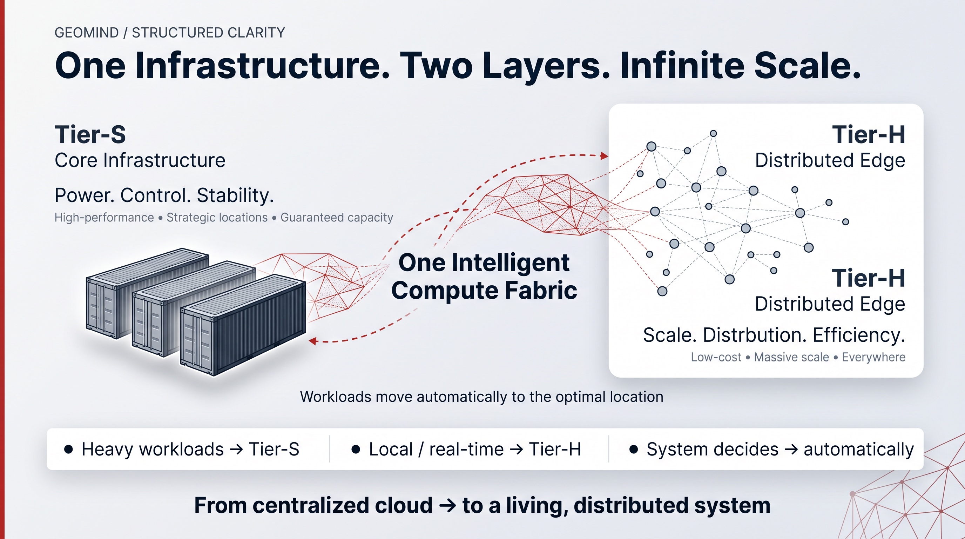
Not every workload belongs in the same kind of place. Training a large model and answering a citizen's request in real time have completely different needs. So GeoMind's technology is built for the full compute continuum — from national-scale, heavy AI processing down to local inference at the very edge — and operators deploy it in two complementary tiers: Tier-S is the core, Tier-H is the distributed edge.
The name is deliberate. The traditional datacenter world grades reliability as Tier I–IV — but those tiers only measure uptime inside a single building, which leaves the building itself as the point of failure. GeoMind's tiers describe something different: the role a node plays in one distributed fabric.

Tier-S — the core
Tier-S is the heavy infrastructure: high-performance, strategically located, sized for guaranteed capacity.
- What runs here: model training, large-scale inference, sovereign national platforms — the compute-intensive, AI-native workloads.
- Form factor: the larger modular pods and containers from the previous page, placed next to strong, ideally green energy.
- Optimised for: power, capacity and stability — a single Tier-S cluster is built to carry national-scale demand.
Tier-S is the regional anchor: fewer, larger sites that do the demanding work — and because the fabric is distributed, no single site is a single point of failure. It eliminates the building as a risk.

Tier-H — the distributed edge
Tier-H is the edge layer: low-cost and designed to be deployed almost anywhere — an office, a tower, a clinic, a community building, a small enterprise, even a home.
- What runs here: local, real-time, latency-sensitive workloads — healthcare AI, real-time government services, autonomous logistics, low-latency agents — anything that must run close to the user or the data.
- Form factor: small nodes, massively replicated.
- Optimised for: scale, distribution, proximity and cost.
Tier-H is how sovereignty and low latency reach the community level, where the data actually lives.

One intelligent compute fabric
The power of the model is that operators do not have to choose. The same GeoMind technology runs on both tiers, and the network and orchestration layers place every workload automatically:
- Heavy jobs route to Tier-S.
- Local and real-time jobs route to the nearest Tier-H node.
- No human decides where anything runs — placement is continuous and autonomous, based on latency, policy, data residency, cost and energy.
 | Tier-S — Core | Tier-H — Edge
Role | Core infrastructure | Distributed edge
Workloads | Heavy compute, training, large inference, national platforms | Local, real-time, low-latency inference and agents
Footprint | Fewer, larger, strategically located sites | Many small nodes, deployed almost anywhere
Optimised for | Power, capacity, stability | Scale, distribution, proximity, cost
Energy | Sized to large, often stranded, green power | Runs on modest local power

This two-tier design also lets the same standard serve every customer — from a large AI campus (Tier-S) down to a single community node (Tier-H). An operator can start small at the edge and grow into the core, or run both at once, without ever changing technology.
Tier-S provides the power. Tier-H provides the reach. GeoMind's technology makes them behave as one living, distributed system — and Aggregating Capacity shows how all of it becomes a single cloud.

Locations, Operators & Jurisdictions
GeoMind does not own buildings, buy hardware, or run sites in any country. That model does not scale, and it is exactly the wrong shape for a world that increasingly demands digital sovereignty.
Instead, GeoMind provides the technology and the standard, and operators build and run the infrastructure locally. The operator follows the energy, partners with local location owners, energy providers and governments, buys and owns the hardware, and runs the cloud in-country. GeoMind enables all of it.

How the model works
Party | Role
GeoMind | Provides the four-layer technology stack, the reference architecture, deployment blueprints, certified bill-of-materials, operating manuals, certification, support and updates, and optional marketplace connectivity — and licenses it. GeoMind does not own or operate infrastructure.
Operators | Buy and own the hardware, own or control the modular datacenter, and operate the cloud locally — using GeoMind's certified technology. Regional infra companies, energy owners, telcos, enterprises, governments and cooperatives.
Energy providers & location partners | Supply site and power — stranded renewables, existing buildings, industrial land, government facilities.
Offtakers & customers | Bring demand — governments, enterprises, AI platforms and cooperatives consuming compute, storage and agentic AI.

The operator owns and operates the infrastructure; the location partner owns or controls the site; GeoMind supplies the technology that makes it all work. Together they unlock capacity none of them could build alone.

Why it works across jurisdictions
Different countries have different rules, different energy, and different sovereignty requirements. A single centralized cloud cannot satisfy all of them. GeoMind's model can, because the same technology stack can be deployed and locally operated by an in-country operator in each jurisdiction:
- Data residency by design. Data physically lives — and stays — where the law requires.
- Local ownership and control. The infrastructure is owned AND operated by the in-country operator — not a foreign hyperscaler routing everything through distant data centres. It is built on GeoMind's sovereign technology, which has no foreign dependencies. (See The Cyber Pandemic for why this matters so much.)
- Regulatory fit. The model maps naturally onto frameworks like the EU's DORA, GDPR, and emerging sovereign-AI mandates.
- Cultural and political alignment. The infrastructure is operated by, and accountable to, the host country.

Multiple routes to demand
An operator's capacity can be sold into several channels:
- A global cooperative marketplace (built with the International Cooperative Alliance — a movement touching ~1.2 billion people), which operators can connect to via GeoMind.
- Existing AI demand channels — aggregators and marketplaces like Lambda, Vast.ai and OpenRouter, which are supply-constrained and hungry for sovereign, compliant capacity.
- Country-level demand — governments and public bodies seeking a sovereign AI cloud.
- Enterprise and cooperative partners — large organizations running their own solutions on top of the stack.
The bottleneck in the market is not demand. It is bringing sovereign, modular capacity online fast enough — which is exactly what GeoMind's distributed model is designed to solve.

How operators deploy with GeoMind
An operator does not need a large team of engineers at each site. GeoMind's stack runs on hardware next to the energy source, and the system runs itself (see Self-Healing). Operators can roll out further modular datacenters — in existing buildings or containers — and grow their footprint pod by pod, location by location, jurisdiction by jurisdiction.

Aggregating Capacity
Operators have followed the energy. They have placed modular datacenters next to it, in many locations, owned by many operators across many jurisdictions. On its own, that would just be a scattering of disconnected boxes.
The final — and decisive — step in the model is to aggregate all of that capacity into one coherent cloud.

From scattered pods to one fabric
GeoMind's network and orchestration layers turn many independent, operator-owned units — Tier-S core sites and Tier-H edge nodes alike — into a single, self-orchestrating compute fabric:
- Workloads are scheduled automatically to the best location, based on latency, policy, data residency and available resources.
- Heavy jobs route to the larger Tier-S core; local and real-time jobs route to the nearest Tier-H edge node.
- One pod, or even one whole region, can go offline without taking the system down.
- No human has to decide where anything runs.
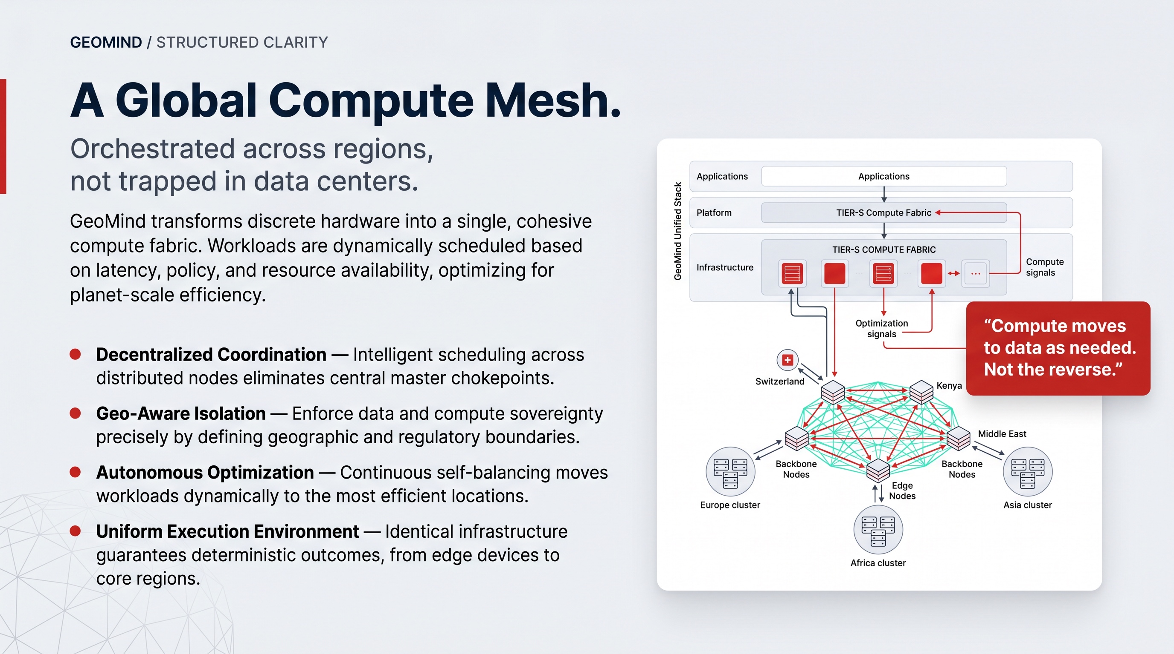

Why aggregation is the whole point
Individually, a 350 kW container next to a solar field is a small datacenter. But aggregate hundreds of them — each owned by a different operator — and you have hyperscale capacity — without ever building a hyperscale building, and without the fragility of putting everything in one place.
This is what makes the energy-first, distributed model commercially sensible:
Without aggregation | With GeoMind aggregation
Many small, hard-to-sell pockets of compute | One large, sellable pool of capacity
Each site managed separately | One fabric, self-managed
Capacity stranded where there's no local demand | Capacity matched to demand anywhere
Single-site fragility | Survives node, site and regional failure

The capacity stays owned by many independent operators — but GeoMind's technology and marketplace make it behave as one.
The model in one line: find energy everywhere → drop in modular datacenters → aggregate it all into one secure, self-healing cloud that behaves as a single planet-scale system.
And making that aggregation secure, efficient and autonomous is precisely the job of the four layers we turn to next.

The Four Layers — Where the Magic Sits
We have said it several times, and it is worth repeating: the container is not the magic. The magic is a four-layer software stack, designed as a single coherent whole rather than assembled from third-party parts.
This is the heart of what GeoMind built. GeoMind does not operate the cloud — operators do, on hardware they own. What GeoMind provides, and licenses to those operators, is this stack. Each layer solves a real problem, and each layer creates value the others cannot.

The four layers at a glance
Layer | Name | What it does | Why it matters to operators
1 | Hardware Operating System | A purpose-built OS that controls the silicon directly — no bloated hypervisor stacks. | More performance per watt, far more security, lower TCO.
2 | Network & Storage | Quantum-safe, self-healing connectivity and storage between every node. | Data that cannot be lost or stolen; secure links even at the edge.
3 | AI | Inference run in the most efficient configuration for the hardware, with an intelligent broker. | Lower cost per token, automatic best-model selection, full security.
4 | Agentic | An operating system for AI agents, open to any agent. | Anthropic-class quality at a fraction of the cost.

How to read the next chapters
- This chapter gives you roughly one page per layer — what each layer is.
- Chapter 7 — What Makes Us Unique then takes each layer and makes it tangible in business terms: the cost saved, the risk removed, the revenue unlocked.
Two qualities cut across all four layers and are worth holding in mind:
- Self-healing. The whole stack repairs and manages itself, so operators can run it across millions of nodes with almost no human operators.
- Secure by architecture. Security is not bolted on afterward; it is a structural property of every layer.
Anyone can buy hardware. The reason capacity built on GeoMind's stack is worth more than its hardware is that these four layers turn raw silicon and raw energy into something secure, autonomous, and agent-ready. GeoMind builds, owns and licenses that technology; operators own the hardware and run it.

Layer 1 — Hardware Operating System
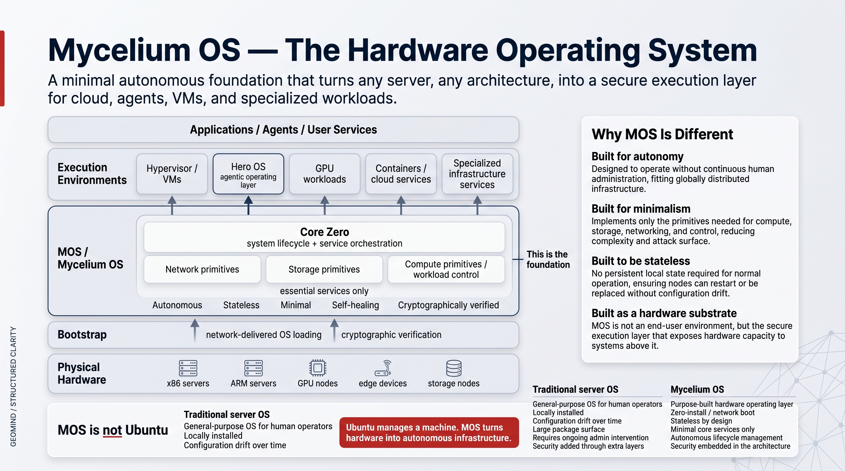
What it is: GeoMind created its own operating system at the hardware level. It gives operators full control over how the silicon is allocated, scheduled and recovered — without depending on the heavy hypervisor stacks and cloud-vendor abstractions that everyone else relies on.
We call it MOS (Mycelium OS). It is built on the Linux kernel, but everything around the kernel has been rebuilt from scratch for one purpose: to use hardware as efficiently and securely as possible.

Three design principles
- Autonomy — it runs without system administrators, locally or remotely. Essential when an operator runs a globally distributed grid.
- Minimalism — only the essential primitives for compute, storage and networking. Less code means less to attack and less to go wrong.
- Stateless — nodes keep no persistent local state. A node can restart or be replaced at any moment with no configuration drift.

What sits where
MOS is a hardware substrate, not an end-user environment. It turns any server an operator owns — x86, ARM, GPU, edge or storage node — into a secure execution layer that everything else runs on:
- At the base: the physical hardware, owned by the operator.
- Then MOS, delivered over the network and cryptographically verified at boot — no local install.
- On top: containers, virtual machines, GPU workloads, and specialized AI infrastructure.

Why it is different from a normal server OS
 | Traditional server OS | Mycelium OS
Purpose | General-purpose | Purpose-built hardware layer
Install | Local installation | Zero-install, network-delivered
State | Accumulates configuration drift | Stateless — fresh on every boot
Operation | Ongoing admin required | Autonomous lifecycle
Security | Added on top | Embedded by design

The business headline
By building and owning the layer closest to the hardware, GeoMind gives operators more reliability, more security, and lower total cost of ownership — and this is exactly what GeoMind licenses to them. The full, tangible version of this argument — context switches, the "onion" of legacy layers, and 20 years of experience — is in What Makes Us Unique → Hardware Used Better.

Layer 2 — Network & Storage
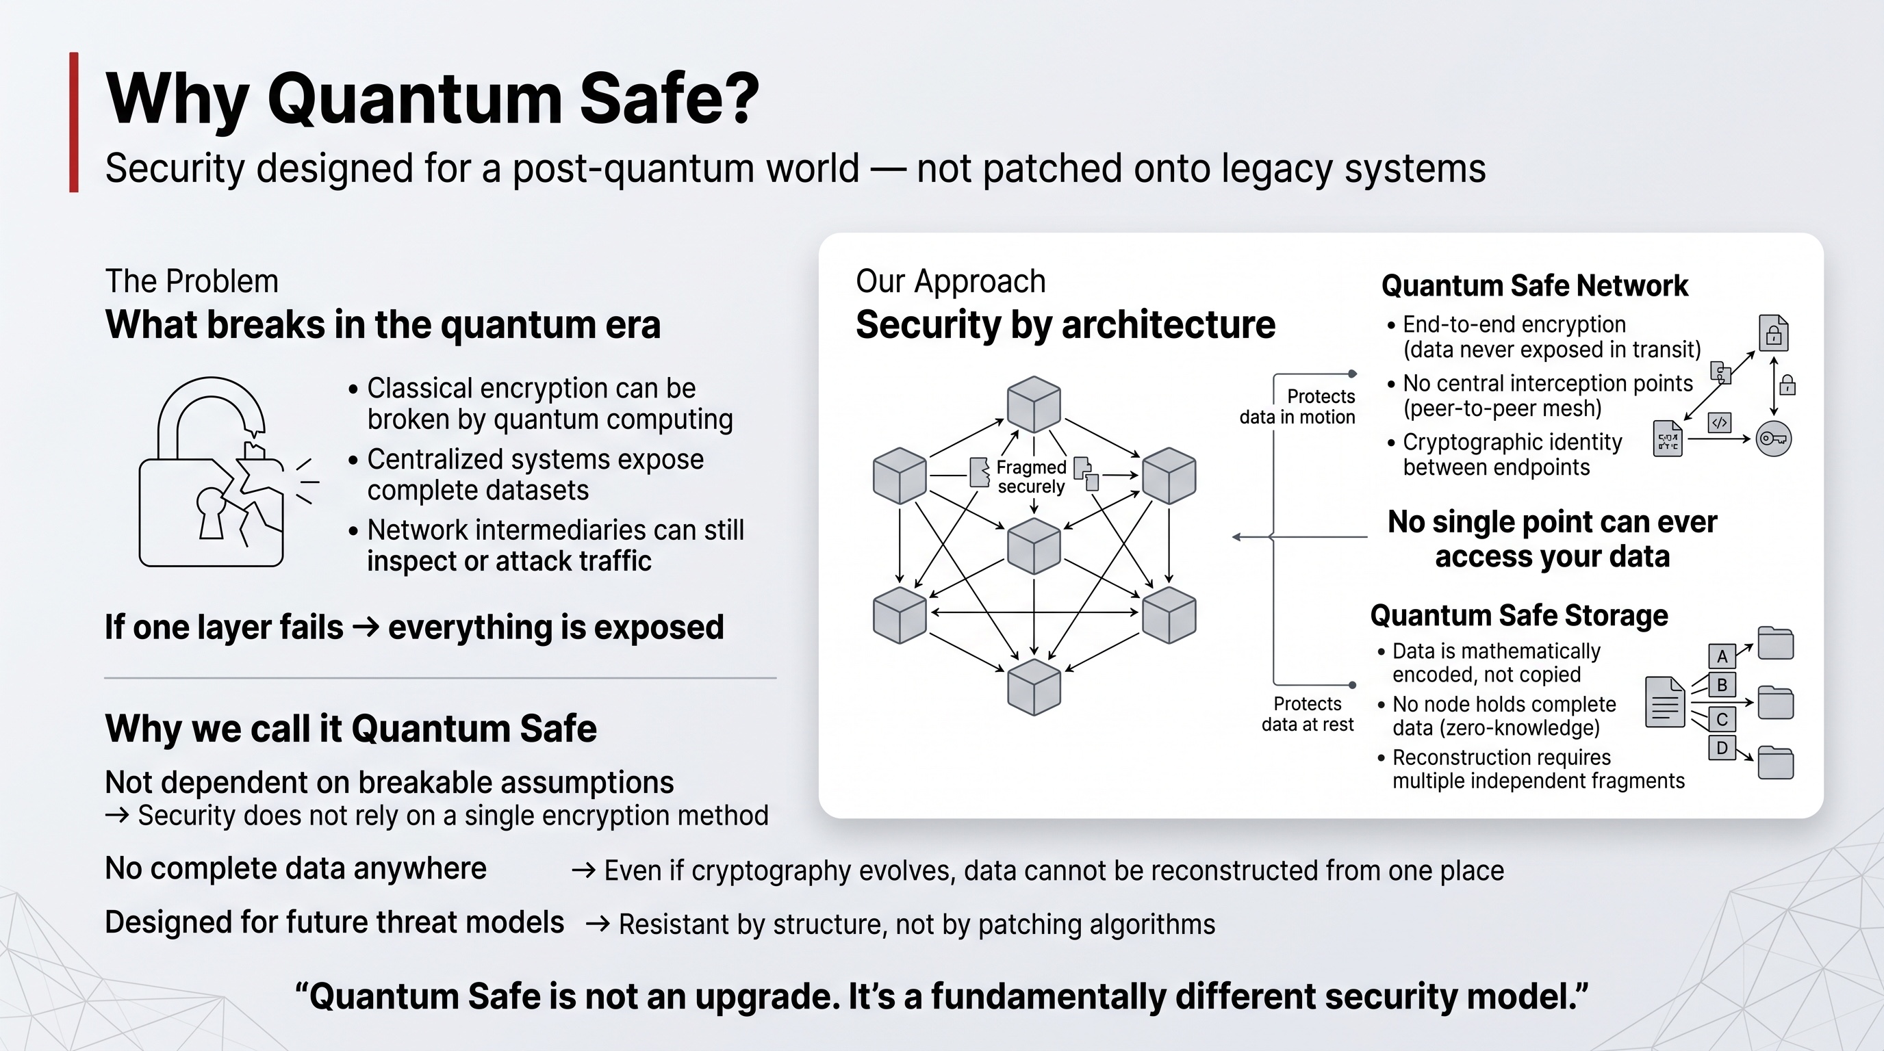
What it is: the layer that connects every node and stores every byte — and it is quantum-safe by design. The network is architected to scale globally while solving security, privacy and reliability at the protocol level. The storage layer is built so that data cannot be corrupted or lost — integrity is a structural property, not a backup strategy.

The network
GeoMind's network (Mycelium) is a secure mesh that runs on top of the existing internet:
- End-to-end encrypted from source to destination — no intermediary, not even a service provider, can read the traffic.
- Private by default — workloads are unreachable from the public internet unless explicitly exposed through a controlled gateway. You cannot attack what you cannot reach.
- Shortest-path routing — traffic takes the most efficient route automatically, which also lowers energy use.
- Resilient — it routes across fibre, cellular, satellite and peer links, holding sessions together even when individual links fail.
This matters enormously for an edge cloud: when an operator's nodes sit in many locations and jurisdictions, the secure channel between them — and between an AI agent and its model — is not a nice-to-have, it is the entire foundation of trust.

The storage
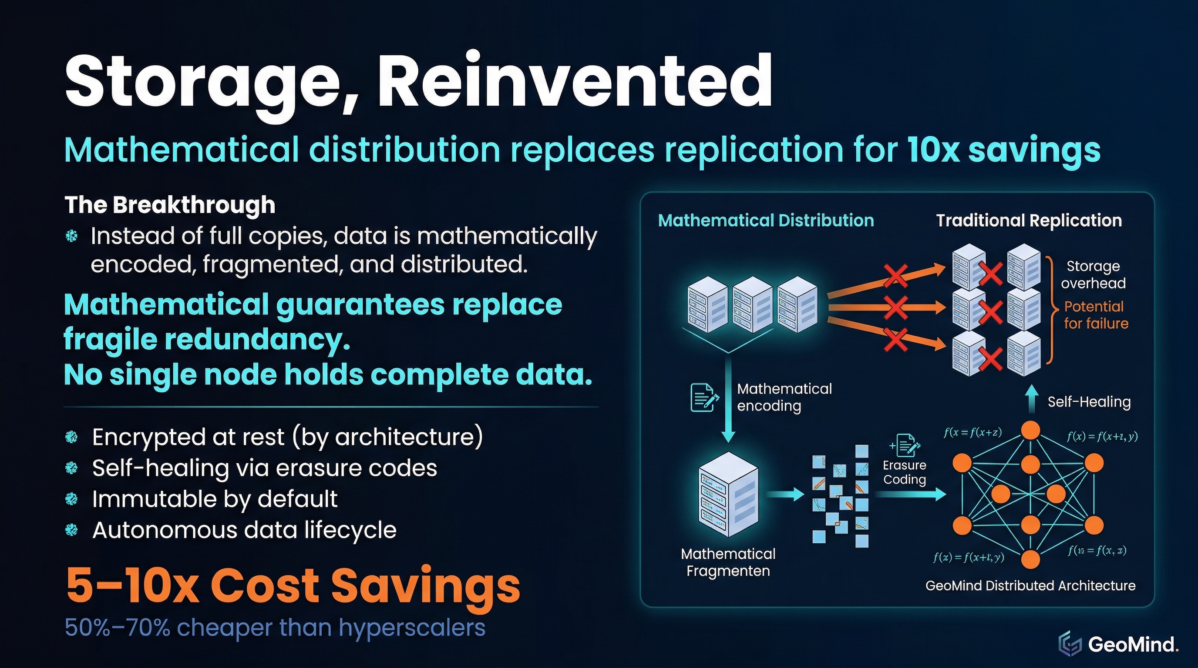
GeoMind's Quantum Safe Storage replaces copying with mathematics:
- Data is fragmented and mathematically encoded (forward error correcting codes), then spread across many nodes.
- No single node holds complete data — each stores only a meaningless fragment, so compromising one node gives an attacker nothing.
- It is self-healing — if a node fails or a disk degrades, the system reconstructs the missing fragments automatically.
- It is dramatically more efficient: roughly 20% overhead for strong redundancy, versus the 300–400% that replication-based systems require.

The business headline
Quantum-safe, self-healing networking and storage gives operators data that cannot be lost or stolen, secure connectivity across the edge, and storage that costs a fraction of the alternatives — all delivered as GeoMind technology they license and run. The tangible version is in What Makes Us Unique → Quantum-Safe Network & Storage.

Layer 3 — AI
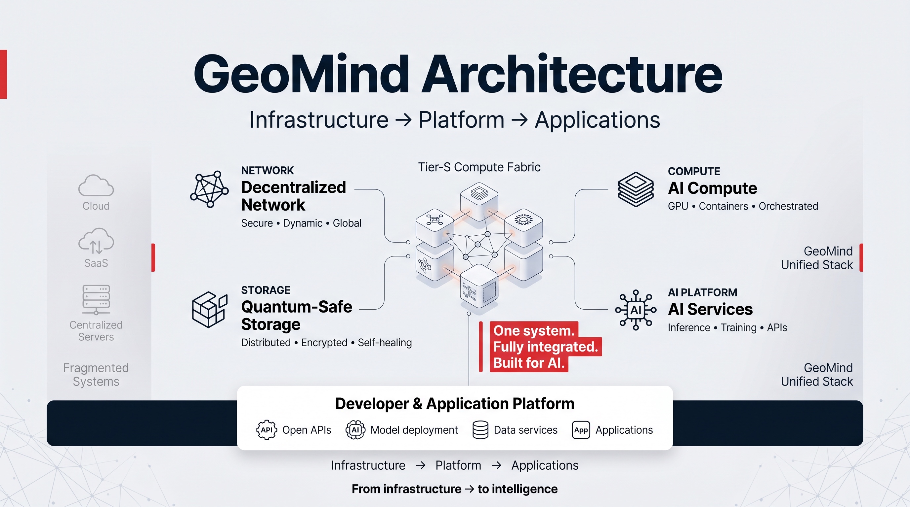
What it is: the layer that runs AI — and runs it in the most efficient possible configuration for the underlying hardware. GeoMind's AI layer continuously improves inference efficiency, lowering the cost of every result while matching or exceeding the performance you would get from a hyperscaler.

Two things this layer does

Efficient inference
Because the stack controls everything from the silicon up (Layer 1) and has a fast, secure data path (Layer 2), operators can run models leaner: less overhead, less wasted compute, more useful work per watt. The result is a lower cost per token for the same quality of output.

The AI broker
On top of efficient inference sits an intelligent AI broker — a single, transparent entry point for any agent or application that needs AI. The broker automatically:
- Routes traffic to the best model for the job — the right model, not just the biggest one.
- Selects models automatically based on the task, cost and quality targets.
- Compresses context and tokens so fewer tokens are used — directly cutting cost.
- Manages context on behalf of the application.
- Provides billing insights — clear visibility into what is being spent and where.
All of this happens seamlessly and transparently: an existing agent or application can use it without being rewritten, and it inherits the full security of Layers 1 and 2 — including the quantum-safe channel between an agent and its model.

Why this is more than "renting a GPU"
A typical neocloud rents you a GPU and leaves the software to you. GeoMind's AI layer lets an operator deliver AI as an optimized service: the model runs efficiently, the broker picks and routes intelligently, and the whole thing is secure and metered out of the box.

The business headline
Run more AI for less money, with automatic best-model selection and full cost visibility — without sacrificing security. This is GeoMind technology operators license to deliver AI as a service. The tangible version is in What Makes Us Unique → The AI Broker.

Layer 4 — Agentic
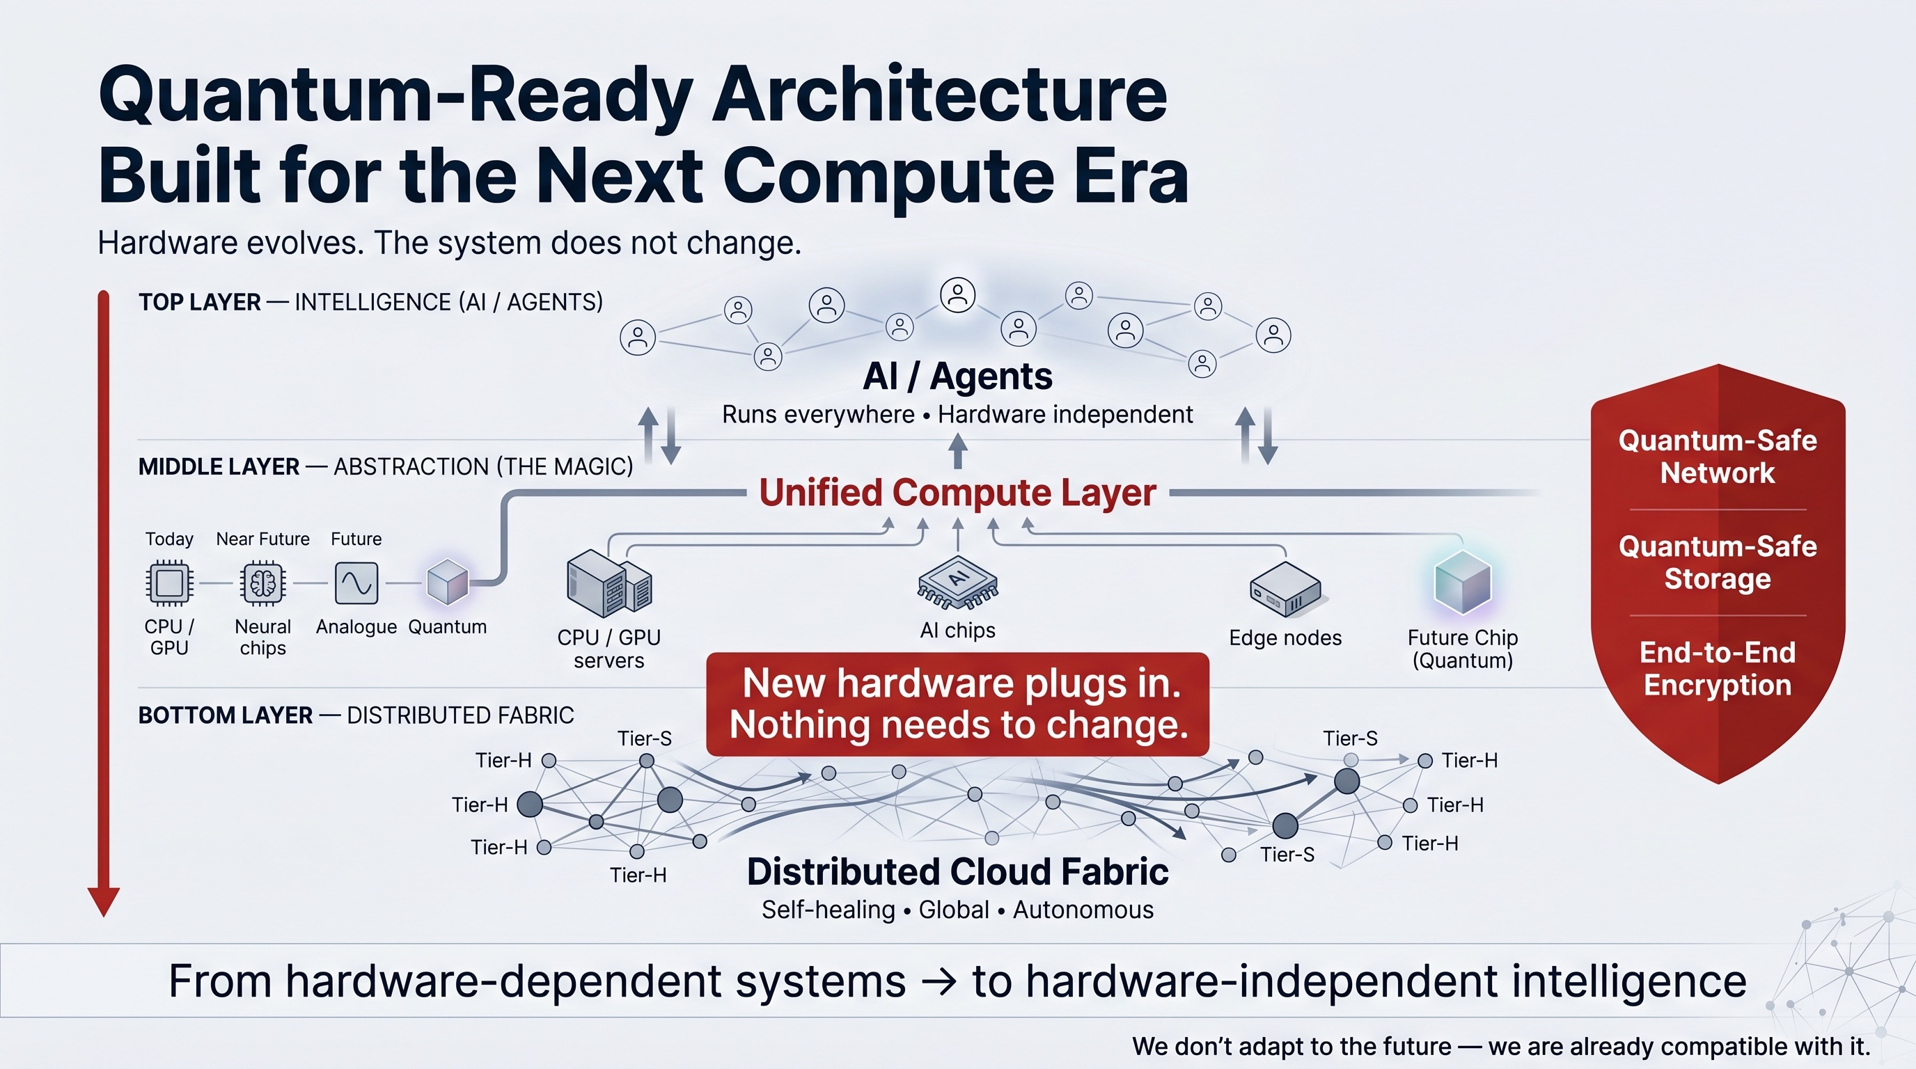
What it is: the top layer — and one of the biggest things GeoMind has built. It is, in effect, an operating system for AI agents. It is open to any other agent, and it allows those agents to reach the quality of the very best AI systems (Anthropic, OpenAI) without having to rely on the largest, most expensive models — which leads to a dramatically lower cost.

Why agents are the real growth story
The next phase of AI is not bigger models. It is agents: persistent, autonomous software that acts, remembers, coordinates and transacts continuously — not one-off requests, but always-on behavior. Agents are memory-heavy, network-intensive and long-lived. There will be billions of them.
Running billions of agents on centralized, GPU-first clouds is possible but inefficient — costs rise faster than revenue. Agents need infrastructure that is always on, secure, auditable and economical at scale. That is exactly what GeoMind's lower three layers provide, and what this fourth layer orchestrates.

What the agentic layer provides
- An operating system for agents — persistent identity, long-term memory, secure state, coordination and event-driven execution, all native.
- Open to any agent — it is not a walled garden; any agent framework can run on it.
- Top-tier quality without top-tier cost — by combining efficient inference (Layer 3), the broker's smart routing, and a well-engineered agent runtime, it reaches Anthropic-/OpenAI-class results using smaller, cheaper models.
- Fully secure and sovereign — agents run inside the operator's own quantum-safe network and storage, not on someone else's cloud.

Why this is genuinely rare
GeoMind may be one of the only technology providers in the world able to deliver a complete, end-to-end agentic AI stack at the quality level of the frontier labs — running entirely within an operator's own sovereign network of capacity, at a materially lower total cost of ownership.

The business headline
Frontier-class agentic AI, owned and run sovereignly by the operator, at a fraction of the cost — and it becomes stickier over time, because customers' agents, memory and workflows live on the platform. GeoMind builds and licenses the agentic layer that makes this possible. The tangible version is in What Makes Us Unique → The Agent Operating System.

The Business Case
Lower TCO, Higher Yield
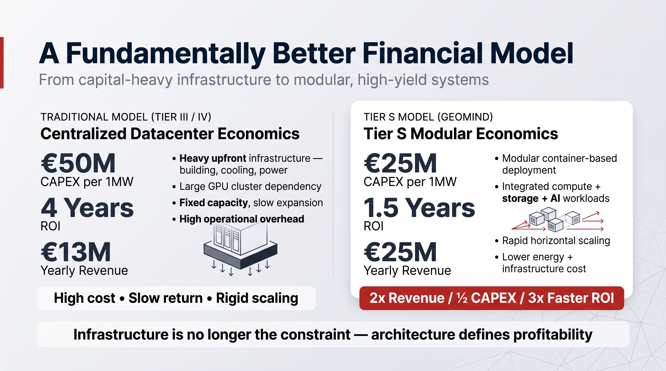
Everything in the previous chapters converges on one commercial point: GeoMind's technology lets operators build a cloud with a lower total cost of ownership and a higher revenue density per megawatt than both traditional datacenters and pure GPU-rental neoclouds. GeoMind does not own or operate the infrastructure — operators do, using the GeoMind stack. The economics below are what the operator achieves; GeoMind's own model follows at the end.

Where the savings come from
Each layer of the GeoMind stack contributes its own saving to the operator, and they stack:
Source | Saving
Hardware used better (Layer 1) | More useful compute per watt; up to 10x energy efficiency on some workloads.
Quantum-safe storage (Layer 2) | 5–10x cheaper storage — 20% overhead vs 300–400% replication.
Self-healing operations | No large ops team; OpEx that doesn't scale with size.
AI broker (Layer 3) | Best-model routing + token compression → lower cost per result.
Agent OS (Layer 4) | Frontier-class outcomes from smaller, cheaper models.
Energy-first deployment | Cheap, local, often-stranded green power; no transmission cost.

The financial shape (for the operator)
A traditional centralized Tier III/IV build is capital-heavy and slow: roughly €50M CapEx per MW, multi-year build cycles, and an ROI around 4 years.
An operator building with the GeoMind modular model changes the equation:
- ~€20–40M CapEx per MW (modular, deployed at the energy source)
- Faster deployment — weeks to months, not years
- Higher revenue density — a target around €10–25M yearly revenue per MW when properly contracted
- ROI closer to ~2 years

Cost center → revenue engine
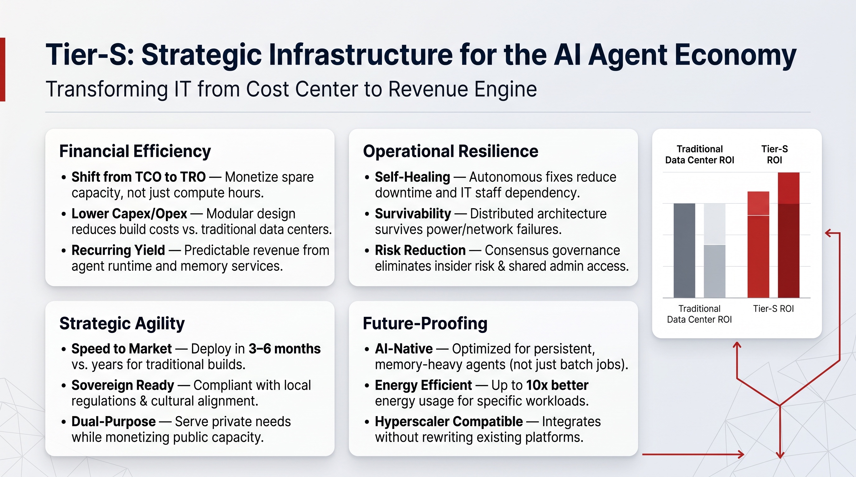
The deepest shift is conceptual. For the operator, infrastructure stops being a fixed expense to be amortized and becomes a productive, yield-generating asset:
- It serves private sovereign needs (government, enterprise) and monetizes public spare capacity simultaneously.
- Agent workloads run continuously, so utilization is high and revenue is recurring.
- The stack stays valuable across multiple GPU generations, because the OS, network, storage and agent layers outlive the GPUs.

How GeoMind earns
GeoMind's own business model is deliberately capital-light. We do not buy GPUs, sign power contracts, or carry hardware on our balance sheet — the operator does. GeoMind is the technology provider and standard-setter, and it monetizes the IP, not the iron:
- License fee — for the four-layer stack, reference architecture, deployment blueprints and certified bill-of-materials, typically tied to the scale of the operator's deployment.
- Recurring maintenance & support — a monthly fee covering updates, security patches, operating manuals and the self-healing tooling that keeps OpEx low for the operator.
- Certification & training — operators and their teams are certified to deploy and run the stack to the GeoMind standard.
- Optional marketplace fees — when operators connect their capacity into the GeoMind marketplace to aggregate and monetize spare supply.
Because none of this requires GeoMind to own assets, the model is recurring and scalable: revenue grows with every megawatt operators deploy, while GeoMind's balance sheet stays light. Every operator that succeeds with our technology compounds our license base and our recurring support and marketplace revenue.
The frame to leave with: for the operator, this is not "better infrastructure at higher cost" — it is lower CapEx, up to 2x faster ROI, and higher recurring revenue, because architecture, not hardware, defines profitability. For GeoMind, it is a capital-light licensing business that scales with every megawatt the operators build.

Summary
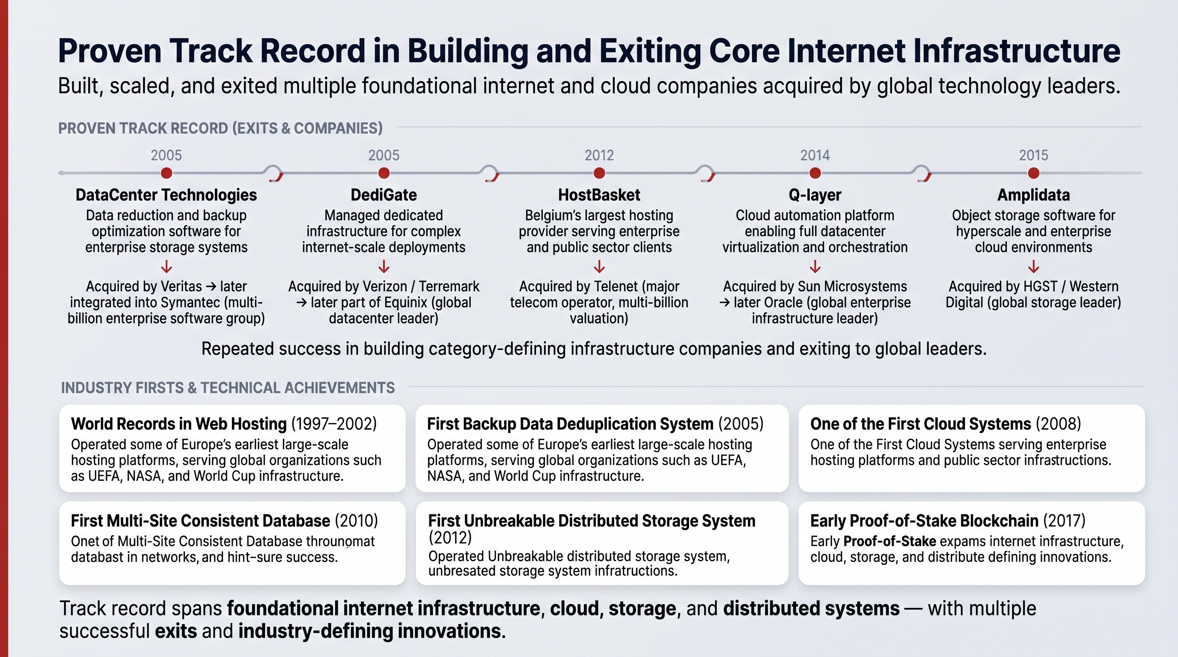
Let's bring it together in one page.

What GeoMind is
A sovereign AI infrastructure technology provider and standard — we build and license the four-layer software stack, but we do not own or operate the infrastructure. Operators buy the hardware, own and control the sites, and run the cloud in their own jurisdiction using GeoMind's technology, reference architecture, certified bill-of-materials, certification and support. Multiple demand channels fill the capacity they build.

How operators deploy with GeoMind
- Follow the energy — find power, ideally green, often stranded.
- Drop in modular datacenters — in existing buildings or as containers.
- Aggregate all of it into one secure, self-healing, planet-scale cloud — via GeoMind's technology and optional marketplace.
The hardware is the easy part. The value is in the software — and that is what GeoMind provides.

Where the magic sits — the four layers
Layer | Unique advantage | Business outcome
1 — Hardware OS | Rebuilt from the Linux kernel up; avoids context switches; tiny attack surface | Lower TCO, higher density, stronger security
2 — Network & Storage | Quantum-safe; data can't be lost or stolen; 20% vs 300–400% overhead | 5–10x cheaper storage, secure edge, sovereignty
3 — AI | Efficient inference + intelligent broker (routing, compression, billing) | Lower cost per token, automatic optimization
4 — Agentic | An OS for agents, open to all, frontier quality without frontier models | Anthropic-class AI at a fraction of the cost

Cutting across all four: self-healing (no humans needed, even at millions of nodes — lower OpEx for the operator) and security by architecture.

Why it wins
For the operator:
- The first wave of the neocloud market is won on raw GPU volume. The long game is won on the layers above the GPU — and GeoMind lets operators own that value instead of buying it piecemeal or skipping it.
- The model is sovereign by construction, lower cost, higher yield, and future-proof across hardware generations.
For GeoMind:
- We own the layers above the GPU and license them — a capital-light model with license fees, recurring maintenance & support, certification, and optional marketplace fees, with no hardware on the balance sheet.
- More than 20 years of experience building, scaling and exiting core internet, cloud and storage companies sits behind the technology and the standard.
The one-sentence pitch: GeoMind provides the full-stack technology that lets operators turn scattered (green) energy into secure, self-healing, agent-ready AI and cloud capacity — deployed anywhere, run autonomously, at a fraction of the cost.
— — — — —
For the deeper technical evidence behind these claims, continue to the Appendix.

Hardware Used Better — and More Securely
Let's make this tangible. Start with an uncomfortable truth about the entire computing industry:
Hardware is used very badly.
A modern server is roughly a million times more powerful than a personal computer from a generation ago — yet the value and efficiency operators get from it have not grown anywhere near as fast. The industry did not run out of hardware. It ran into architecture limits.
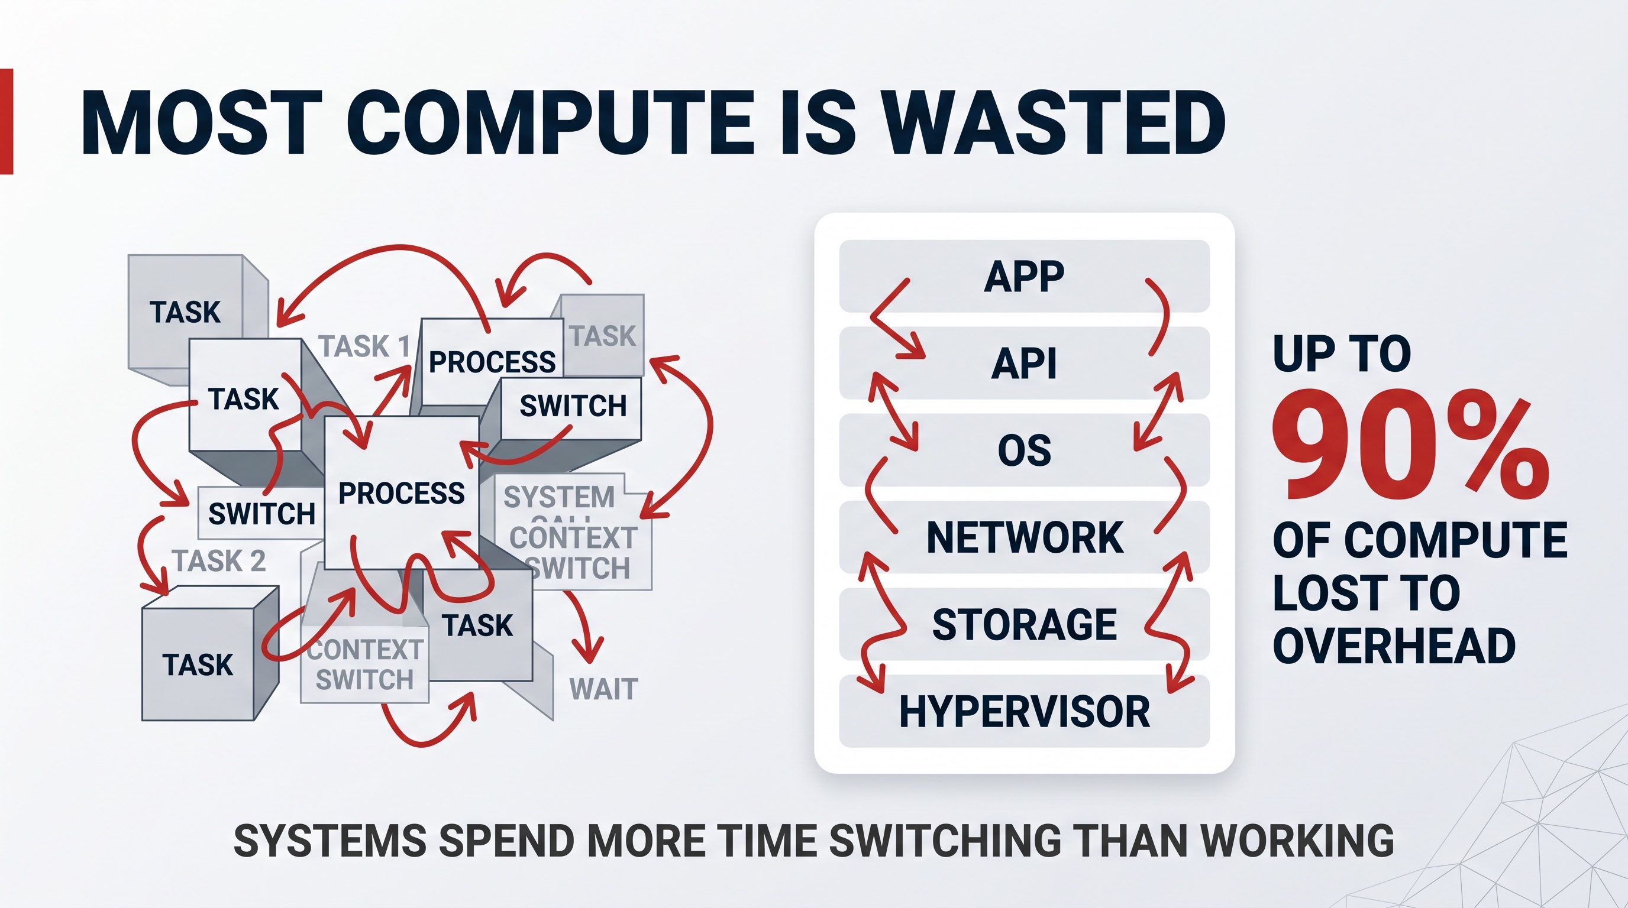

The problem: bloated, layered operating systems
Today's operating systems and clouds are bloated. They are stacked in many layers — application, API, OS, network, storage, hypervisor — and each layer constantly talks to the others. Two things follow:
- Context switching. The machine spends an enormous share of its time just switching between tasks and layers rather than doing useful work. By some estimates, up to 90% of compute is lost to this overhead.
- The onion problem. Each new layer was added to patch a flaw in the layer below. Complexity goes up, cost goes up, security goes down, and fragility goes up.
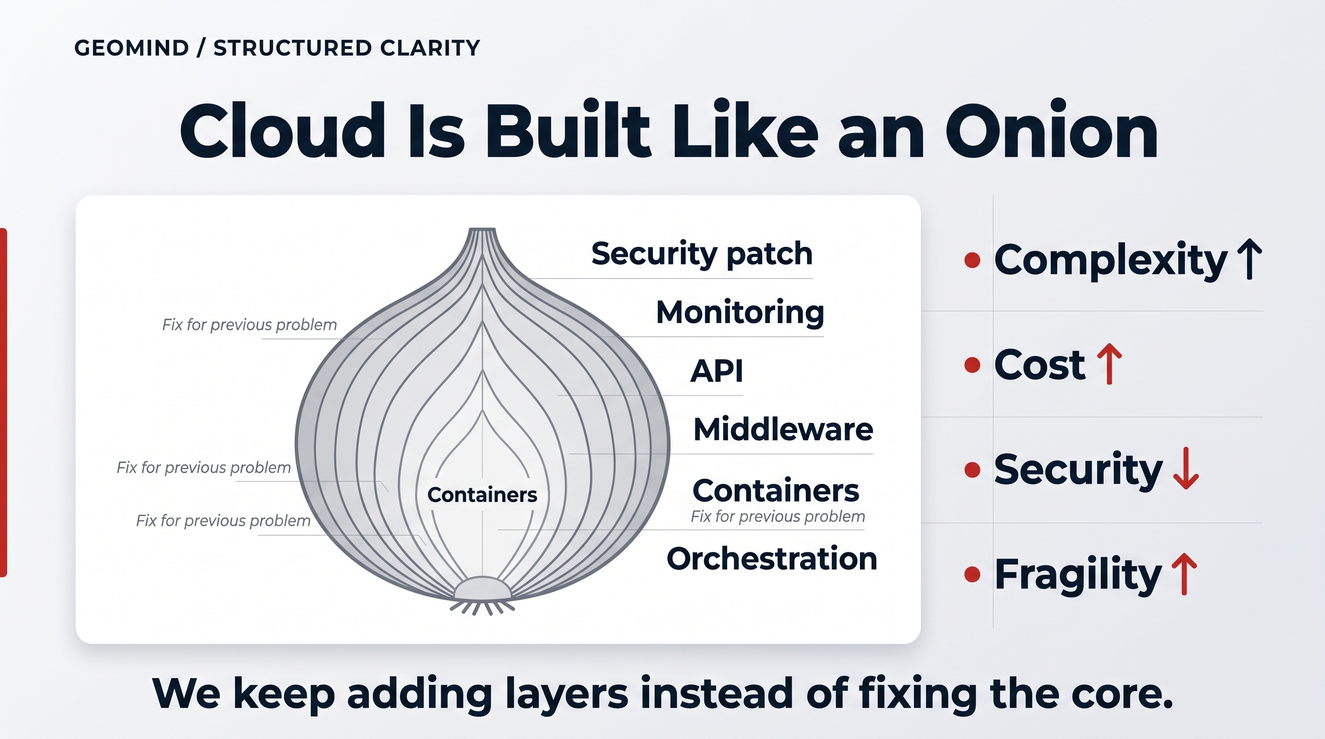
This is why simply "adding more hardware" never fixes the problem. The waste is architectural — and it is exactly what GeoMind's technology removes for the operators who run it.

What GeoMind built about it
GeoMind has benefited from more than 20 years of experience building internet, cloud and storage companies — and used it to rebuild the operating system from the Linux kernel up. Everything around the kernel was re-created to use hardware in the most optimal form. This is GeoMind's technology, licensed to the operators who own and run the hardware.
Two big consequences for the operator:
- Context switches are avoided. A minimal, stateless, event-driven OS does far more useful work per watt, because it isn't constantly managing itself. This is where the up to 10x energy efficiency on some workloads comes from — efficiency the operator captures directly.
- Far more security. By not relying on a tall stack of third-party layers — no shell, no exposed server interface, a tiny attack surface, end-to-end encryption between nodes — whole categories of vulnerability are removed. Less to attack means less that can be attacked.
And GeoMind keeps going: it does active research into how to use hardware in its most optimal form, so the efficiency gap the operator benefits from keeps widening.

The tangible business outcome
Benefit | What it means for the operator
Lower TCO | The obvious one: more useful compute per server and per watt → lower cost per workload.
Higher density | Better hardware utilization means more revenue from the same megawatt.
Stronger security | Fewer layers, smaller attack surface, encryption by default.
Longer asset life | The OS, network and storage layers outlast multiple GPU generations.

The headline: GeoMind's technology lets operators use more hardware, better — and that single fact ripples through cost, density, security and asset life. (And because compute moves efficiently to data, it ripples into the network and storage story too — next page.)

A Quantum-Safe Network & Storage System
This is one of the most genuinely unique things GeoMind has built — and it is worth phrasing it as strongly as it deserves: GeoMind created a quantum-safe storage and networking system in which data cannot be lost, and cannot be stolen. It is technology GeoMind builds, owns and licenses to the operators who run the infrastructure.
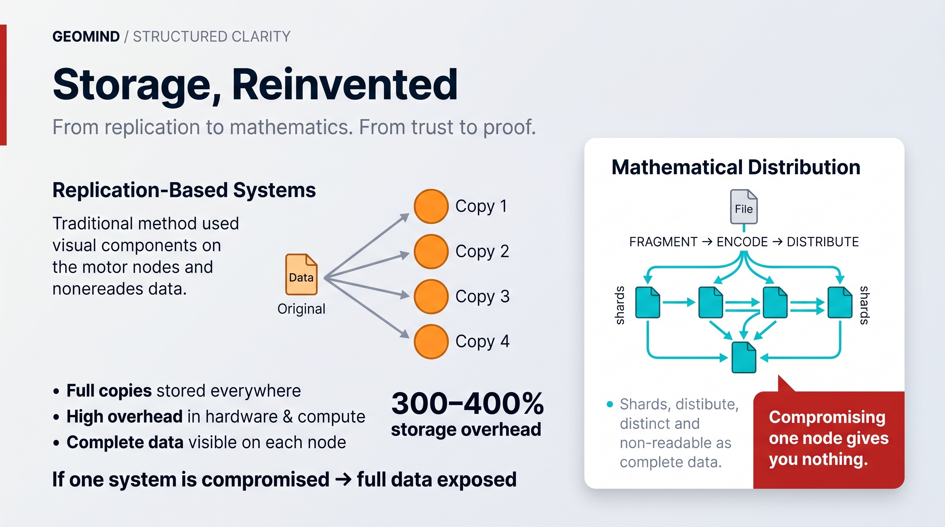

Why secure networking between nodes is crucial
Operators built on GeoMind's technology run a distributed, edge cloud. Capacity sits in many places — containers next to solar fields, racks in existing buildings, edge nodes close to users. Every one of those nodes has to talk to the others.
If those links are not secure, the whole model collapses. So this is not optional — it is absolutely crucial:
- The connection between any two nodes is end-to-end encrypted, with no point in the middle that can read or tamper with it.
- The link between an AI agent and its large language model runs over the same secure channel. An agent's reasoning, an enterprise's data, a government's records — all move only over channels that no intermediary can inspect.
- It is quantum-safe: built on principles that do not depend on the cryptographic assumptions a future quantum computer could break. Traffic intercepted today cannot be quietly decrypted tomorrow.
At the edge, where infrastructure is physically more exposed and spread across jurisdictions, this secure fabric is what makes an operator's sovereign, defense-grade workloads possible at all.

Why the storage is unbreakable
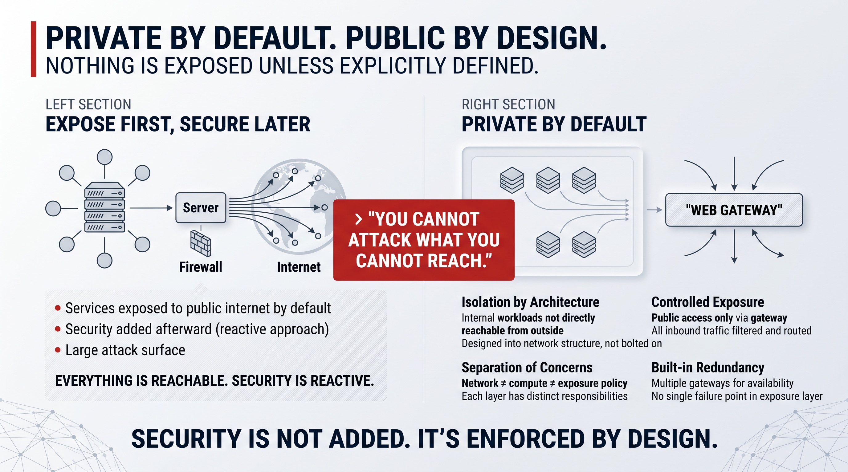
Traditional systems keep data safe by making full copies — three, four, five times over. That is wasteful (300–400% overhead) and, paradoxically, insecure: every copy is a complete, readable target.
GeoMind's technology does something fundamentally different. Data is mathematically encoded, fragmented, and scattered across many nodes:
- No single node holds the data. Each holds only a meaningless mathematical fragment. Compromising one node gives an attacker nothing.
- It cannot be lost. If nodes or disks fail, the system reconstructs the missing fragments from the others, automatically. Integrity is structural, not a backup you hope works.
- It is radically more efficient — roughly 20% overhead for strong redundancy, against the 300–400% of replication. That is the basis of 5–10x storage cost savings (50–70% cheaper than hyperscalers).

The tangible business outcome
Property | Business value for the operator
Quantum-safe by architecture | Future-proof security; suitable for defense, finance, health, government.
Data cannot be stolen | One breached node exposes nothing — eliminates a whole class of breach.
Data cannot be lost | Self-healing integrity removes the cost and risk of backup regimes.
5–10x cheaper storage | Mathematics replaces 300–400% replication overhead.
Secure edge connectivity | Sovereign, distributed deployments become viable and trustworthy.

Security here is not a feature you switch on. It is the shape of the system. That is why GeoMind describes it as a fundamentally different security model — not an upgrade.

A Self-Healing System
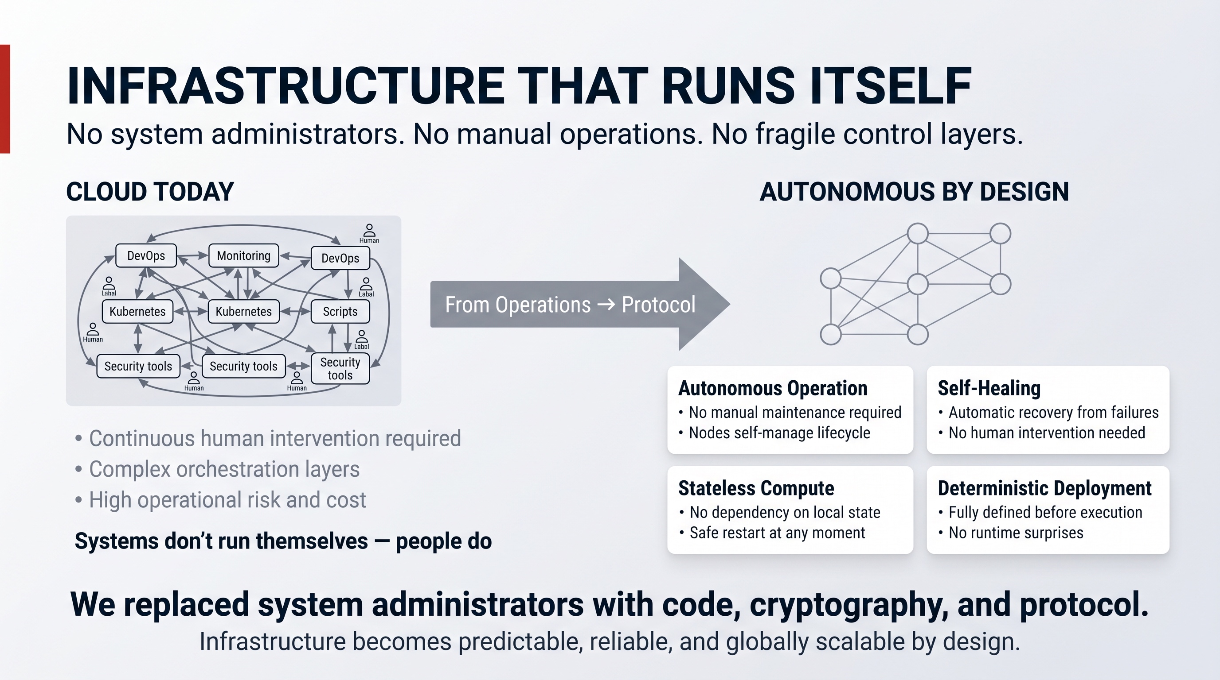
Here is a claim that sounds impossible until you understand how it's built:
GeoMind's technology lets an operator run sovereign capacity at every location without a large engineering team — even at millions of nodes.
This is the self-healing property, and it is woven through every layer GeoMind builds. It is the operational backbone that makes the distributed, edge model actually work for the operator.

What "self-healing" means in practice
In a normal cloud, people run the system. Teams of DevOps engineers, Kubernetes operators, monitoring tools, on-call rotations and custom scripts — all needed because the system cannot look after itself. As the operator grows, they must grow the operations team with it.
GeoMind's technology replaces that with code, cryptography and protocol:
- Autonomous operation — nodes manage their own lifecycle. No manual maintenance.
- Self-healing — when something fails, the system recovers automatically. Storage fragments are rebuilt, workloads are rescheduled, no human is paged.
- Stateless nodes — a node holds no precious local state, so it can be restarted or replaced at any moment with zero configuration drift. A fresh, verified system loads on every boot.
- Deterministic deployment — everything is fully defined and cryptographically verified before it runs. If it isn't defined, it doesn't run. No runtime surprises.

Why this is a low-level achievement
This does not come from a clever management dashboard on top. It comes from the way GeoMind designed the lowest layers — the stateless OS (Layer 1) and the self-healing, mathematically-encoded storage and mesh network (Layer 2). Autonomy is the foundation, not a feature added later.

The two big payoffs

Lower cost to operate
No armies of system administrators. No managed-services contract per site. The operator's deployment scales to any size without scaling the operations team proportionally — which is decisive in emerging markets and sovereign deployments where skilled infrastructure engineers are scarce and expensive.

Amazing security benefits
A system run by humans is a system that can be attacked through those humans — credentials, insider risk, social engineering, configuration mistakes. By removing human operators from the loop:
- There is no root access to steal or abuse.
- Human error, the cause of a huge share of outages and breaches, is largely designed out.
- Every change is cryptographically verified, so tampering is detectable by construction.

The tangible business outcome
Benefit | What it means for the operator
No ops team needed | The operator runs sovereign capacity at every location without a large engineering staff.
Scales without limit | The same model works for 10 nodes or 10 million.
Lower OpEx | One of the largest line items in any cloud simply disappears.
Insider risk removed | No human root access = a whole attack vector eliminated.
Higher uptime | Failures heal automatically instead of waiting for a human.

Self-healing is what turns "a distributed cloud across many jurisdictions" from an operational nightmare into something that quietly runs itself — built into the lowest layers of GeoMind's technology so the operator inherits it for free.

AI Inference & the AI Broker
GeoMind has deep expertise in AI inference — running models to produce answers efficiently. But its real differentiator at this layer is the AI broker: a single, intelligent, transparent gateway that sits between any agent or user and the world of AI models. It is technology GeoMind provides, which operators and their customers and agents use.

What the broker does — automatically and seamlessly
Think of the broker as an extremely smart switchboard for AI. Any agent or application points at it, and it handles the rest:
- Routes traffic to the best model for the job. Not always the biggest, most expensive model — the right one. A simple task goes to a small, cheap model; a hard task goes to a powerful one.
- Automatic model selection. The broker decides, so the application doesn't have to.
- Automatic token compression. It compresses prompts and context so fewer tokens are used — and tokens are what the customer pays for.
- Context management. It manages the conversation/context window on the application's behalf.
- Billing insights. Clear, automatic visibility into spend — by model, by application, by team.
All of this is completely transparent. An existing agent or any other application can use the broker without being rewritten. It just works, and it works better and cheaper.

Done more efficiently, and fully secure
Two things make GeoMind's broker different from a generic "model router":
- Efficiency. Because the broker sits on top of GeoMind's own efficient inference (Layer 3), optimized OS (Layer 1) and fast network (Layer 2), it does the same work with less compute and fewer tokens — compounding the savings the operator and their customers see.
- Security. It maintains the full quantum-safe security described earlier. The link between an agent and its model never leaves GeoMind's encrypted fabric. The customer gets smart routing and sovereignty — not a trade-off between them.
The broker can also use the network features behind it — placing inference close to the data, respecting jurisdiction, and routing over the most efficient secure path.

The tangible business outcome
Capability | What it saves / unlocks
Best-model routing | Stop overpaying — use a big model only when you actually need one.
Token compression | Fewer tokens per result → directly lower bills.
Automatic selection & context | Less engineering effort; teams ship faster.
Billing insights | No more surprise AI bills; real cost control.
Transparent integration | Any existing agent/app benefits with zero rewrite.
Security preserved | Cost savings without giving up sovereignty or quantum-safety.

The broker turns AI from an unpredictable, expensive black box into a managed, optimized, transparent utility — and it does it without anyone having to change their code.

An Operating System for Agents
This is one of the biggest things GeoMind has built — and it is the layer that turns everything below it into a business that compounds for the operator.
GeoMind created an agent layer — effectively an operating system for agents — that is open to any other agent, and that reaches the quality of Anthropic or OpenAI without having to resort to their biggest, most expensive models. The result is a much lower cost.

Why this matters now
The center of gravity in AI is shifting from models to agents. Agents are persistent: they run continuously, hold memory, coordinate with each other, and act on behalf of people and organizations. The growth curve is no longer "how big is the model" — it is "how many agents are running, all the time."
That changes the economics completely. Agents create durable, around-the-clock demand rather than spiky one-off jobs — which is exactly the kind of demand that fills an operator's distributed capacity well and produces predictable, recurring revenue.

What GeoMind's agent OS provides
- A real operating system for agents — persistent identity, long-term memory, secure state, coordination, and event-driven execution, all built in.
- Open to any agent. It is not a closed ecosystem. Any agent or framework can run on it.
- Frontier-class quality, lower-cost models. By combining a well-engineered agent runtime with the broker's smart routing and GeoMind's efficient inference, agents reach top-tier results without depending on the largest, priciest models — so the cost per outcome falls dramatically.
- Sovereign and secure end to end. Agents run entirely inside GeoMind's quantum-safe network and storage. Memory, reasoning and data never leave the controlled fabric.

Why it's rare — and why it's sticky
GeoMind's technology may be one of the only in the world able to deliver a complete, end-to-end agentic stack at frontier-lab quality, running inside an operator's own sovereign capacity, at a materially lower TCO.
And commercially, it is the layer that locks value in for the operator. As customers run agents, store memories, build workflows and integrate applications on the operator's GeoMind-powered platform, the value moves far beyond raw compute. The infrastructure becomes part of how the customer operates — which raises the operator's margins, extends customer lifetime, and reduces any dependence on GPU resale pricing.

The tangible business outcome
Benefit | What it means for the operator
Anthropic-/OpenAI-class quality | Compete at the top without frontier-model bills.
Much lower cost per outcome | Smaller models + smart orchestration = better margins.
Open to any agent | Broadest possible market; no lock-out of other ecosystems.
Durable, 24/7 demand | Agents fill capacity continuously → predictable revenue.
Sticky platform | Memory + workflows on-platform = long customer lifetime.
Sovereign by construction | Frontier agentic AI that governments and enterprises can actually own.

Layers 1–3 make the hardware productive, secure and cheap to run. Layer 4 is where that turns into a defensible, compounding business for the operator — agentic AI at frontier quality, owned sovereignly, at a fraction of the cost.

Appendix — The Deeper Technology
This appendix exists as evidence, not required reading. The main document deliberately stayed at the business level; here we go one level lower for readers who want to see that the claims rest on real engineering. None of it changes the business story — it underpins it. GeoMind builds, owns and licenses the technology described here; operators buy and own the hardware and run the infrastructure on top of it.
— — — — —

Layer 1 — Mycelium OS (MOS), in more detail
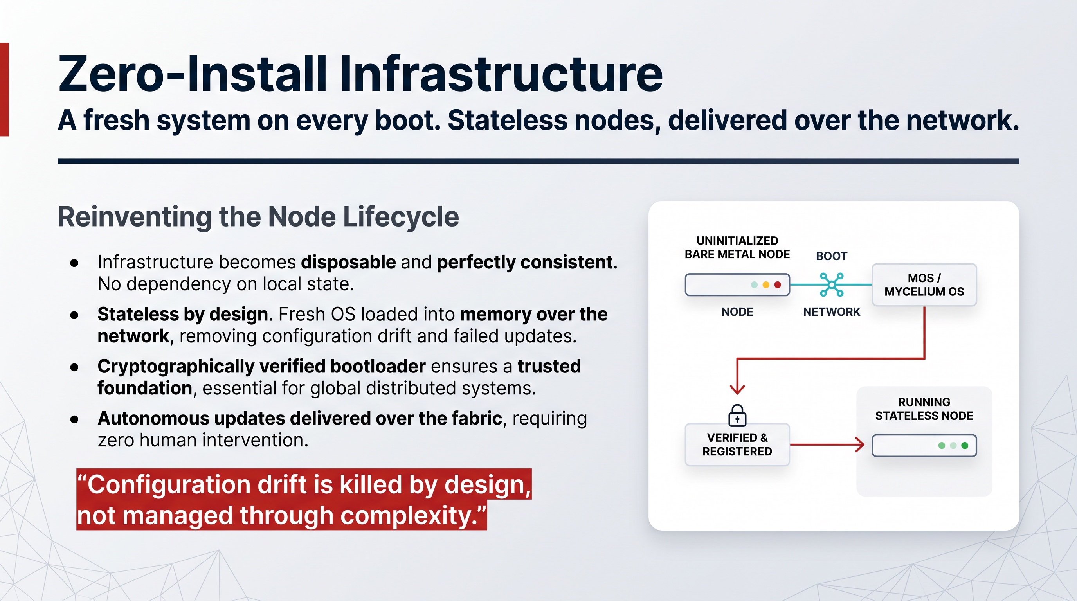
- Stateless network boot. MOS is delivered to a node over the network on every boot — no local installation. A minimal bootloader (via USB or network boot) is cryptographically verified, then retrieves and verifies the OS components. This is why nodes never accumulate configuration drift.
- Minimal primitives only. MOS supports just three core primitives — compute, storage and network capacity management — plus compatibility for Docker containers, VMs and Linux workloads.
- Deterministic deployment. A workload is fully specified, all dependencies resolved, then cryptographically signed and registered on a distributed ledger before it runs. Nodes detect, verify and execute it exactly as defined. If it isn't defined, it doesn't run.
- MyImage. Instead of shipping a ~2 GB container image, MOS ships a metadata description (<2 MB) and streams only the files actually needed, each cryptographically verified. Result: ~1000x smaller metadata, ~10x less transfer, and up to 100x faster startup.
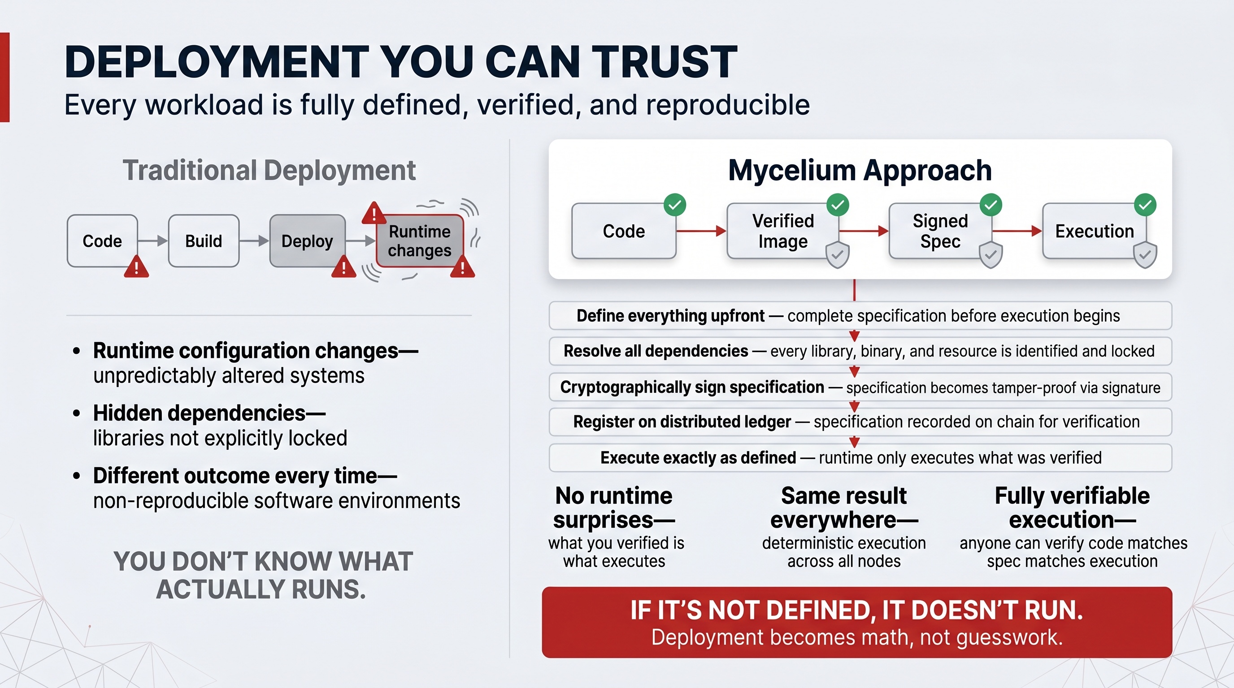

Reduced attack surface
No shell or server interface is exposed; communication between nodes is end-to-end encrypted; compute/storage is isolated from network services; containers run in dedicated VMs. Removing human operators removes human error as an attack vector.
— — — — —

Layer 2 — Network & Storage, in more detail

Mycelium network
- A secure peer-to-peer mesh overlay on top of the existing internet; each participant runs a network agent.
- End-to-end encryption with no readable intermediary; shortest-path routing based on latency, bandwidth, reliability and geography; multi-hop transmission when needed, without ever decrypting in the middle.
- Private by default — public exposure only through an explicit, redundant Web Gateway, keeping backend workloads unreachable.
- Throughput up to ~1 Gbps per agent on devices, and wire-speed (e.g. 100 Gbps) inside deployed infrastructure.

Quantum Safe Storage
- A three-tier design: a filesystem layer (Quantum Safe FS), an encode/distribute layer (ZSTOR), and a physical layer (ZDB, append-only/immutable).
- Data is forward-error-corrected into fragments spread across 20+ geographically distributed nodes. Zero-knowledge: each node holds only a mathematical fragment, insufficient to reconstruct anything.
- Self-healing against both bitrot and hardware failure; ~20% overhead for tolerating multiple node failures (vs 300–400% for replication); optional post-quantum cryptography.
— — — — —

Layer 1–2 energy efficiency
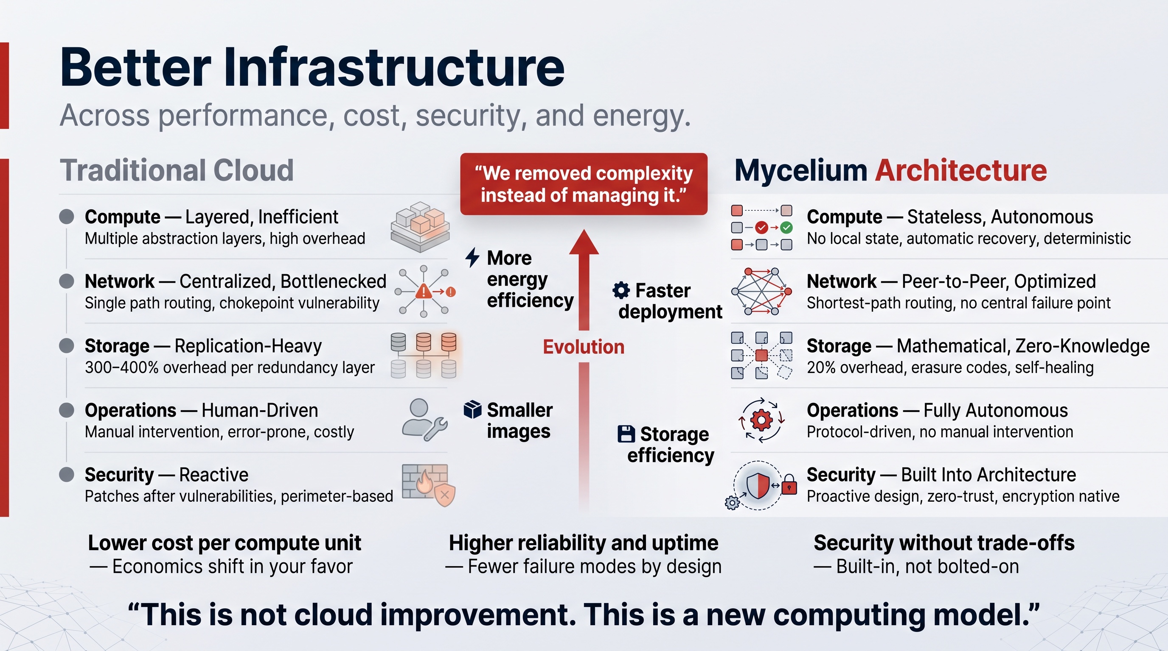
The efficiency gains are concrete: a stateless, low-overhead OS reduces context switching; a "single-instance" model avoids the 100x duplication typical of conventional cloud presence; forward error correcting codes needs up to ~5x fewer disks and allows slow, green, low-power drives. A typical 60 W edge node can host 100–200 lightweight agents — well under 1 watt per agent, yielding up to 10x overall efficiency on suitable workloads.
— — — — —

Why sovereignty is not optional — the cyber pandemic
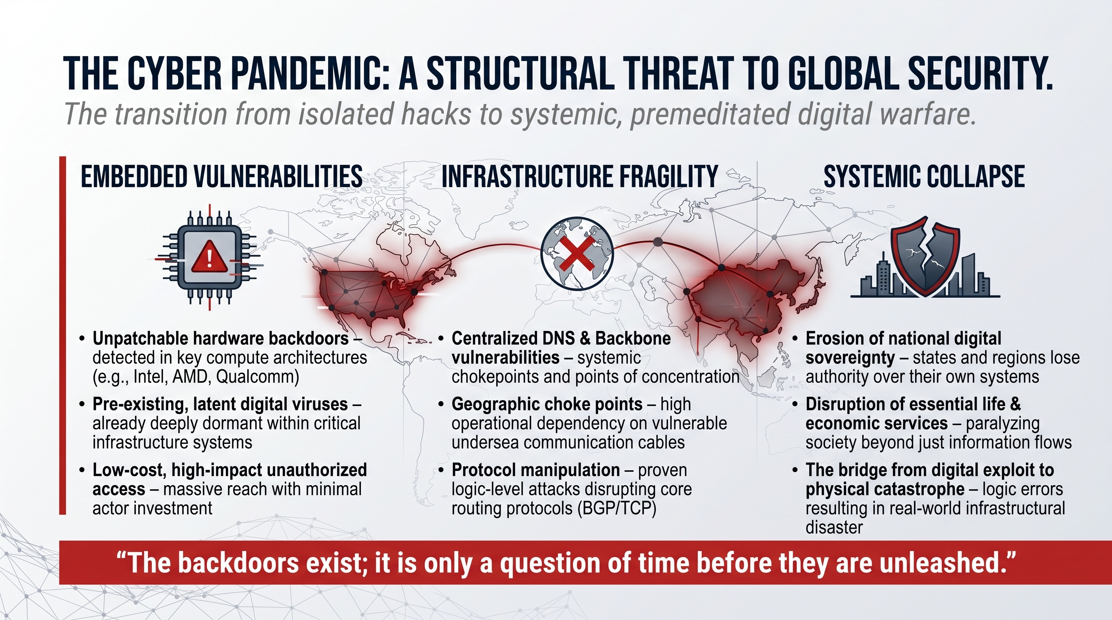
The security architecture is a response to a real threat landscape: documented hardware backdoors in mainstream CPU/chip architectures, centralized DNS and backbone choke points, undersea-cable dependencies, and protocol-level (BGP/TCP) fragility. Most national internet usage leaves the country, and a single cut cable or DNS attack can disrupt an entire nation.
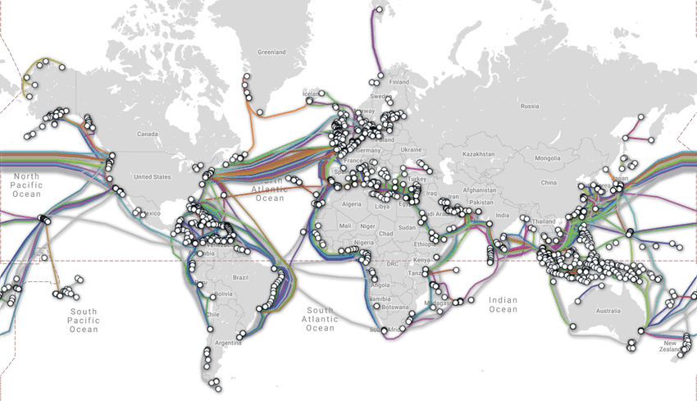
GeoMind's technology enables a distributed, encrypted, self-healing, locally-owned model — owned and operated by in-country operators — built precisely so that no single backdoor, choke point or foreign operator can compromise or switch off a nation's infrastructure.
— — — — —

Comparison table — Mycelium architecture vs traditional cloud
Dimension | Traditional cloud | GeoMind / Mycelium
Compute | Layered, high context-switch overhead | Stateless, autonomous, deterministic
Network | Centralized bottlenecks, single-path | Peer-to-peer, optimized, no central failure
Storage | 300–400% replication overhead | ~20% forward-error-correcting codes overhead, self-healing
Operations | Human-driven, error-prone | Fully autonomous, protocol-driven
Security | Reactive, patched after the fact | Built-in, zero-trust, encryption-native

The point of the appendix: every business claim in this document — lower TCO, unbreakable storage, secure edge, self-healing operations, efficient AI — is the visible surface of a deliberate, first-principles engineering decision underneath.

